Overview and instructions for uploading to Moodle the Student Course Survey – Themes and Response

The template for the Student Course Survey – Themes and Response can be found on Te Aka | The Nest:
Student Course Surveys on Te Aka | The Nest

- Identify the three most common themes to emerge from the course survey.
These could be issues that need to be addressed, or positive features of a course that need to be maintained or perhaps given greater emphasis.

- In the ‘Response’ sections, describe how you have addressed the three themes.

- Upload the completed Student Course Survey – Themes and Response to the 'Feedback' section in Moodle, under the heading 'You Said, We Did'.

- Make the plan available in Week 1 or 2 of the new course and go through it in class, so students are clear about what has been done in response to course feedback. This is important because ākonga will see the value in completing course evaluations, and it will also give them an opportunity to ask questions.
Please note, if you do not receive a Student Course Survey report, you still need to complete the Student Course Survey – Themes and Response template. The Theme will be “Survey response rates too low for robust data” and the Response will be whatever the plan is to increase the response rates within your course.

How to organize the Student Course Survey: Themes and Response documents in your course (on the Feedback page)

In the example below, a S1 2026 course contains one current and two previous Themes and Response documents. All three courses are available to the current (S1 2026) cohort of students.

They are organized under appropriate headings, with documents from previous semesters in reverse chronological order, so that students can quickly identify the themes that emerged from the most recent deliveries, and whether these have been been addressed.

This is what the Themes and Response documents would look like in two different Moodle formats ('One Topic' and 'Tiles').

In 'One Topic' (tabs)
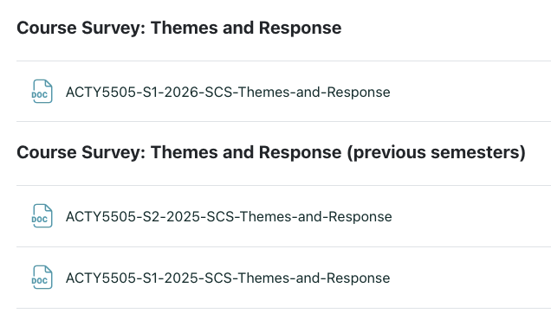
In 'Tiles'
