Updating your Unitec email signature

October 2025

How to update your email signature to the Unitec single brand.

Some hints:
- Use the vertical layout provided – it means your signature works when viewed on both mobile and laptops/desktops.

- Old signatures often used a table to lay out the information – sometimes that might have worked, but it meant information was chopped off when viewed on a mobile, and that’s a fail.

- Don’t be tempted to change the font type, style, colour or size - keeping it simple makes it easiest for a wide range of people to read (accessibility) and also keeps our brand consistent.

- You can choose to use either your direct dial, mobile phone, or both. Extensions are clumsy and unnecessary.
If you need to find you direct dial, in Teams click on the phone icon in the left hand menu, then take note of the Work number that appears (you can ignore the extension).

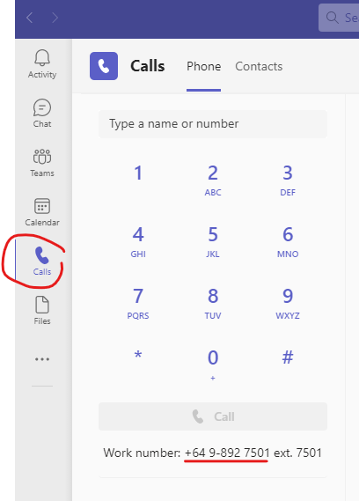

- You don’t need to add a legal disclaimer as this is included automatically in external emails.

- You don’t need to include your email address in the signature because …. you’ve already sent the email from that address ;)

- When was the last time you actually read and looked up information that someone else added underneath their email signature?
In reality we’re all too busy and just filter out the noise. Let’s keep things simple and not include:
  - working from home details (instead update your outlook calendars and set up automatic email replies about flexible working days).
  - additional messages, quotes, etc
  - additional images
  - Unitec badges
If there’s something important to say, just add it to the main body of your email.

Step by step guide for updating your signature

Update the outlook program on your laptop

- Click on File

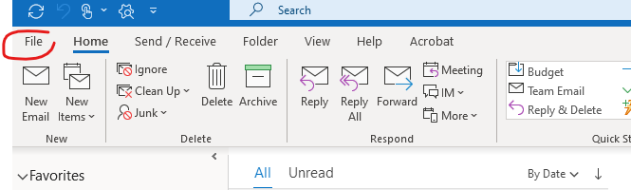
- Click on options
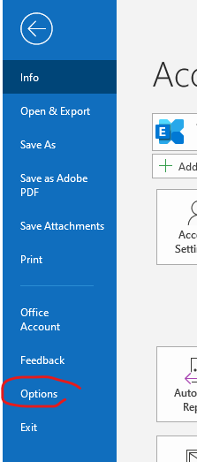
- Click on Mail, then Signatures
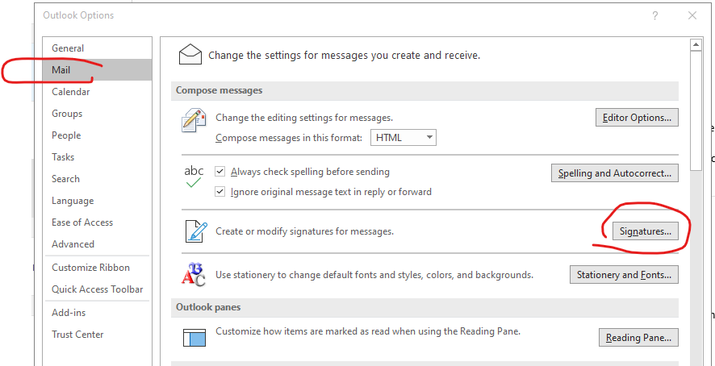

- Click on New,
Give your signature a name,
then click OK. (Alternatively, you can edit your existing signature)
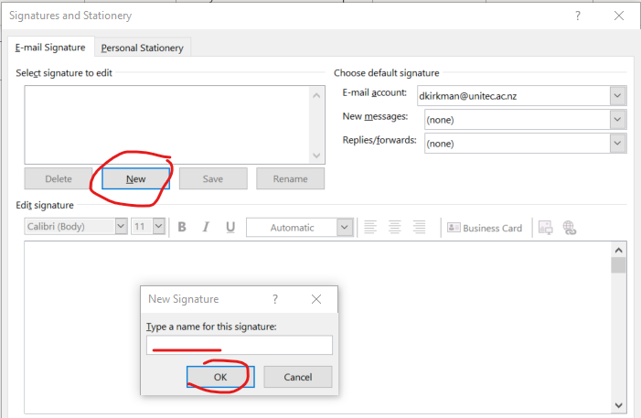

- Copy the template signature from below and paste into body of the signature,
Update your details, adding suggested and optional details as appropriate (don’t be tempted to add extras or change fonts etc!).
You can also refer to guidance for pronoun use in email signatures.
Click OK.
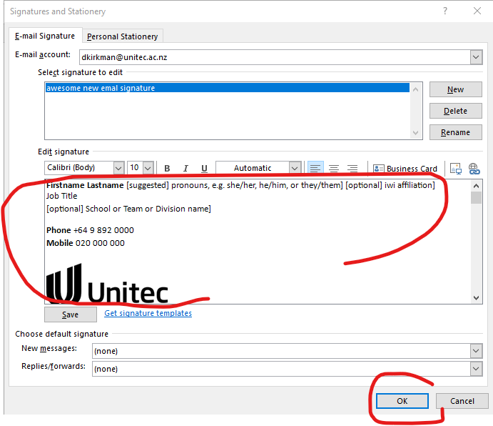

Firstname Lastname [suggested] pronouns, e.g. she/her, he/him, or they/them] [optional] iwi affiliation]
Job Title
[optional] School or Team or Division name]

Phone +64 9 892 0000
Mobile 020 000 000

Te Whare Wānanga o Wairaka
Unitec.ac.nz

Click OK one more time and, you’re done!
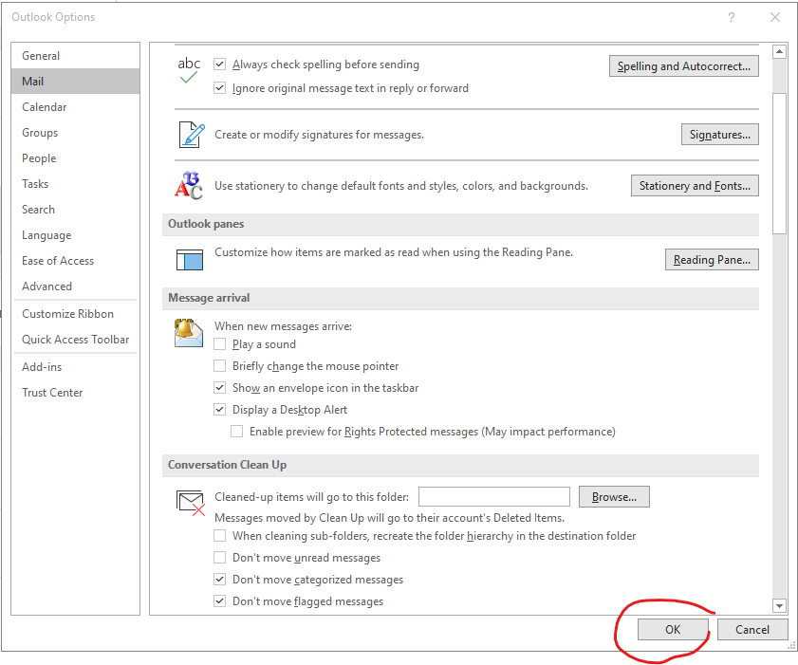

- Remember to alter all your existing signatures should you have more than one.

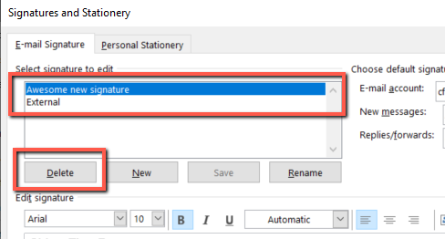

Step by step guide for updating your signature on a Mac

First, highlight the complete signature text below, right-click and select “Copy” (or cmd-C)

Firstname Lastname [suggested] pronouns, e.g. she/her, he/him, or they/them] [optional] iwi affiliation ]
Job Title
[optional] School or Team or Division name ]

Phone +64 9 892 0000
Mobile 020 000 000
Te Whare Wānanga o Wairaka
Unitec.ac.nz

Next, open the Outlook application on your Mac

- Select “Preferences…” from the Outlook drop-down menu (next to the Apple Menu Item)

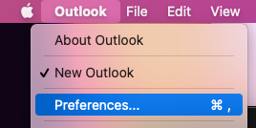

- Click on the “Signatures” preference

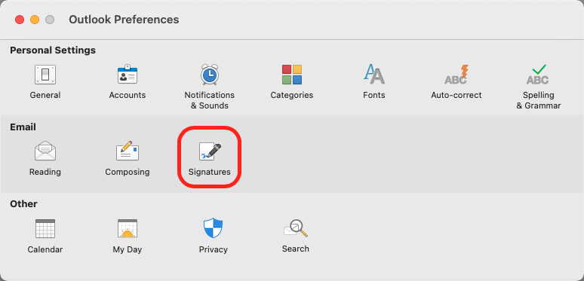

- Click the “+” symbol to add a new signature
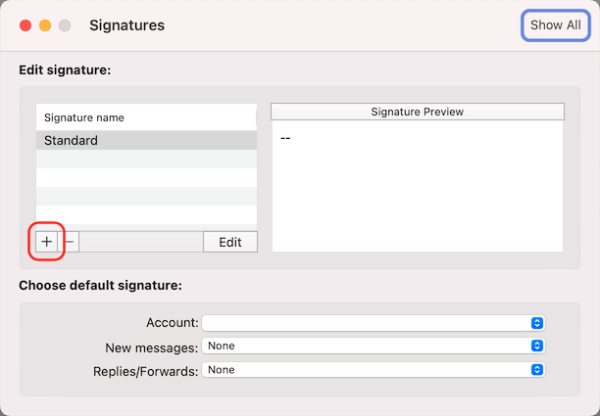

- Give the new signature a unique name.

Then right-click in the body of the signature and choose “Paste” (or cmd-V).
Edit the “Firstname Lastname (iwi affiliation), Job Title, School or Team, and phone numbers.
Now click the Save icon (shown by the red arrow) or simply close the window.

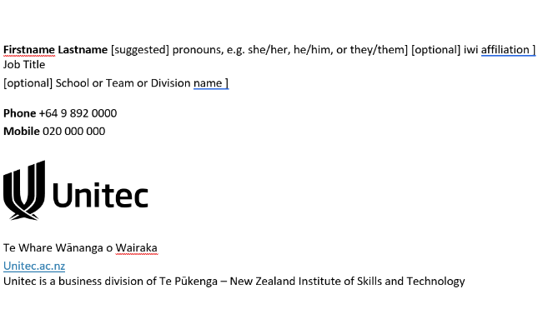
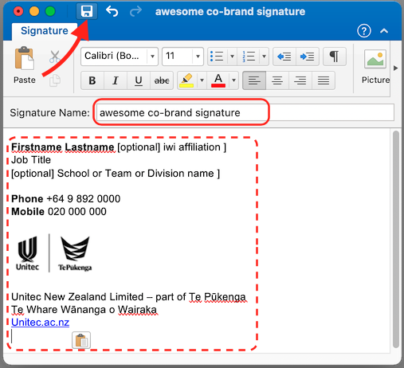

- Finally, choose “New messages” to use your newly created signature

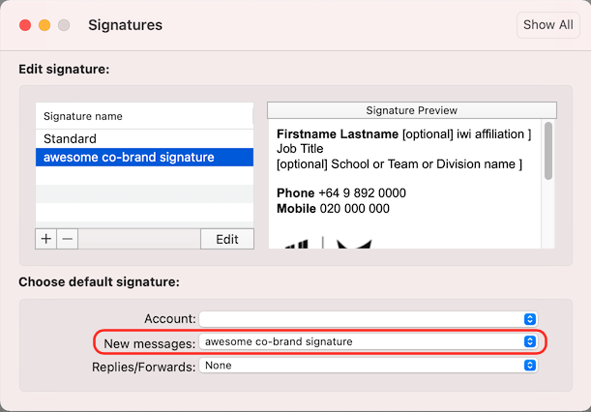
- Click the red “close window” button and you’re done!

