**Head of School & Investigator Checklist for Reconsideration of Final Grade**

* Student should submit the reconsideration form within 10 working days of grade publication.
* *The HoS may decide whether or not the grounds are met, or this can be delegated to a peer. Grounds include but are not limited to:

1. an irregularity in the conduct of summative assessment OR
2. in the results reporting and approval process within ten working days of the course final grade.

* Follow principles of natural justice (refer section 5 of the [Ākonga Concerns & Complaints Policy)](https://www.xn--tepkenga-szb.ac.nz/assets/Policies/2023/National-Akonga-Concerns-and-Complaints-Policy-v2.pdf)

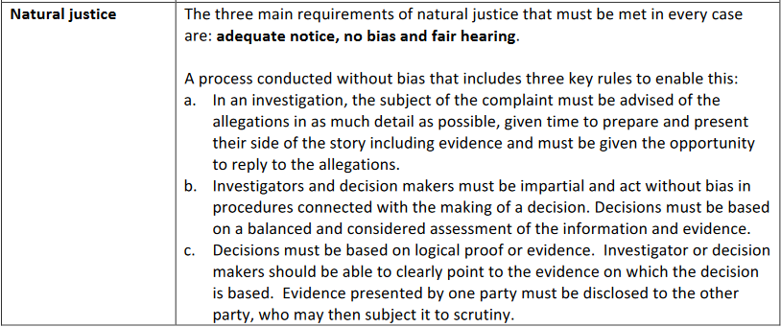

|  | **Who** | **Action** | **Due** | **Complete** |
| --- | --- | --- | --- | --- |
| 1 | HoS | Receive Reconsideration of Course Final Grade form via [studentcomplaint@unitec.ac.nz](mailto:studentcomplaint@unitec.ac.nz)  Refer [Ākonga Concerns & Complaints Policy](https://www.xn--tepkenga-szb.ac.nz/assets/Policies/2023/National-Akonga-Concerns-and-Complaints-Policy-v2.pdf) and [Ākonga Complaints Procedure](https://www.unitec.ac.nz/about-us/unitec-policies/%C4%81konga-student-complaint-procedure) | Within 3 working days of receipt of form |  |
| 2 | HoS | **Consider if** **you are sufficiently without bias** to assess whether or not the grounds* for reconsideration are met. If not, delegate to a peer. | Within 3 working days of receipt |  |
| 3a | HoS | If grounds **are** met, an academic investigator from another School to be appointed to proceed with an investigation (*Volunteer list of academic investigators provided*). Provide the investigator with the analysis to determine grounds document and any other paperwork, evidence which proved the grounds were met. |  |  |
| 3b | HoS | If grounds **are not** met, notify student *(Grounds not met template provided*)  cc [studentcomplaint@unitec.ac.nz](mailto:studentcomplaint@unitec.ac.nz) | Within 5 working days of receipt |  |
| 4 | Investigator | Introduce yourself by email to student and all other parties. Notify any relevant kaimahi (staff). Share the reconsideration form with support person **if requested**, with agreement that it remains confidential. Refer 2.2.6 of the [Ākonga Concerns & Complaints Policy](https://www.unitec.ac.nz/sites/default/files/public/documents/National-Akonga-Concerns-and-Complaints-Policy-v2.pdf). | Within 3 working days of receipt |  |
| 5 | Investigator | Read [Ākonga Concerns & Complaints Policy](https://www.xn--tepkenga-szb.ac.nz/assets/Policies/2023/National-Akonga-Concerns-and-Complaints-Policy-v2.pdf) and [Ākonga Complaints Procedure](https://www.unitec.ac.nz/about-us/unitec-policies/%C4%81konga-student-complaint-procedure) |  |  |
| 6 | Investigator | Find out what was addressed at the informal concern stage. |  |  |
| 7 | Investigator  *use Power BI or Peoplesoft to access this data | Consider sources such as:   * Moderation * Gradebook grades for whole class* * Power BI course survey data* * Student’s Peoplesoft historical academic record* * Assessment and marking guide/rubrics (does the student understand how marks have been awarded?) * Exam scripts (contact Exams Office) * Course Moodle page * Establish if the learner had access to the same assessment information & teaching as other students in the same class | Before the due date – Within 15 working days of the form being received by Student Complaints  **Note:** **Due date includes few days for the relevant executive to take a decision and provide outcome to the Complainant** |  |
| 8 | Investigator | Where possible, meet with the complainant and other parties separately in a neutral space*.* If it is not possible to meet in person, meet on Teams/Zoom if the student or kaimahi agree. Advise them that they may bring a support person to any meetings.  Any person making a statement needs to verify the accuracy of their statement by signing and dating the statement in front of a witness.  Notes taken at the meetings/interviews should be emailed to the interviewee to verify the accuracy and give an opportunity to correct if misinterpreted.  Document each step of investigation, dates, who was present, discussion and resolution if any was reached  Follow principles of natural justice (refer section 5 of the [Ākonga Concerns & Complaints Policy](https://www.unitec.ac.nz/sites/default/files/public/documents/National-Akonga-Concerns-and-Complaints-Policy-v2.pdf)) |  |  |
| 9 | Investigator | Liaise with Director Student Success if complainant is an international student  Liaise with Te Korowai Kahurangi if you have any questions or concerns  Liaise with Te Pukenga Legal Counsel if necessary |  |  |
| 10 | Investigator & HoS | Provide weekly updates to all parties until student receives outcome. Investigator (if not HoS) copy in HoS and [studentcomplaint@unitec.ac.nz](mailto:studentcomplaint@unitec.ac.nz) | Weekly |  |
| 11 | Investigator | Complete investigation report *(use reconsideration investigation and decision report template)* & forward to HoS with recommendations. Provide interim findings to student at this stage. | Due as in step 5 to 9 |  |
| 12 | HoS | Decide on outcome of investigation *(reconsideration outcome template provided)* and inform student in writing providing a rationale cc [studentcomplaint@unitec.ac.nz](mailto:studentcomplaint@unitec.ac.nz). Notify any other involved parties. Outcome letter should include information about student’s further options & student’s right to appeal if grounds can be met.  Also email the completed Reconsideration Investigation and Decision Report to Student Complaint mailbox. | Before the due date – Within 15 working days of the form being received by Student Complaints |  |