**Head of School & Investigator Checklist for Reconsideration of Assessment Decisions**

* Student should submit the form within 10 working days of receiving the assessment result.
* Follow principles of natural justice (refer section 5 of the [Ākonga Concerns & Complaints Policy)](https://www.xn--tepkenga-szb.ac.nz/assets/Policies/2023/National-Akonga-Concerns-and-Complaints-Policy-v2.pdf)

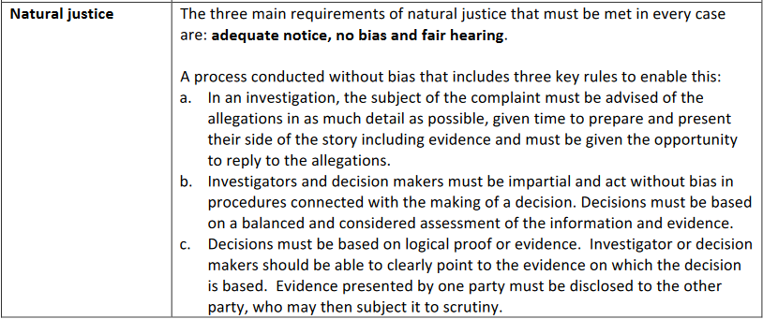

|  | **Who** | **Action** | **Due** | **Complete** |
| --- | --- | --- | --- | --- |
| 1 | HoS | Receive reconsideration of assessment decision form via email from [studentcomplaint@unitec.ac.nz](mailto:studentcomplaint@unitec.ac.nz).  Refer [Ākonga Concerns & Complaints Policy](https://www.xn--tepkenga-szb.ac.nz/assets/Policies/2023/National-Akonga-Concerns-and-Complaints-Policy-v2.pdf) and [Ākonga Complaints Procedure](https://www.unitec.ac.nz/about-us/unitec-policies/%C4%81konga-student-complaint-procedure) | Within 3 working days of receipt |  |
| 2 | HoS | **Consider if** **you are sufficiently without bias** to investigate the reconsideration. If not (or for another reason) you may delegate to an academic investigator from another school. (*Volunteer list of academic investigators provided*) | Within 3 working days of receipt |  |
| 3 | HoS | Decide if it is necessary to liaise with relevant HR Business Partner |  |  |
| 4 | Investigator | Introduce yourself by email to student and all other parties. Notify any relevant kaimahi (staff). Share the reconsideration form with support person **if requested**, with agreement that it remains confidential. Refer 2.2.6 of the [Ākonga Concerns & Complaints Policy](https://www.unitec.ac.nz/sites/default/files/public/documents/National-Akonga-Concerns-and-Complaints-Policy-v2.pdf) | Within 3 working days of receipt |  |
| 5 | Investigator | Read [Ākonga Concerns & Complaints Policy](https://www.unitec.ac.nz/sites/default/files/public/documents/National-Akonga-Concerns-and-Complaints-Policy-v2.pdf) and [Ākonga Complaints Procedure](https://www.unitec.ac.nz/about-us/unitec-policies/%C4%81konga-student-complaint-procedure) |  |  |
| 6 | Investigator | Find out what was addressed at the informal concern stage. |  |  |
| 7 | Investigator | Consider sources such as:   * Moderation * Gradebook grades for whole class * Power BI course survey data * Student’s Peoplesoft historical academic record * Assessment and marking guide/rubrics (does the student understand how marks have been awarded?) * Exam scripts (contact Exams Office) * Course Moodle page * Establish if the learner had access to the same assessment information & teaching as other students in the same class | Before the due date – Within 15 working days of the form being received by Student Complaints  **Note:** **Due date includes few days for the relevant executive to take a decision and provide outcome to the Complainant** |  |
| 8 | Investigator | Where possible, meet with the complainant and other parties separately in a neutral space*.* If it is not possible to meet in person, meet on Teams/Zoom if the student or kaimahi agree. Advise them that they may bring a support person to any meetings.  Any person making a statement needs to verify the accuracy of their statement. This may be done by signing and dating the statement in front of a witness.  Notes taken at the meetings/interviews should be emailed to verify the accuracy and give the interviewee the opportunity to correct if misinterpreted.  Document each step of investigation, dates, who was present, discussion and resolution if any was reached  - Follow principles of natural justice (refer section 5 of the [Ākonga Concerns & Complaints Policy](https://www.unitec.ac.nz/sites/default/files/public/documents/National-Akonga-Concerns-and-Complaints-Policy-v2.pdf)) |  |  |
| 9 | Investigator | Liaise with Director Student Success if complainant is an international student  Liaise with Te Korowai Kahurangi if you have any questions or concerns  Liaise with Te Pukenga Legal Counsel if necessary |  |  |
| 10 | Investigator & HoS | Provide weekly updates to all parties until student receives outcome. Investigator (if not HoS) copy in HoS and studentcomplaint@unitec.ac.nz | Weekly |  |
| 11 | Investigator | If investigation was delegated, provide investigation report *(use reconsideration investigation and decision report template)* to HoS with recommendations. Provide interim findings to student at this stage. | Due as in step 5 to 9 |  |
| 12 | HoS | Decide on outcome of investigation *(reconsideration outcome template provided)* and inform student in writing providing a rationale cc [studentcomplaint@unitec.ac.nz](mailto:studentcomplaint@unitec.ac.nz). Notify any other involved parties. The outcome letter can be emailed to student complaint mailbox with request to email the student of the outcome. Outcome letter should include information about student’s further options & student’s right to appeal if grounds can be met.  Also email the completed Reconsideration Investigation and Decision Report to Student Complaint mailbox. | Before the due date – Within 15 working days of the form being received by Student Complaints |  |