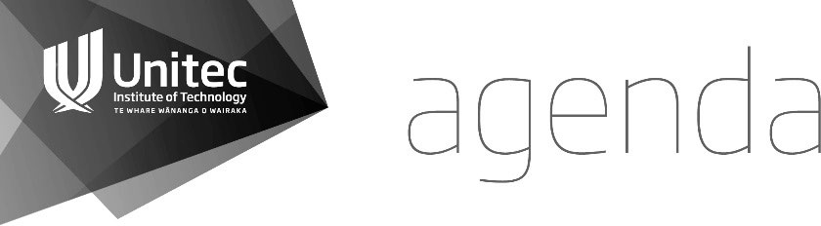

**Unitec Research Ethics Committee**

Topic: UREC October

Time: Oct 27, 2021 02:00 PM Auckland

Location: MT

Chair: Maria Humphries-Kil

Deputy Chair: Nigel Adams

UREC Administrator: Evangelia Papoutsaki

Join MT Meeting

<https://apc01.safelinks.protection.outlook.com/ap/t-59584e83/?url=https%3A%2F%2Fteams.microsoft.com%2Fl%2Fmeetup-join%2F19%253a9dd28d8b9fbc437ebb676bc9039b420e%2540thread.tacv2%2F1635216291783%3Fcontext%3D%257b%2522Tid%2522%253a%252280f389b2-7380-4b67-b527-7f711a578130%2522%252c%2522Oid%2522%253a%2522657f1ebe-2d8e-47d7-942b-dc1167aba6da%2522%257d&data=04%7C01%7Cepapoutsaki%40unitec.ac.nz%7Cbbe930e74c6f433f327e08d9982a971a%7C80f389b273804b67b5277f711a578130%7C0%7C0%7C637708130968552075%7CUnknown%7CTWFpbGZsb3d8eyJWIjoiMC4wLjAwMDAiLCJQIjoiV2luMzIiLCJBTiI6Ik1haWwiLCJXVCI6Mn0%3D%7C1000&sdata=h0CcX4vH4UgRK7XYPPmXaWP%2F8HBFZObYt0B9u7paojE%3D&reserved=0>

**KARAKIA TIMATANGA | OPENING KARAKIA**

|  |  |  |  |
| --- | --- | --- | --- |
| Manawa mai te mauri nuku Manawa mai te mauri rangi Ko te mauri kei au he mauri tipua Ka pakaru mai te pō Tau mai te mauri Haumi e, hui e, taiki e! | Embrace the power of the earth Embrace the power of the sky The power I have Is mystical And shatters all darkness Cometh the light Join it, gather it, it is done! |  |  |

## APOLOGIES

## WELCOME and WHAKAWHANAUNGATANGA

## CELEBRATIONS AND ACKNOWLEDEMENTS

1. **CONFLICTS OF INTEREST**

## MINUTES OF PREVIOUS MEETING

That the Committee approve the minutes of the meeting held on Sept 22, 2021 as a true and accurate record.

**First:**

**Second:**

## CURRENT APPLICATIONS

**2021-1039 Catherine Mitchell**

*Mā te Huruhuru, ka rere te manu: The experiences of postgraduate tauira Māori within a vocational education context*

**Nigel Adams** (H. Abraham, M. Hamilton)

**2021-1040 Helena Bassett**

*Management and treatment of mouth breathing in children: A qualitative study of clinical practices and approaches of allied healthcare professionals.*

**Maria Humphries-Kil** (H. Smith, S. Heath)

* 1. **Nathan McComish**

*The Role of Manual Therapy for Osteopaths in the Management of Temporomandibular Disorders - A Qualitative Analysis*

**Falaniko Tominiko** (T. Gomwe, N. Adams)

* 1. **Zena Zeigler**

*An exploration of the experience of osteopaths managing individuals with physical symptoms associated with endometriosis.*

**Samantha Heath** (E. Boamah, M. Humphries-Kil)

**2021-1043** **Jenny Lee-Morgan**

*He tātai whetu ki te rangi, he rangatahi ki te kāinga: Rangatahi pathways to safe, secure and affordable homes*

**Maria Humphries-Kil** (H. Smith, E. Boamah)

1. **PREVIOUS APPLICATIONS**

**2021-1034 Rain Zhao**

*The Influence of Cultural Philosophies on Clinical Practice of Spinal Manipulation - A Comparison of Chinese Manipulative Therapy vs New Zealand Osteopathy for the Treatment of Musculoskeletal Disorders*

**Mark Hamilton** (L. Rata, E. Boamah)

**2021-1035 Sara Goodwin**

*Exploration, using the Treaty of Waitangi principles of protection, participation and partnership as a framework, of the experiences of Māori Deaf with mental distress who have used mental health and addiction services*   
**Hazel Abraham** (F. Tominiko, M.Humphries-Kil)

**2021-1036 Cheryl Talamaivao**

*The challenge of maintaining good self-care for Samoan social workers in Aotearoa, New Zealand*

Saiedeh Aminian (L. Rana, H. Abraham)

**2021-1038 Jenny-Lee Morgan**

*Ko Te Aka Pūkāea kia ita, ko Te Aka Pūkāea kia eke! The success of reo rūmaki in mainstream schools. Research partnership with Te Aka Pūkāea, Newton Central School.*

**Falaniko Tominiko** (M. Humphries-Kill, S. Heath)

**2021-1030 Heath** Saeideh Aminian

**2021-1031 Heath**

Maria Humphries-Kil

**2020-1055 Baker**

Samantha Heath

**2020-1044 Venus Rangi**

**Nigel Adams** (Rihi Tenana original Reader) (minor amendments-extension request/approved)

**2020-1040 Jenny Lee-Morgan**

*Moko*

**Nigel Adams** (Maria Humphries-Kil original PR) (amendments request)

1. **FORM B APPLICATIONS FOR NOTING**
2. **FORM C APPLICATIONS**

Application for Ethical Approval for a Research Component of a Teaching Programme

1. **MATTERS ARISING FROM PREVIOUS APPLICATIONS**
2. **CORRESPONDENCE - OTHER BUSSINESS**

*11.1 UREC 2022 meeting dates approval memo*

*11.2 UREC Readers feedback process*

*11.3 Saeideh Aminian: conflict of interest in acting as primary reader on Osteopathy Ethics applications*

Ka wehe atu tātou I raro i te

rangimārie Te harikoa Me te

manawanui Haumi ē! Hui ē! Taikiē!  
  
“We are departing Peacefully  
Joyfully And resolute   
We are united, progressing forward!”

## 

## DATE OF THE NEXT MEETING:

**24 November 2021 2pm**

**Venue: Zoom**