Individual ADEP Plan Template 2022 Refer to the Performance Partnering Portal for guidance.

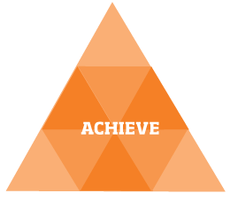Some of the standard (or common) goals will apply depending on your role.  Then consider: What are the most important individual goals for you to achieve? They should clearly align with your Team Takitahi and Action Plan and should be agreed with your manager.  Remember: Make them SMARTA goals. | 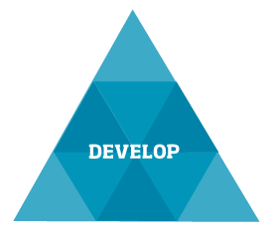Unitec-wide Development Requirements apply to all staff – although the specific requirements may differ depending on role. Identify any other professional development you will undertake to help you achieve your goals. Our leadership competencies apply to all staff, and others may also apply depending on role. Then record your PD leave entitlement and how you intend to use your leave.  Remember: Use the 70/20/10 principle for development.

 | Standard (or Common) Goals Delete only those goals that are not applicable to you. |  |  | Unitec-wide Professional Development Requirements for 2022 - Badges
 | For all staff  - Meet the key accountabilities of your role  - Timely completion of Performance Partnering requirements: 2021 Review, 2022 ADEP Plan  - Prompt communication of non-attendance & illness/injury; prompt entry of leave in system  - Complete an online module (available from Q2) to demonstrate your knowledge and understanding of the Tertiary and International Code of Practice  For all teaching staff  - Completion of professional development requirements for 2022:  Achievement of at least two badges; at least one must be an approved parity badge for teachers  For all non-teaching staff  - Completion of professional development requirements for 2022:  Achievement of at least one approved parity badge for non-teachers  For all people managers  - 100% completion of Performance Partnering requirements for my direct reports  - Prompt follow up & management of all forms of leave and injury/illness for team members  For all cost centre managers  - Management within budget; timely & accurate input for month end reporting  For all research staff  - [insert a summary of the key research goal/s from your Individual Research Plan (IRP)] |  |  | To help us achieve our strategic priority of parity for Māori, Pacific & Under 25 students by 2024, in 2022 we require all staff to undertake specific professional development relating to this in the form of parity badge/s. Delete only those goals that are not applicable to you.  For all teaching staff  - What: Supporting achievement of parity for Māori, Pacific & Under 25  - Badges: [Select one or more of the parity badges available for teachers]  - What: Ongoing teacher capability development - [insert the teaching competency/s you intend to focus on for development in 2022]  - Badges: [Select one or more of the teacher capability badge/s]  For all non-teaching staff  - What: Supporting achievement of parity for Māori, Pacific and Under 25  - How: [Select one or more of the parity badge/s available for non-teachers]
 |  |  |  | Other professional development as relevant to role
For all staff: Leadership competencies
For all research staff: Research competencies
Other: Relating to industry, discipline or professional currency/best practice
- What: [insert any leadership, research and/or other competencies you will focus on for your development depending on your role]
- How: [insert the development activities you will undertake]

 | Individual Goals (4-5 top priority goals)
 |  |  |  | PD Leave
Leave entitlement: [XX] days
Intended usage: [please provide a brief summary of how you intend to use your leave; including an estimate of PD leave dedicated to completion of badge requirements]

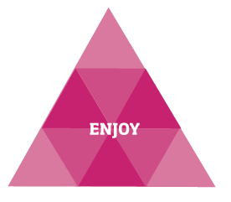What makes work and the workplace enjoyable for you? Also consider the things that sustain your performance when times get tough.  Record below the key things you are going to do to ensure you build these into your day-to-day work. | 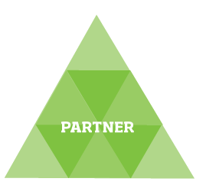Consider who you will need to partner with to achieve your goals:  Who are the key individuals and/or groups – internal and/or external - that are key partners for you in your role?  Record below the things that you will do to build and enhance those partnering relationships – how will you bring the values of Te Noho Kotahitanga to life?

 | What makes work and the workplace enjoyable for you? What will you do to ensure you build these things into your day-to-day work? |  |  | Who will you need to partner with, and how will you bring the values of  Te Noho Kotahitanga to life through your partnerships?
 |  |  |  | This shouldn’t just be a list of individuals/groups you interact with on a day-to-day basis – think more about who your key partners are, and what you will do to demonstrate each of the values through your partnering with them

Employee Name: [Insert name]  Employee ID Number: [Insert ID number]  Employee Signature: [insert electronic signature or print & sign by hand]  Date: | Manager Name: [Insert name]  Manager Signature: [insert electronic signature or print & sign by hand]  Date:
When your ADEP Plan is agreed, finalised and signed off by both you and your manager, please submit it by uploading it to PeopleSoft through Staff Self Service – click here for instructions. If you are scanning your document to upload, please ensure you scan and upload all pages.

