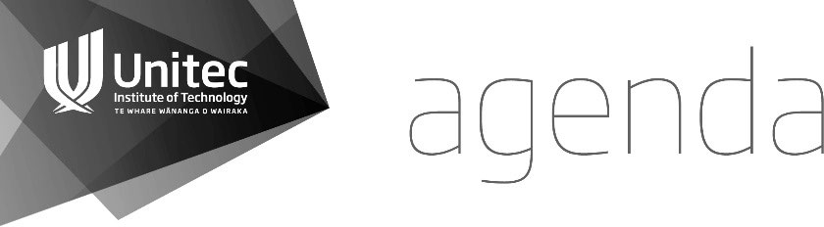

Unitec Research Ethics Committee

(UREC) 23 June 2021 at 2.00 pm   
Zoom -

Join Zoom Meeting

<https://unitec-ac-nz.zoom.us/j/91032775948?pwd=dE9tcVdTWDYvMk11WUR2NktwL2lRUT09>

Meeting ID: 910 3277 5948

Passcode: 196684

**KARAKIA TIMATANGA | OPENING KARAKIA**

|  |  |  |  |
| --- | --- | --- | --- |
| Manawa mai te mauri nuku Manawa mai te mauri rangi Ko te mauri kei au he mauri tipua Ka pakaru mai te pō Tau mai te mauri Haumi e, hui e, taiki e! | Embrace the power of the earth Embrace the power of the sky The power I have Is mystical And shatters all darkness Cometh the light Join it, gather it, it is done! |  |  |

## APOLOGIES

1. **WELCOME**

**Approval of the April Memo  
First:   
Second:**

1. CONFLICTS OF INTEREST

**2021-1007 Adams**Nigel Adams is the supervisor for this application.   
  
**2021-1010 Robson**  
Niko primary supervisor

## MINUTES OF PREVIOUS MEETING

That the minutes of the meeting held on May 26th 2021 to be confirmed:

**First:**

**Second:**

## CURRENT APPLICATIONS

**None to be noted**

1. **PREVIOUS APPLICATIONS**

**2021-1008 McGarrigle**   
*INCLUSIVE AND CONSISTENT ASSESSMENT OF DRAWINGS ACROSS TUTORS ON ARCHITECTURAL TECHNOLOGY COURSES* **Nigel Adams  
Ratified**

**2021-1010 Robson***The Final Frontier: A Research of transition gaps from adolescent to young adult in state care from a Pasifika perspective***Maria Humphries  
To be Ratified**

**2021-1011 Wake***Building post-Covid19 resilience into outdoor play environments in New Zealand***Maria Humphries  
To be Ratified**

**2021-1012 Pizzini***Male student engagement with secondary school counsellors***Eric Boamah  
Ratified**

1. FORM B APPLICATIONS FOR NOTING

**2021-1013 Silva**

Maria Humphries

**2021-1019 Vallyon**Samantha Heath

**2021-1020 Wilkins**Eric Boamah

**2021 - 1021 King**Lata Rana

1. FORM C APPLICATIONS

**2021-1018 Robertson**  
Nigel Adams

1. MATTERS ARISING FROM PREVIOUS APPLICATIONS

**2020-1040 Lewis**  
Maria Humphries

Notes: Addition of Survey

1. CORRESPONDENCE
2. GENERAL BUSINESS

Ka wehe atu tātou I raro i te

rangimārie Te harikoa Me te

manawanui Haumi ē! Hui ē! Taikiē!  
  
“We are departing Peacefully  
Joyfully And resolute   
We are united, progressing forward!”

## DATE OF THE NEXT MEETING:

**July 28th 2021 2pm**

**Venue: Zoom**