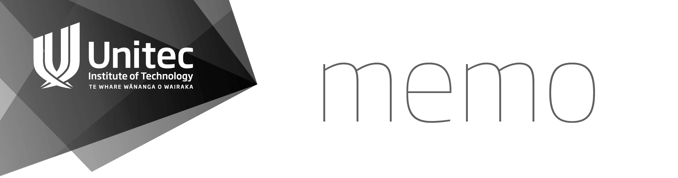
To | Unitec Research Ethics Committee | Date | 13 Mary 2021
From | Asher Lewis | Phone No. | 021 401 965
 | Secretary, Unitec Research Ethics Committee
Subject | Electronic Confirmation in lieu of April Meeting
- Approval of March Minutes (attached)
- Ratification of 2021-1005 Williams by Primary Reader Nigel Adams
- Approval of amendments to the following applications
  - 2020-1005 Perry
  - 2020-1060 Russell
  - 2020-1003 Turner
  - 2019-1038 Heath

