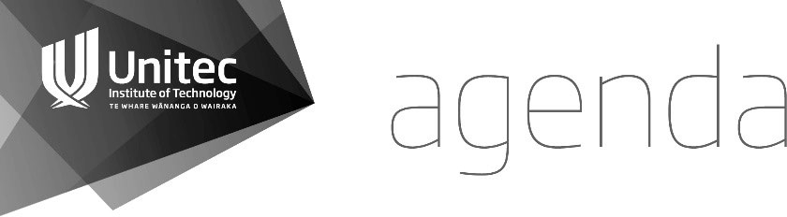

Unitec Research Ethics Committee

(UREC) 17 June 2020 at 2.00 pm   
Meeting to be held electronically

**KARAKIA TIMATANGA | OPENING KARAKIA**

# Manawa mai te mauri nuku Manawa mai te mauri rangi Ko te mauri kai au

he mauri tipua

Ka pakaru mai te pō Tau mai te mauri Haumi e, hui e, taiki e!

Embrace the power of the earth Embrace the power of the sky The power I have

Is mystical

And shatters all darkness Cometh the light

Join it, gather it, it is done!

## APOLOGIES

Nimbus Straniland

Lisa Maurice-Takerei  
Cris De Groot

1. **WELCOME**

## MINUTES OF PREVIOUS MEETING

That the minutes of the meeting held on May 20th 2020 to be confirmed electronically post-meeting.

1. CONFLICTS OF INTEREST

Rihi Te Nana - 2020-1018 Te Nana

## CURRENT APPLICATIONS

## 2020-1018 Te Nana

## *Urban Intergenerational Kainga Innovation: Marae ki te Kainga*

## Maria Humphries-Kil

## 2020-1019 Geest

## *Two E-Students*

## Lisa Maurice-Takerei

## 2020-1021 Shaw

## *Creating appreciation and community support for parents caring for a child with an anxiety disorder*

**Sue Wake**

**2020-1023 Ngalaufe**

*Effective Incredible Years Parenting Course on Tongan parents.*

**Rihi Te Nana**

1. **PREVIOUS APPLICATIONS**

**2020-1008 Woodruffe**

**Cris De Groot**

To be Ratified  
  
**2020-1015 Moala**

*Recognizing cultural diversity in the workplace: A study on the contributing factors that keep Pacific people working for New Zealand Police Communications.*   
**Rihi Te Nana**

1. **FORM B APPLICATIONS FOR NOTING**

**2020-1022 Cameron**

*Lockdown learning: Understanding student success during the COVID-19 pandemic* **Nigel Adams**

**2020-1025 Heath***Online from Monday: The experiences of tertiary teaching staff during the New Zealand Covid-19 emergency response* **Nigel Adams**

1. FORM C APPLICATIONS

**2020-1020 Mahmood  
 Maria Humphries-Kil**

## MATTERS ARISING FROM PREVIOUSAPPLICATIONS None to be noted.

## CORRESPONDENCE

Site Approval For Study

1. GENERAL BUSINESS

Ka wehe atu tātou I raro i te

rangimārie Te harikoa Me te

manawanui Haumi ē! Hui ē! Taikiē!  
  
“We are departing Peacefully  
Joyfully And resolute   
We are united, progressing forward!”

## DATE OF THE NEXT MEETING:

**July 15 2020 2pm**

**Venue: TBC**