How to create a change request

Navigate to VOE Home | - You will find the VOE Home page on PeopleSoft by going to the following: Main Menu > Records and Enrolment > Enrol Students > VOE Home
Step 1  Enter Student ID | - Enter the student ID in the “Empl ID” then click Search  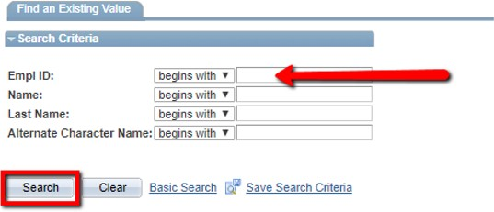
Step 2  Create the change request | - Select the Career and Semester for the student in the “Career and Term” dropdown box.  - Select the correct Request Type in the “Request Type” dropdown box.  - Click “Start Request” button  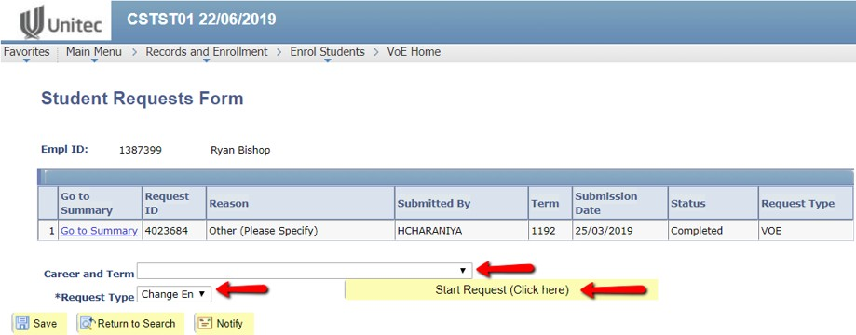
Step 3a  To Add Courses | - Enter the class field in the “Class Number #” field  - Click the “Add Class” button  - (The class will appear in the “Your Class Schedule” section  - Click the “Review” button  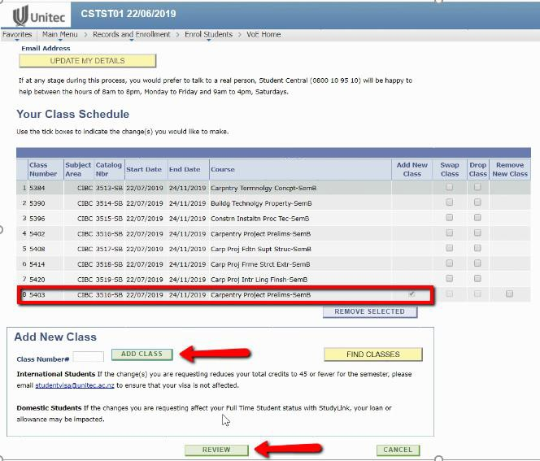  - Go to Step 4

Step 3b  To Drop Courses | - Select the class the student would like to drop under the “Drop Class” column.  - Click the “Review” button  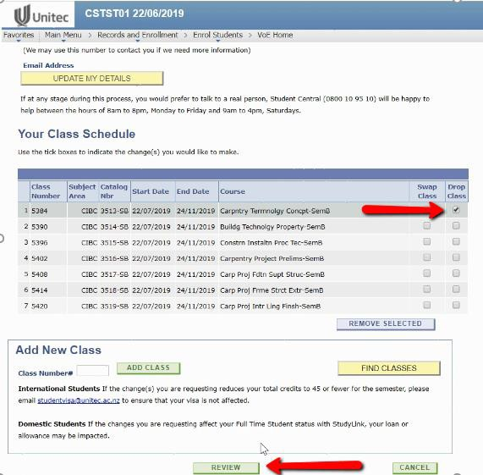  - Go to Step 4
Step 3c  To Swap Courses | - Select the class the student would like to swap under the “Swap Class” column (A new class number field will appear).  - Enter the new class number in the “New Class Number” field  - Click the “Review” button  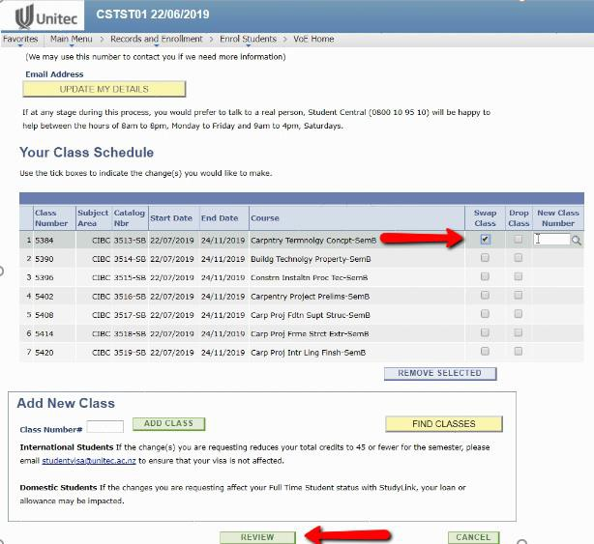  - Go to Step 4

Step 4  Change request information | - Select the reason of the change request in the “Reason for Changing” drop down box  - Add any further detail that supports the change request in the “Supporting Information” box  - Attach any supporting documents.  Please note for some COE, you must attach supporting documents before progressing to the next step  - Click the “SUBMIT” button  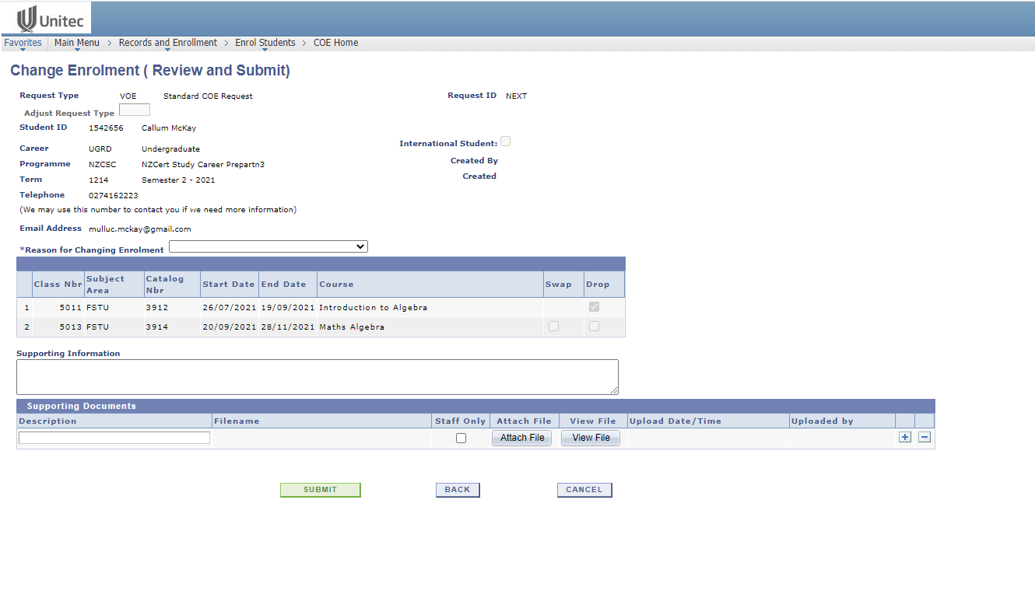
Step 5  Change request generated | - Change request has now been completed  - Your change request ID will be generated under the “Request ID” column  