**Start Guide – NZ Premium Content - Domain Solution – Unitec Staff**

1. To create an account, go to: <https://www.nzherald.co.nz/my-account/register/>
2. Use your **Unitec email address** (ending with @unitec.ac.nz)and create a password. If you already have a Herald account simply sign in at the bottom of the page.
3. You can **tick** ‘keep me signed in’.
4. Once you’re done, click **‘Create my account’.**
5. The next two screens are optional to complete.
6. You should now be signed in
7. Visit <https://www.nzherald.co.nz/my-account/profile/subscriptions/> and enter this access code **OLY4FJSL** in the redeem code section and press activate

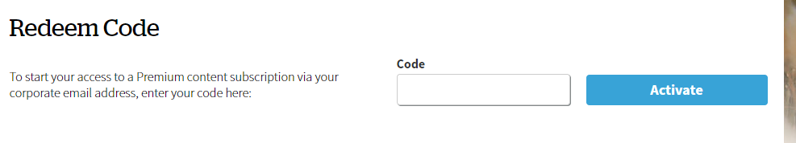

1. A message will appear saying “*you have an active digital subscription” (see screenshot example on page 2 below)*
2. You should now be able to read Premium Content. Try by seeing if you can read all this article [Here](https://www.nzherald.co.nz/business/news/article.cfm?c_id=3&objectid=12328518)
3. Make sure you sign in on all devices eg your mobile phone, app, desktop etc. Each site is unique, so you need to be signed into all

**Download the NZ Herald news App**

Visit the [App](https://protect-au.mimecast.com/s/aGu1COMxVlc2QwAzcv5rPN?domain=apps.apple.com) store (Apple iOS) or [Google Play](https://protect-au.mimecast.com/s/sU7tCP7yXmt5VZ48I1aS3R?domain=play.google.com) (Android), Get **NZ Herald News,** Install and open. Make sure you sign in using profile.

**Here is a screenshot of what step 8 looks like**