**Programme Review (5 Year Review)**

**Title:**

**Level:**

**School:**

**Qualification reference and version number**:

**Date submitted**:

**Completed by**:

1. Programme Review and Planning

In this section you should give a brief overview of your programme by summarising information readily available through your PEPs, Monitor’s visits (these should be incorporated summarily in the PEP, Industry/Stakeholder Consultation Logs, Registration bodies, and Student/Graduate Evaluation and feedback surveys.

You and the team must refer to the original aims of the programme and reflect on your level of achievement to answer the following questions:

1. What evidence do you have to support your evaluation of whether or not they been achieved? Start by looking at your last five years of PEPs. Specifically, note the S & R trends, feedback and actions.

2. Have you applied for programme changes (either Type 1 or Type 2) to better address programme issues or student feedback/evaluation over the past five years? If so, what are they and have these changes evidenced a positive change if not, why not?

3. What has the monitor reported and were there any recommendations/actions? Have all these actions enhanced the student/graduate experience, or have they detracted from it. Are there any trends that have been noted?

The answer to these questions will be used to inform the starting point for the review journey.

Other considerations for your review should include the following criteria which will need to be evaluated and assessed critically with the [NZQA Programme Approval criteria.](https://www.nzqa.govt.nz/providers-partners/approval-accreditation-and-registration/programme-approval-and-provider-accreditation/criteria-for-programme-approval-and-accreditation/) This involves asking if the following areas of the programme are still ‘fit for purpose’:

1. *The qualification to which the programme leads*

*2: Its title, aims, graduate and learning outcomes and coherence*

*3: Delivery methods*

*5: Regulations*

*6: Assessment and moderation*

*7: Assessment and review*

*8: Research required for degrees and post-graduate qualifications*

YOU and your team may have implemented change and believed that it would be worthwhile and beneficial however, do your success, retention and feedback support this? You are now ready to embark on creating questions to elicit stakeholder feedback.

Ultimately, the programme review is used to self-assess and determine the viability of the programme. It answers whether, or not, the programme is still relevant and acceptable to all stakeholders. The questions developed are used to gain meaningful responses to inform your review and responses in the programme review. This review will utilise evidence found through consultation with your stakeholders and yearly reports, note actions and improvements for the programme. The flow chart indicates what actions should be taken into consideration for this review. This guide is divided into the same sections on the flowchart and should step you through it. It can also be used as a template.

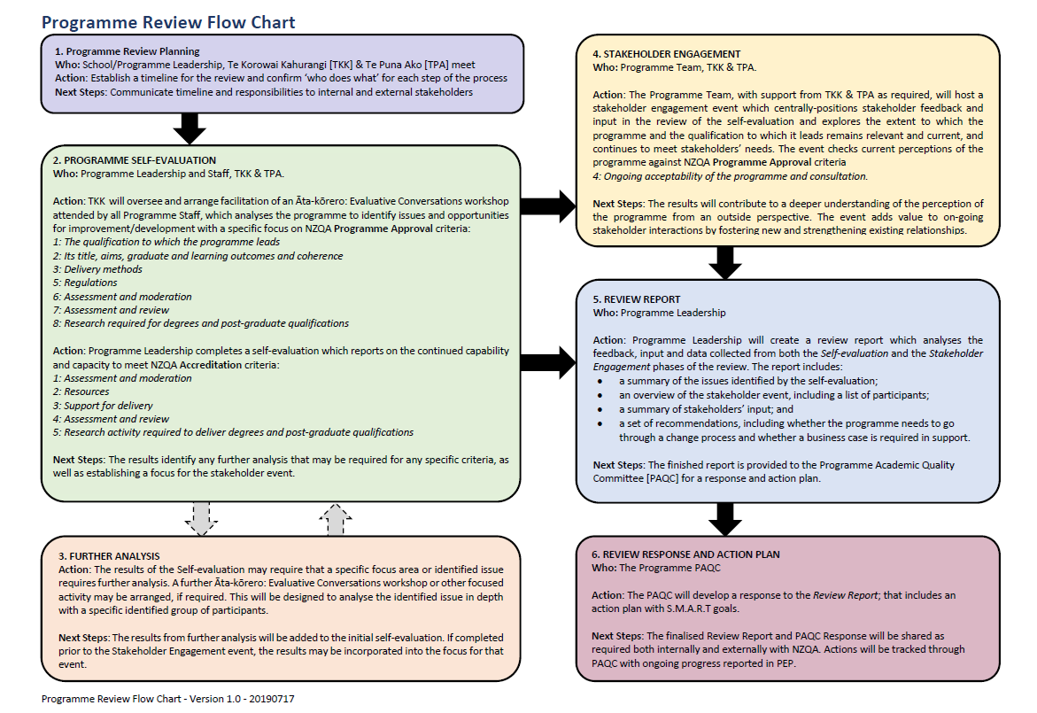

2. The Programme: Self –Evaluation and Analysis

The review process should start with a programme team in depth analysis and debrief of trends occurring across the five-year period. This is often called an Āta Kōrero workshop. This in-depth analysis and subsequent conversation should refer to a number of documents such as; PEP actions, Moderator’s report, industry consultations, student/staff feedback, internal stakeholders, accreditation/registration board and, if included, EER action points. Prior to this workshop, it would be helpful to distribute the aforementioned documents across the team so the analysis and debrief are summarised. The Āta Kōrero workshop should yield information that helps inform the programme team as to whether the graduate profile, learning outcomes, assessment, learner performance, enrolment and completion data were still fit for the originally intended purpose.This should guide your workshop debrief and analysis. By the end of the workshop, the programme team should be able to develop a number of questions to ask all stakeholders to inform the review (refer Section 3).

3. Questions developed from the Āta Kōrero Workshop

The following questions were developed to gauge whether or not our programme is still relevant or if changes were required.

Check back with the notes of the Āta Kōrero workshop to ensure that they have covered the information required for the review.

*\*Suggested areas to probe: important to note that student feedback and course evaluation/moderation would be evidenced through your CEPs, PEPs, Moderation, Monitor’s Report, EER, Student Evaluation and feedback. The following questions would specifically focus on industry collaboration, graduates and employers.*

* *The Bachelor of xxxx has majors/strands, are these still relevant in the market today? What evidence do you have to support this? Evidence to support this includes; industry consultations, student/staff feedback, internal stakeholders, graduates, accreditation/registration board and, if included, EER recommendations over the last five years.*
* *Would the Bachelor of xxxx benefit from an additional major/strand to modernise it and make it more relevant, marketable and cover an existing gap? Evidence to support this includes; industry consultations, student/staff feedback, internal stakeholders, accreditation/registration board and, if included, EER recommendations over the last five years.*
* *Is this degree, along with the majors/strands, still offering career pathways to our graduates? Evidence your answer.*
* *Is the name of the degree and its courses still identifiable?*
* *With reference to the Graduate Profile, below, are these still fit for purpose? Is the language still relevant? If not, why not? Be specific.*
* *If you are a graduate, did the graduate profile and specific attributes describe you after completing the degree?*
* *If you are an employer, or in the industry, does the graduate profile and specific attributes resonate with your experience in the profession?*
* *If you employ a Unitec graduate, what is their position and do they meet the expectations you had for a graduate (refer Graduate Profile if necessary)?*
* *Would you employ other Unitec graduates?*
* *Are the current delivery methods; face to face/blended/online the best utilisation of time in that they maximise the learning experience? If not, why not and what would your suggestion(s) be?*
* *Participation in research: if this was an option in the degree, were you able to collaborate with industry and was there support available?*
* *If you were able to change this programme, from your current position, what would you suggest?*

4. Stakeholder Engagement

Once the questions are confirmed by the team, they need to be distributed by one/several of the following methods:

1. A stakeholder event that specifically targets information and intel for the answers required to the questions.

2. Attaching the questions to the yearly Monitor’s/accreditation/registration visit to utilise the fact that all your stakelholders are represented during this time.

3. Sending/emailing a survey.

4. Getting several of the programme team to telephone stakeholders and ask the questions.

5. Review Report

Programme Leadership collates, analyses and reviews the information gathered and writes the self-evaluation report. It should include the following:

* A summary of the issues identified
* An overview of the stakholder event, including a list of all participants
* A summary of stakeholders input
* A set of recommendations, including whether the programme needs to go through a change process and whether a business case is required
* Statement on the continued capability and capacity to meet NZQA Accreditation Criteria:
* Assessment and modertation
* Resources
* Support for delivery
* Assessment and review
* Research activity required
* A statement of intention to continue or discontinue the programme including a rationale for the decision

6. Review Response and Action Plan

The PAQC will develop a response to the Review Report. It will need to include:

A response and a SMART goal action plan.

NEXT STEPS:

The finalised Review Report and PAQC response will be shared both internally and externally with NZQA. Actions will be tracedthrough the PAQC with ongoing progress reported in the PEP.