WELCOME TO ENROLMENT & ACADEMIC OPERATIONS TEAM

INDUCTION GUIDE

DATED:

# TABLE OF CONTENTS

|  |  |
| --- | --- |
| 01 | Nau Mai Haere Mai |
| Welcome to Enrolment & Academic Operations |

|  |  |
| --- | --- |
| 02 | Performance Partnering |
| Performance Partnering framework |

|  |  |
| --- | --- |
| 03 | Unitec Institute of Technology |
| Important Links – Values, Key Policies, HR Information, Online Induction |

|  |  |
| --- | --- |
| 04 | Knowledge Management & Resources |
| Our Tools & Systems |

|  |  |
| --- | --- |
| 05 | Unitec Institute of Technology Structure |
| Organisational Charts  Meet Our Business Partner Concentrix |

01

NAU MAI HAERE MAI

Welcome to the Unitec Enrolments & Academic Operations business group.

On behalf of the leadership team, we’re excited to have you join the team and look forward to supporting you in your new role. Our primary focus is to lead student centric academic operations and is at the heart of our Performance Diamond aka the Unitec Takitahi Weave.

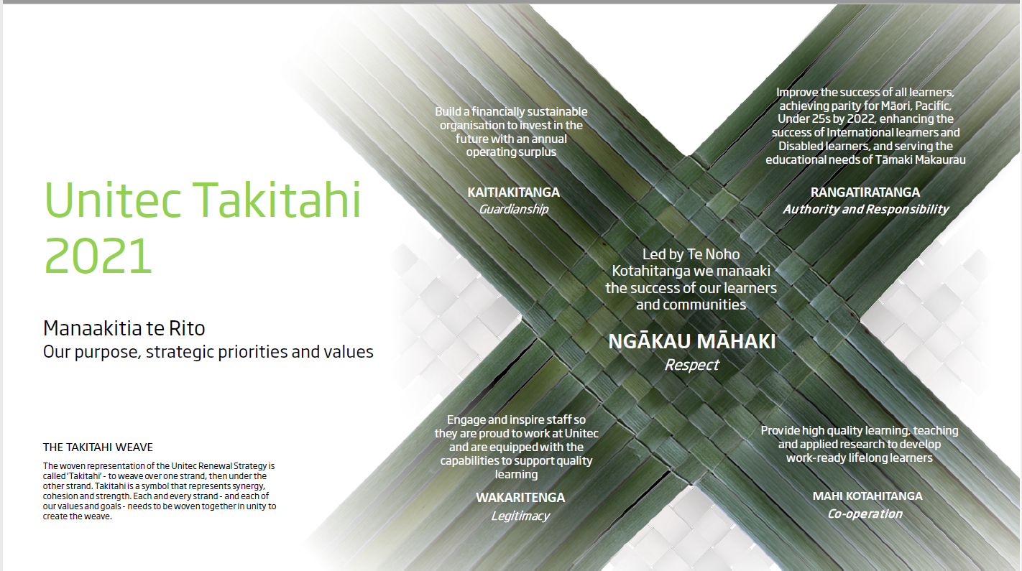

The Operations team play an important and critical part at Unitec Institute of Technology. It is made of several arms, each playing a part in delivering all of Unitec Institute of Technology’s customer application and student enrolment activity. The lifecycle begins from enquiry right through to the successful graduation of our students.

Unitec Institute of Technology is New Zealand’s largest institute of technology, with more than 20,000 students studying over 115 work-oriented programmes. We offer employment-focused education at our two campuses in Mt Albert and Waitakere.

### Enrolment and Academic Operations Teams:

Enrolments - Set-up & Continuous Improvement

The Enrolments Set-up team provide management of the enrolment set up process ensuring that all online applications are available and the Enrolment cart is opened within required timeframes relating to the Unitec Academic Calendar. The Enrolment Set Up Team are also responsible for producing all Study Plans for all Unitec programmes.

Continuous Improvement are responsible for delivering Operational Improvements in line with the Operations Annual Plan and key objectives in order to improve the experience of our students and customers

Enrolments Processing

The Enrolment processing team manages applications end to end, ensuring applications processed are aligned to Unitec’s policies and program regulations.

Enrolment Processing are broken down into 3 teams responsible for different functions to deliver a seamless enrolment journey for our applicants.

The teams are:

* Pre-assessment and Admissions - Assessment support/International Administration - Preparing applications to be ready for assessment, Enrolling applicants into courses, processing changes to enrolments
* Student Enrolment Managers /International Advisors- Assessing Domestic applications ensuring applicants meet regulatory requirements.
* Enrolment Administration - Processing “No Show” students. Owners of the Cross Credit, APL, VOE, Class Capacity, & Fail prerequisite processes.

Student Finance & Graduation

Supporting our students through the payment process of their fees and resolution of any debts created during their course of study with a focus on empathy and ensuring that we are focussed on their continued study progression.

Once the hard mahi has been completed, ensuring that students are eligible to graduate, are ratified through the formal academic approval and that the input for Graduation ceremony, the culmination of our students’ studies, reflects the success that they have achieved.

Timetabling

Focuses on the collation and setup of academic timetabling requirements including class setup, programme planning, and the construction of academic timetables in timetabling systems.

The Timetabling office also manages the academic calendar, ad-hoc bookings, the management of timetable changes, as well as exam scheduling.

02

PERFORMANCE PARTNERING

Performance conversations are not new at Unitec. People are already involved in establishing agreed expectations and priorities with their manager and have regular catch-ups to discuss progress and get support.

From early 2017, the Unitec Performance Partnering framework will guide these conversations, and create a consistent approach to the way we talk about performance and capability.

Performance Partnering ensures everyone can see how the work they do makes an important contribution to the achievement of the wider Unitec goals. It provides the tools to set individual goals for the year ahead, with regular check-ins every 90 days, allowing for changes in the plan as the year unfolds.

Through our commitment to Performance Partnering we can all move confidently together to make lives better through teaching and learning, and use our values to guide our thinking, decision making and actions.

For more information, follow the link below:

<https://thenest.unitec.ac.nz/TheNestWP/working-unitec-2/working-unitec/performance-partnering/>



03

IMPORTANT LINKS/EVENTS

Te Noho Kotahitanga

One of Unitec’s most defining features as a tertiary institution, is the formalised partnership between Māori and non- Māori.

In 2001, Unitec honoured its commitment to Te Tiriti o Waitangi (Treaty of Waitangi) through the adoption of the partnership agreement Te Noho Kotahitanga. Since then, the partnership, which is based on five guiding

principles, has helped staff and students to examine how they can engage with Māori knowledge, how Māori and non-Māori interact with each other, and how we all can behave in our local communities. <https://www.unitec.ac.nz/about-us/te-noho-kotahitanga-and-unitec>

Our Kaupapa

A Kaupapa is a set of principles and plans, which people have agreed on as a foundation for their actions.

Here is our Unitec Kaupapa – bringing our purpose, aspiration and values together to provide a strong anchor as we focus on delivering student centric academic operations and our performance diamond deliverables.

We live our Kaupapa through our values and our values are framed by living Te Noho Kotahitanga. Our values guide our thinking, decision making and our actions. So let’s make our actions count. <https://thenest.unitec.ac.nz/TheNestWP/our-unitec/te-noho-kotahitanga-our-values/>

Staff Orientation

Your Manager/Team Leader will arrange for you to attend Unitec’s Staff Orientation held at [Ngākau Māhaki](https://thenest.unitec.ac.nz/TheNestWP) [Wharenui.](https://thenest.unitec.ac.nz/TheNestWP) Your day will begin with a pōwhiri to welcome you onto the marae and into the Unitec whānau.

Key Policies

* Academic Statute
* Code of Conduct
* Countering Harassment Policy
* Electronic Devices and Systems Policy
* Health & Safety Policy
* Leave Management Q&As

<https://thenest.unitec.ac.nz/TheNestWP/policies-and-forms/policies-and-procedures/>



Human Resources Information

Hear from the HR Team in their own words:

As well as providing advice, guidance and information to staff, managers and Unitec’s leadership team on a wide range of HR issues, we also provide a high-quality HR administration service and a payroll service to the organisation. As a part of the broader People & Safety group we are also involved in implementing organisation- wide initiatives in the HR arena that are designed to continually encourage, maintain and enhance the contribution of our staff to Unitec’s organisational performance.

Our Human Resources team practices a business partnership model whereby the HR Business Partners work closely with allocated networks/service groups, thus enabling them to become active business partners. In this way we aim to get to know and understand the strategic drivers for each area of Unitec and therefore are able to recommend and deliver innovative HR solutions targeted to the requirements of each business unit. To check which HR Business Partner is allocated to your department, visit our Human Resources Staff page. <https://thenest.unitec.ac.nz/TheNestWP/working-unitec-2/diy-hr-home/>

Online Induction

Your manager will work with you over the coming days and weeks to ensure you are ready to play your part in student success. In the meantime, take some time to work your way through Your Unitec Induction – it will step you through what you can expect over your first day, week, months and year. It’s self-paced and full of useful information and loads of opportunities to get connected into our community and our Kaupapa. <https://thenest.unitec.ac.nz/TheNestWP/working-unitec-2/induction/>

Induction Quality Survey

As a new member joining our whanau, we would like to ensure you have the best possible start to your role. To help us make sure we are getting this right, we want to hear about your induction experience.

<https://unitec.wufoo.com/forms/z99p7v108fhc0c/>

04

TOOLS + SYSTEMS

Unitec has a set of central systems that are used to store student and programme information and to communicate with internal and external stakeholders. Further to this we have our corporate website ([www.unitec.ac.nz](http://www.unitec.ac.nz/)) and a staff intranet and our core Knowledge Management system (our Unitec WIKI) which are all important in keeping up to date with changes and things that are going on around Unitec.

PEOPLESOFT CAMPUS SOLUTIONS

PeopleSoft is the People Management System that Unitec uses to process all of its online and manual applications and enrolments. It is also where key programme and course information is kept, where student information can be accessed, and where timetabling information can be viewed. Different Operations teams use different areas of PeopleSoft so there will be PeopleSoft pages more directly related to your work that you can discover with your team.

MICROSOFT OUTLOOK

Outlook is the messaging system Unitec uses. In simple terms it is the communication method between staff members and departments and most importantly our customers. You will have access to:

* + Your Personal Inbox
  + Shared inbox proxies

*Note: All Student Communications should be sent from the shared inbox proxies only.

MICROSOFT TEAMS

Microsoft Teams is our main method of communicating within Unitec via phone call or through instant messaging. It can also be used to call students and external stakeholders. Note: We cannot chat with students over instant messaging.

OFFICE 365 ONLINE (MICROSOFT OFFICE)

We frequently use the Microsoft Office 365 Portal. This will be your main method of accessing your One Drive and shared team folders.

ONEDRIVE

OneDrive is both the home of your own files and any files shared with others. It is likely that you will use this tool every day and is accessible anywhere. You must be mindful of what you are sharing and whether you have permission to edit documents within One Drive.

MICROSOFT EXCEL

A lot of the team work allocation is conducted out of online shared spreadsheets. You will have access to a number of these and must adhere to the formatting and filtering functions in shared files. Changes you make will impact the rest of the team so please do not re-filter or re-format shared excel spreadsheets.

UNITEC WIKI

The Unitec WIKI is our knowledge management system that houses all of our process documentation and work instructions for all of our core tasks. You will have access to the WIKI for all of your training information.

<https://unitecwiki.atlassian.net/wiki/spaces/SS/overview?homepageId=1671184>

UNITEC CORPORATE WEBSITE

This is the gateway to Unitec’s Programme, Course & Service Information. The website is the most up to date location for most information. You will need to become very quick in navigating this tool. In summary some useful functions to keep in mind:

* Course & Timetable Information
* Programme Start & Finish Dates and Unitec Academic Calendar
* Online Applications and Re-Enrolment Information
* Student Support Service Information
* Basic Studylink EFTS information & Scholarship Information
* Student Central Information including locations & opening times

THE NEST

The Nest is the Unitec Staff Intranet that stores a multitude of different resources. This Intranet gives large-scale & overall information and updates about Unitec. In summary useful access to the following tools is through The Nest:

* + Campus wide updates and Staff Notices
  + Unitec Staff Search
  + Staff Forms & Guides
  + Shortcuts to: IMS HEAT, Unitec Websites & Services

04

ORGANISATION CHARTS

CHIEF EXECUTIVE & EXECUTIVE

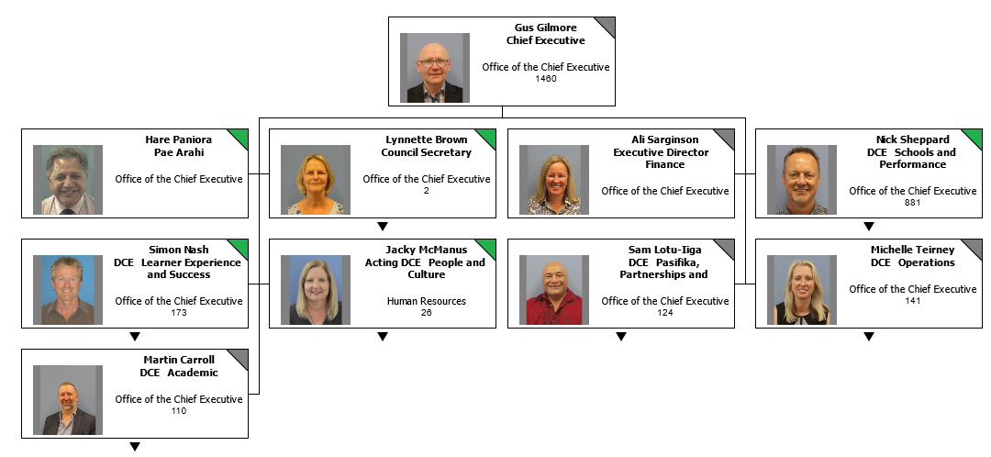

### OPERATIONS EXECUTIVE

### 

**Peseta Sam Lotu-Iiga**

**DCE Pasifika, Partnerships and Support**

Responsibilities: Pasifika Strategy and Success, Pasifika Development Office (MIT), Enrolment, Marketing, Communications, Industry Partnerships, External Relations / Engagement, International, Timetabling, Graduation, Alumni, Health Centre (Unitec) and Health provider relationship (MIT)

### ENROLMENT & ACADEMIC OPERATIONS DIRECTOR

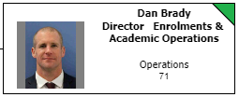

Welcome to Enrolment & Academic Operations.

A little history about our team, commencing in mid-2017 a number of key support services have come under the umbrella of what is now Enrolment and Academic Operations. Specifically, these are:

* Enrolment Processing
* Enrolment Set Up
* Timetabling
* Graduation
* Student Finance
* Outsourced services (Concentrix)

The centralised services enable greater consistency, improved ability to cover areas of work, quality assurance and development for staff in terms of their breadth of knowledge as well as developing centres of excellence for each business function.

We partner with other support services (Student Success & Te Korowai Kahurangi) as well as schools to ensure the smoothest possible progression for applicants to become enrolled students.

OPERATIONS LEADERSHIP

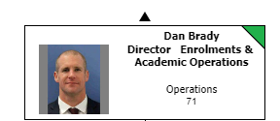

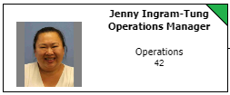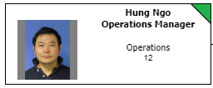

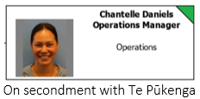

## ENROLMENT SET UP & CONTINUOUS IMPROVEMENT TEAM

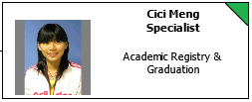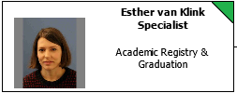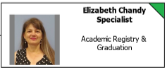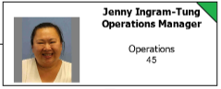

ENROLMENT PROCESSING

Enrolment Managers & International Advisors



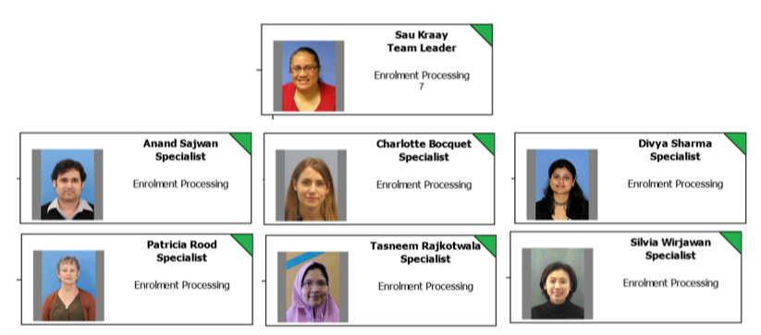

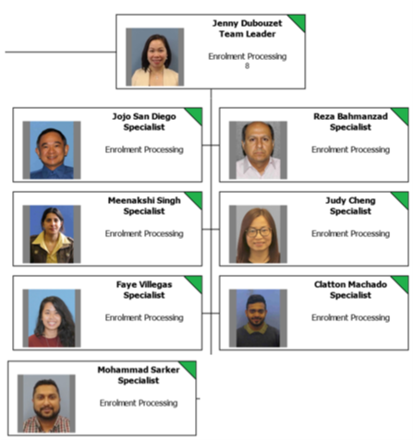

## ENROLMENT PROCESSING TEAM

## Assessment Support & Enrolment Processing

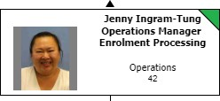

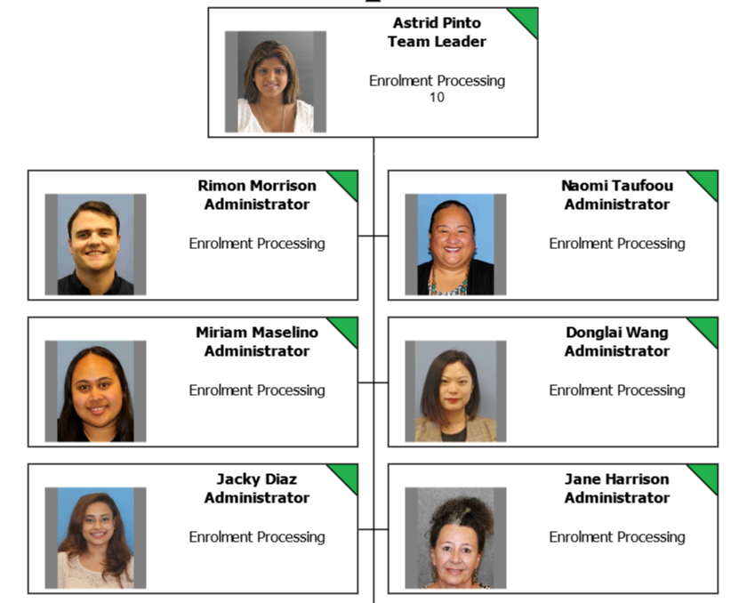

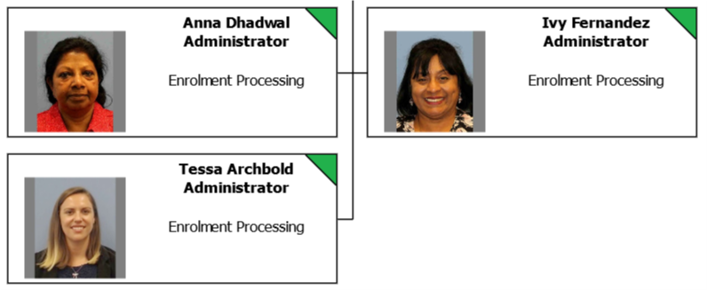

ENROLMENT ADMINISTRATION TEAM

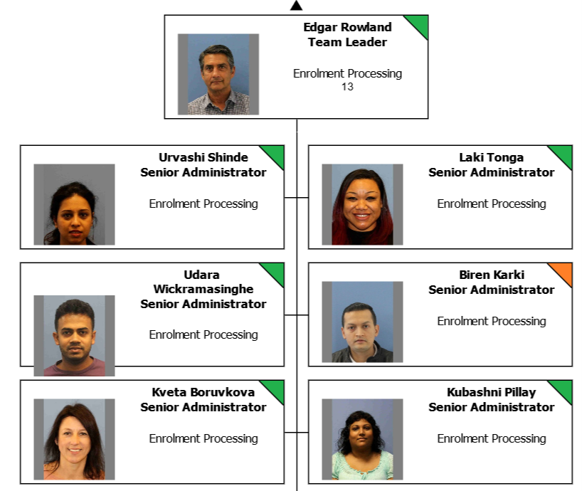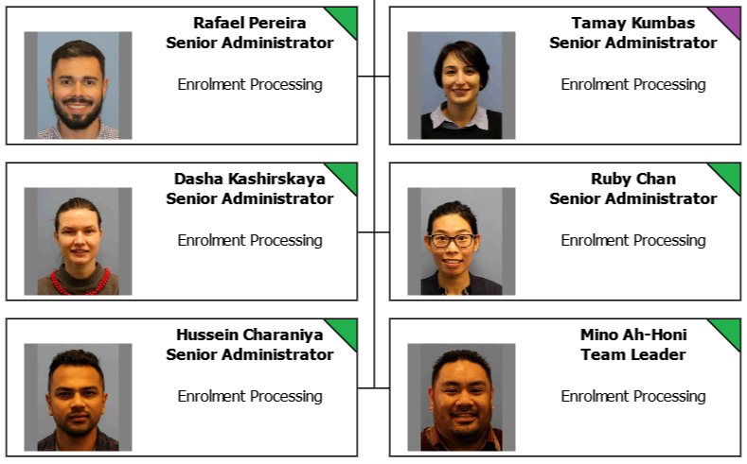

STUDENT FINANCE TEAM

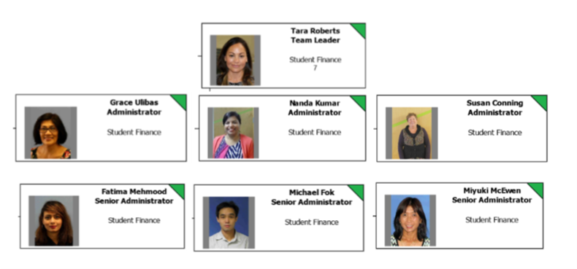

GRADUATION TEAM

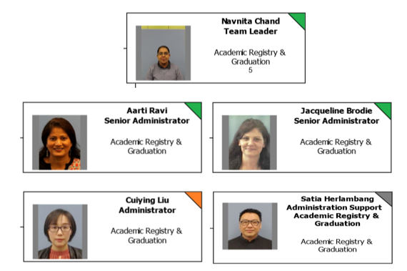

TIMETABLING TEAM

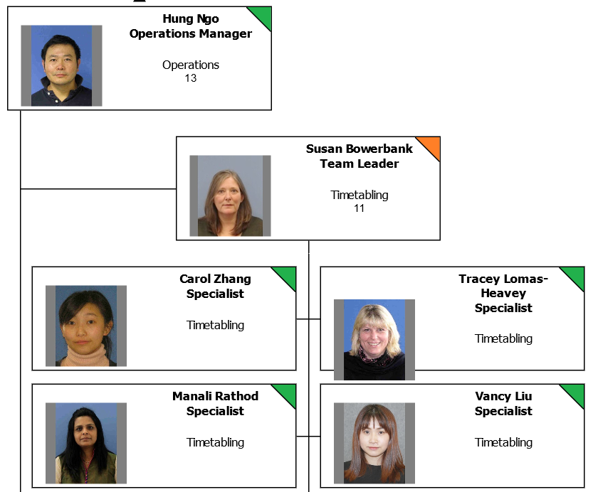 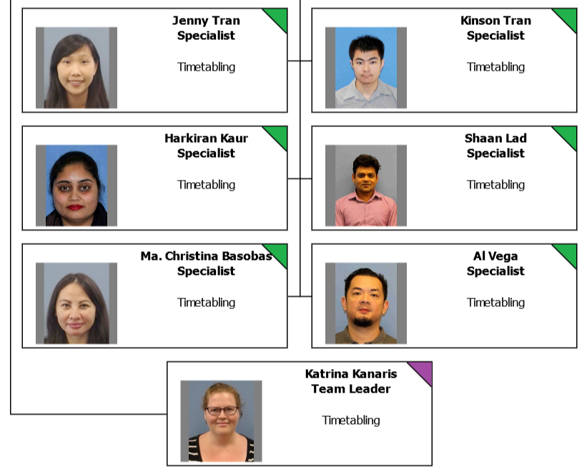

# Meet our Business Partner

Concentrix

#### A little message from our Concentrix team:

We’re now the 2nd largest provider of customer engagement services in the world. We provide customer support and customer service, but we also do so much more!

We support many of the world’s best brands – probably many of your favourite brands, and you wouldn’t have known it. Whether you’re buying a pair of jeans online, flying over Asia, calling tech support about your new headphones, using an app to get a ride, or ordering a cup of coffee, there is a good chance that Concentrix is behind the scenes, making sure it all runs smoothly.

Our commitment partnership with Unitec:

* Concentrix look Student Services 0800 10 95 10 call centre and our IMS Help Desk team. The staff and team members work for Concentrix representing Unitec.
* Student Services Team is a very friendly team that handles all queries from students and non-students.
* IMS help desk- tier 1. Assisting tier 1 queries and is first point of contact for IMS 8484
* Back office work- Managing our [study@unitec.ac.nz](mailto:study@unitec.ac.nz) proxy

#### Our team

Antonio Montano Operations Manager

Kelsi Morrow Team Leader Student Services Tanisha Khan Team Captain

# Karakia to open meeting

# &

# close meeting

# 

# 

# Helpful links

0nitec Acronyms reference link

<https://thenest.unitec.ac.nz/TheNestWP/teaching-and-research/te-korowai-kahurangi/key-links/glossary-of-acronyms-and-terms/>

# Notes