2020 Programme Evaluation and Planning (PEP) Report without exemplars
PeopleSoft Code: | Title of Programme:
XXX | e.g. New Zealand Certificate in Mechanical Engineering (Level 3)
Leading to the:
NZQA Qualification No.: | NZQA Qualification Title:
e.g. 2715 | e.g. New Zealand Certificate in Mechanical Engineering (Level 3)

2020 School Name: | Filenames to be used:
e.g. School of Trades and Services | e.g. 2020_PEP_EoY_TandS_NZCME_30Dec2020_final.docx
Head of School Name: | Report Writer:
e.g. Dr. Aaaaa Bbbbbbbb | e.g. Aaaaa Bbbbbbbb

Purpose of the 2020 Programme Evaluation and Planning Report (EoY PEP)
The EoY PEP reflects on educational performance and self-assessment capability of programmes, for Key Evaluation Questions and the Tertiary Education Indicators.
Unitec does this to:
- Monitor and improve our performance in delivering positive outcomes for our students and other stakeholders
- Monitor and improve our ability to reflect on the effectiveness of our actions in doing the above.
- Increase consistency in performance and self-assessment across the organisation
- Report on our performance to our key external stakeholder NZQA

Key Evaluation Questions
Outcome questions KEQ 1 and 2
Answered by the programme team and the PEP writer
KEQ 1 How well do students achieve?
KEQ 2 What is the value of the outcomes for key stakeholders, including students?
Process questions KEQ 2 to 6
Answered by programme team and the PEP writer
KEQ 3 How well do programme design and delivery, including learning and assessment activities, match the needs of students and other relevant stakeholders?
KEQ 4 How effectively are students supported and involved in their learning?
Pro-Forma answered by the HOS/APM and discussed in the team
KEQ 5 How effective are governance and management in supporting educational achievement?
KEQ 6 How effectively are important compliance accountabilities managed?

Capability in self-assessment demonstrated by the EoY PEP will be determined by the Programme Academic Quality Committee (PAQC) (see Appendix B - Capability in Self-Assessment Rubric).

What stage in its life cycle is your programme?
Provide a brief snap shot including:
- how long the programme has been offered
- dates of the last 5-year review (L7 and above), monitor’s visit (L7 and above) or consistency review. (If never, when are they due?)
KEQ 1: How well did students achieve in 2020?
Key indicative evidence sources
2020 EoY PEP Dashboard | Live Data Dashboard (TKK)
Student Course Surveys Dashboard (TKK) | CEP Online Dashboard Sem1 2020 (TKK) (D1/2/3/4)
Course Survey Reports | CEP Online Dashboard Sem2 2020 (TKK) and DEPs (C3, D1, D2, D3)
Student EPI TEC Dashboard | Assessment data * Where SCC is less relevant

External Benchmarks
From current TEC, ITP Ngā Kete - Tertiary Performance – Single Data Return (SDR)

Educational Performance Rubric Guidance
Excellent | - Overall SCC% (or predicted SCC%) are at or above Programme SCC target 2022  - Priority groups’ SCC% (or predicted SCC%) are at or above priority group targets 2020  - SMART goals and/or actions taken to improve SCC show a positive impact  - Further actions to maintain/improve SCC and expected impacts are identified  - QCR is at or above Programme QC target 2022  - Progression and First Year Retention is, at or above, Programme targets 2022  - Benchmarking SCC, QC, First-year retention and progression against available current TEC, ITP benchmarks are above in all applicable metrics
Good | - Overall SCC% (or predicted SCC%) are at or above Programme SCC target 2022  - Priority groups’ SCC% (or predicted SCC%) are no greater than 5% under respective priority group targets 2020  - SMART goals and/or actions that may have contributed to SCC are identified; their impact on SCC is mostly positive  - Further actions to improve SCC are identified  - QCR is no greater than 10% below Programme QC target 2022  - Progression and First Year Retention is no greater than 10% below Programme targets 2022  - Benchmarking SCC, QC, First-year retention and progression against available current TEC, ITP benchmarks are comparable in all applicable metrics
Marginal | - Overall SCC% (or predicted SCC%) are no greater than 10% under Programme SCC target 2022  - Priority groups’ SCC% (or predicted SCC%) are no greater than 10% under their respective priority group target 2020  - SMART goals and actions which may have contributed to improve SCC over the last year are mostly identified  - Further actions to improve SCC are identified  - QCR is no greater than 15% below Programme QC target 2022  - Progression and First Year Retention is no greater than 15% below Programme targets  - Benchmarking SCC, QCR, First-year retention and progression against available current TEC, ITP benchmarks are comparable in 50% of applicable metrics
Poor | - Overall SCC% (or predicted SCC%) are more than 10% under Programme SCC target 2022  - Priority groups’ SCC% (or predicted SCC%) are more than 10% under their respective priority group  - SMART goals and actions to improve SCC are behind schedule or have not made a noticeable difference to SCC  - QCR is more than 15% below Programme QCR targets 2022  - Progression and First Year Retention are more than 15% below of Programme targets 2022  - Additional/new gaps are evident and there are challenges with addressing these  - Benchmarking SCC, QCR, First-year retention and progression against current TEC, ITP benchmarks are below in most applicable metrics
Overall | - Consider the number of students that contribute to gaps or weaknesses  - Where predicted SCC is used there should be a strong evidence base e.g. previous performance and assessment data may be used to support predictions  - Where programme targets are not available then School targets may be used  - Trends are considered

SUMMARY
The rating of Excellent / Good / Marginal / Poor [Choose one] is made due to, analysis and interpretation of [Enter SCC All phrase], [Enter priority group SCC phrase], [enter SCC for courses phrase], [enter other EPI against programme targets and external benchmarks phrase]and [other phrase].


[Use the Snipping Tool to snip and paste from the 2020 EoY PEP Dashboard (link): KEQ 1 Summary 1 PEP – Programme Level Enrolment and EPI. This summary is available 8 February and uses the January 2021 Single-Data Return) (However if you are looking at SCC results before the 8 February then use 02 Live Data Dashboard – PEP SCC%) Delete the message in these square brackets]
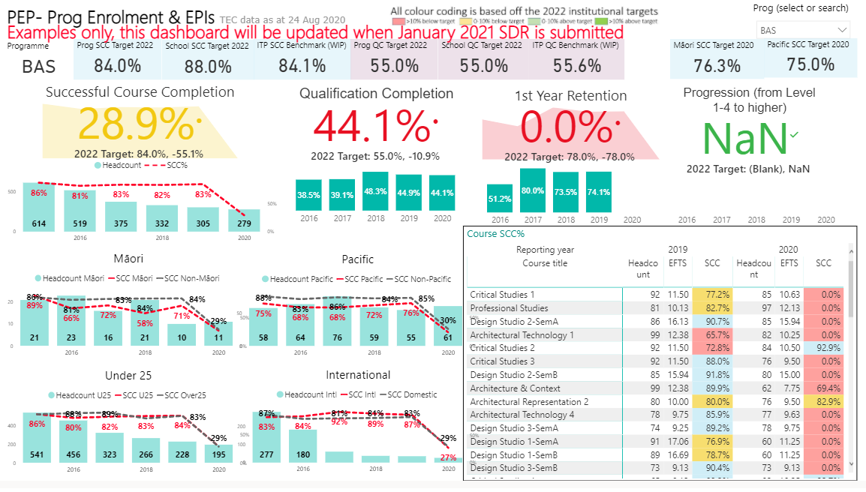

1.1 How well did all students achieve in 2020 (SCC overall)?
What is the data telling us? What's going up? Down? Staying the same? By how much? Are we above, on, near or far from targets and TEC benchmarks?

Why do we think this is?

What did we say we were going to do about overall SCC? Did we do it and did it work? (SMART and other actions)

What are our gaps/challenges to achieve overall SCC targets?

What are we planning to do about it? (SMART Goals)

1.2 How well Māori students achieve in 2020?
What is our data telling us? Is Māori SCC going up or down or staying the same? By how much? Are we above, on, near or far from targets and TEC benchmarks?

Why do we think this is?

What did we say we were going to do about Māori SCC? Did we do it and did it work? (SMART and other actions)

What are our gaps/challenges to achieve Māori SCC targets?

What are we planning to do about it? (SMART Goals)

1.3 How well did Pacific students achieve in 2020?

What is our data telling us? Is Pacific SCC going up or down or staying the same? By how much? Are we above, on, near or far from targets and TEC benchmarks?

Why do we think this is?

What did we say we were going to do about Pacific SCC? Did we do it and did it work? (SMART and other actions)

What are our gaps/challenges to achieve Pacific SCC targets?

What are we planning to do about it? (SMART Goals)

1.4 How well did Under 25 students achieve in 2020?

What is our data telling us? Is Under 25s SCC going up or down or staying the same? By how much? Are we above, on, near or far from targets and TEC benchmarks

Why do we think this is?

What did we say we were going to do about Under 25 SCC? Did we do it and did it work? (SMART and other actions)

What are our gaps/challenges to achieve Under 25 SCC targets?

What are we planning to do about it? (SMART Goals)

1.5 How well did international students achieve in 2020?

What is our data telling us? Is international SCC going up or down or staying the same? By how much? Are we above, on, near or far from targets and TEC benchmarks?

Why do we think this is?

What did we say we were going to do about International SCC? Did we do it and did it work? (SMART and other actions)

What are our gaps/challenges to achieve International SCC targets?

What are we planning to do about it? (SMART Goals)

1.6 How well did all students achieve in courses in, 2020?

What is the data telling us (areas of success, areas for improvement, trends)?

Why do we think this is? (team actions, factors inside and outside of the team)?

What did we say we were going to do about course SCC? Did we do it and did it work? (SMART and other actions)

What are our gaps in course SCC?

What are we planning to do about it? (SMART Goals)

1.7 How well did our students achieve qualifications (QCR), progressed to higher education or be retained in study?

What is the data telling us (areas of success, areas for improvement, trends)?

Why do we think this is? (team actions, factors inside and outside of the team)?

What did we say we were going to do about QCR, Progression and Retention? Did we do it and did it work (SMART and other actions)?

What are our gaps in QCR, Progression and Retention?

What are we planning to do about it? (SMART Goals)

KEQ 2: What is the value of the outcomes for key stakeholders, including students?
Indicative evidence sources:
2020 EoY PEP Dashboard/Graduate Dashboard (TKK) | Staff research/industry engagement
Industry Advisory meetings and feedback | Practicum feedback/experiences
Professional body feedback/accreditation | If Unitec graduate survey data is unreliable, then other GESC evidence should be used:  - Consistency and 5-year programme reviews  - Programme surveys of graduates
Iwi and community engagement/feedback | Monitor feedback

Educational Performance Rubric Guidance
Excellent | Programme consistently prepares students well for their next destination evidenced by:  - Previous SMART goals and actions to improve stakeholder outcomes are completed and have had positive impact  - GESC 85% (or above) of graduates in full-time employment or study  - Total positive responses of 80% (or above) of graduates for job requirements, relevance to employment and education and worth of investment  - Graduate Outcome KPIs consistently meets Unitec target or has increased over time  - Job titles and/or further education pathways are closely aligned to employment and educational pathways identified in the programme document  - Any challenges/weaknesses have minimal impact on overall graduate outcomes and there are appropriate responses in place  - Each GPO is rated as either Strongly agree or Somewhat agree by 80% of respondents  - At least one formalised engagement with industry or community stakeholders and positive feedback received from this  - Industry accreditation is maintained (where relevant) and positive feedback received  - All eligible staff research active and green lit, with research clearly benefiting industry  - Further actions to maintain/improve stakeholder outcomes and their expected impact identified
Good | Programme prepares students well for their next destination evidenced by:  - Previous SMART goals and actions to improve stakeholder outcomes completed and impact is mostly positive  - GESC 65 to 85% of graduates in full-time employment or study  - Total positive responses of 60 to 79% in graduate survey for job requirements, relevance to employment and further education, and worth of investment  - Graduate Outcome KPIs on or near target this year but variable over time  - Job titles and/or further education pathways are mostly aligned to employment and educational pathways identified in the programme document  - Any challenges/weaknesses have some impact on overall graduate outcomes and there are appropriate responses in place  - Each GPO is rated as either Strongly agree or Somewhat agree by 65% to 79% of respondents  - Evidence of some engagement with industry or community stakeholders and feedback received  - Industry accreditation is maintained (where relevant) with generally good feedback  - All eligible staff research active with 80% green lit and research relevant to industry  - Further actions to maintain/improve stakeholder outcomes are
Marginal | Programme generally prepares students for their next destination, with some inconsistencies evidenced by:  - Previous SMART goals and actions to improve stakeholder outcomes are partially completed with some positive impact  - GESC 45to 64% of graduates in full-time employment or study  - Total positive responses of 45 to 59% in graduate survey for job requirements, relevance to employment, and worth of investment  - Graduate Outcome KPIs below or near target this year and variable over time  - Some job titles and/or further education pathways are aligned to employment and educational pathways identified in the programme document  - Challenges/weaknesses have an impact on overall graduate outcomes and there are few appropriate responses in place  - Each GPO is rated as either Strongly agree or Somewhat agree by 45% to 64% of respondents  - Evidence of minimal engagement with industry or community stakeholders  - Industry accreditation is maintained (where relevant) with mixed feedback and/or actions required.  - 60 – 79% of eligible staff research active and 60-79% green lit and research relevant to industry  - Some actions to maintain/improve stakeholder outcomes are identified
Poor | Programme does not prepare most students for their next destination evidenced by:  - SMART goals and actions to improve stakeholder outcomes are behind schedule or have been ineffective  - GESC 0 to 44% of graduates in full-time employment or study  - Total positive responses of 0 to 44% in graduate survey for job requirements, relevance to employment, and worth of investment  - Graduate Outcome KPIs consistently below target  - Few job titles and/or further education pathways are closely aligned to employment and educational pathways identified in the programme document  - Many challenges/weaknesses have impact on overall graduate outcomes and there are no obvious responses in place  - Each GPO is rated as either Strongly agree or Somewhat agree by 0% to 44% of respondents  - No evidence of engagement with industry/community stakeholders  - Industry accreditation may/may not be maintained (where relevant) with significant changes suggested  - Under 60% eligible staff research active and green lit  - No/Limited actions to maintain/improve stakeholder outcomes are identified

SUMMARY
The rating of Excellent / Good / Marginal / Poor [Choose one] is made due to [Outcome Statement 1], [Outcome Statement 2] and, [Outcome Statement 3].

[Use the Snipping Tool to snip and paste from the 2020 EoY PEP Dashboard (link): KEQ 2 Summary 1- Graduate Outcomes KPIs
Click on the link to the PDF provided for the Graduate Outcomes survey responses in bar chart format.
An example of what this will look like follows. Delete the message in these square brackets]

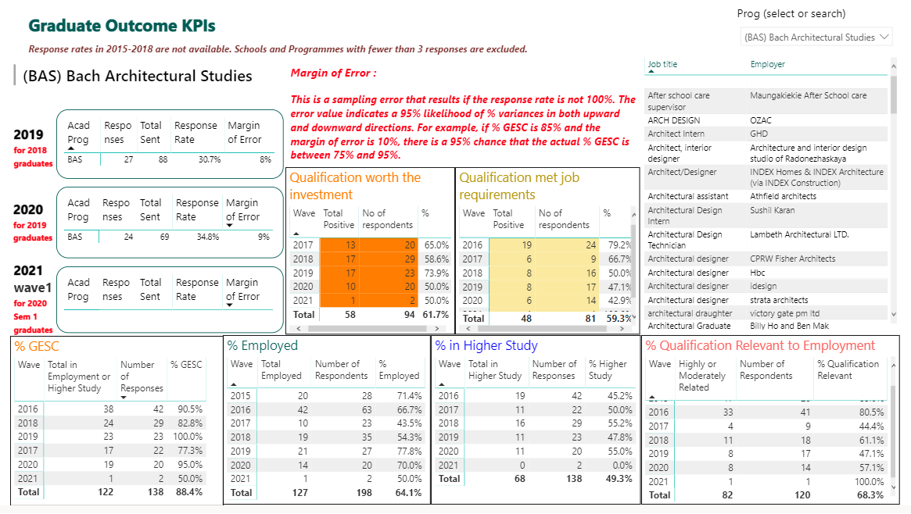

[Use the Snipping Tool to snip and paste from the 2020 EoY PEP Dashboard (link): KEQ 2 Summary 2- GPO Statement. Click on the link to the PDF provided for the Graduate Outcomes survey responses in bar chart format.
An example of what this will look like follows. Delete the message in these square brackets]

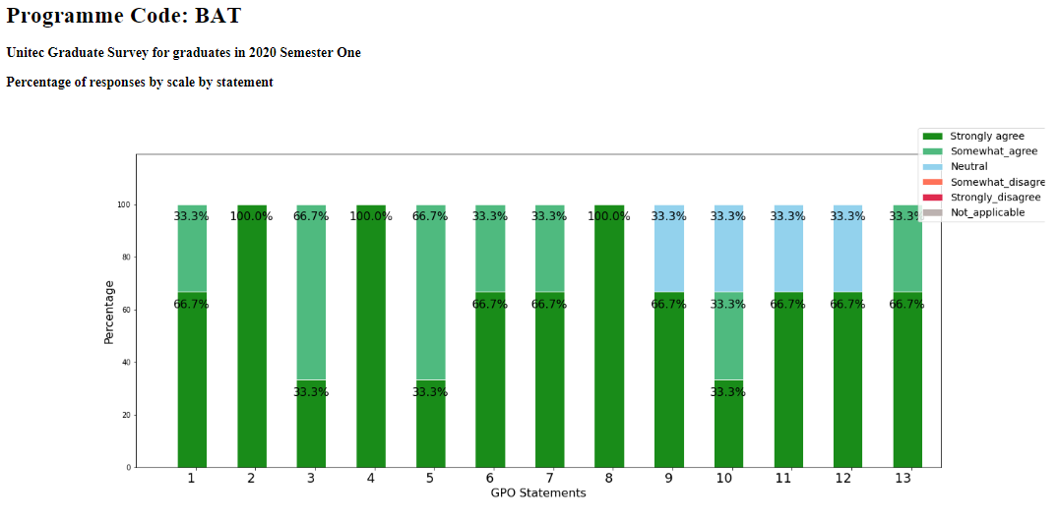

2.1 What is the value of the programme to graduates? Consider overall and specific outliers of priority groups (Māori, Pacific, International and Under 25s).

What is this data telling us (are graduates in relevant employment or relevant study? Do their jobs match the programme document? How do graduates rate the value of the programme? Areas of success, improvement, trends)?

Why do we think this is?

What goals (SMART and others) did we set about graduate outcomes last time, have we achieved them and what was their impact?

What are our gaps in GESC, Qualification relevance and value, job roles and Graduate Profile statements?

What are we planning to do about it? (SMART Goals)

2.2 What is the value of the programme to stakeholders?

What do we do to find out if the programme is useful to stakeholders? s (feedback from employers, placements, industry advisory groups, accreditation bodies, iwi and community feedback, consistency reviews, monitor feedback, value of staff research/industry engagement)? What “two-way” feedback loops do we have with stakeholders, including industry advisory groups?

What is this data telling us?

Why do we think this is?

What goals did we set about the value of the programme to other stakeholders last time, have we achieved them and what was their impact on outcomes?

What are the gaps in stakeholder outcomes and value?

What are we planning to do about it?

KEQ3: How well do programme design and delivery, including learning and assessment activities match the needs of students and other relevant stakeholders?
Indicative evidence sources:
2020 EoY PEP Dashboard/SCC Dashboard | CEP Sem 1 Dashboard Semester 1 (B5, B6, D4, D5, D6, D7, D19, D20, D21)
Moderation feedback and actions (internal and external) | CEP Sem 2 questions: B5, B6, B7, B8, D9, D17, D18, D19
Student Representative feedback | Course Surveys
Course/Assessment/Programme changes | Industry feedback and actions
Industry accreditation | Iwi/community feedback
Monitor feedback | Consistency Reviews Reports
Literacy and Numeracy Assessment results

Educational Performance Rubric Guidance
Excellent | Course Development  - Analysis of moderation themes and relevant actions identified and implemented  - Relevant changes are made throughout the year  - All courses contain relevant Mātauranga Māori and Pacific content  - All relevant courses contain low stakes assessment  - Strategies and processes for teaching and learning in response to COVID 19 minimised impacts on student SCC and stakeholder outcomes  Student Needs Met  - All Course survey ratings are at or above Unitec positive rating targets  - Students receive feedback on surveys, suggestions or comments  Stakeholder Needs Met  - Formal and informal processes for stakeholder feedback are maintained with relevant actions identified and implemented  - Stakeholder feedback is positive  - Stakeholders receive feedback on their input  General  - SMART goals and actions to address student and stakeholder needs are completed and their impact on SCC and/or stakeholder outcomes are positive
Good | Course Development  - Analysis of moderation themes and relevant actions identified and implemented  - Relevant changes are made throughout the year  - 80% - 90% of courses contain relevant Mātauranga Māori and Pacific content  - Low Stakes assessment is embedded in 80 – 90% of relevant courses  - Strategies and processes for teaching and learning in response to COVID 19 worked to minimise impact on SCC and stakeholder outcomes but there were still some negative impacts  Student Needs Met  - 80 – 90% of overall Course Survey ratings are at or above Unitec positive rating target  - Students receive feedback on most surveys, suggestions or comments  Stakeholder Needs Met  - Some Formal and informal processes for stakeholder feedback are maintained with some relevant actions are identified and implemented.  - Stakeholder feedback is mostly positive  - Stakeholders mostly receive feedback on their input  General  - SMART goals and actions to address student and stakeholder needs are mostly completed and their impact on SCC and/or stakeholder outcomes are mostly positive
Marginal | Course Development  - Some themes from moderation may be identified with some actions implemented  - Some changes are made throughout the year  - 60 - 79% of courses contain relevant Mātauranga Māori and Pacific content  - Low stakes assessment is embedded in 60 – 79% of relevant courses  - Strategies and processes for teaching and learning in response to COVID 19 showed mixed results in minimising the impact of Covid 19 on SCC and stakeholder outcomes  Meeting Student Needs  - 60-79% of course survey overall ratings at or above Unitec positive rating target  - Processes to provide feedback to students on surveys, suggestions or comments are not consistently used  Meeting Stakeholder Needs  - Processes for stakeholder feedback may not be consistently used and some actions may be identified  - Stakeholder feedback is mixed  - Feedback to stakeholders about their input may be inconsistent  General  - Some SMART goals and actions to address student and stakeholder needs are completed and their impact on SCC and/or stakeholder outcomes may be mixed or unclear
Poor | Course Development  - Themes from moderation not identified and no actions implemented.  - No or inappropriate changes are made throughout the year  - Under 60% of courses contain relevant Mātauranga Māori and Pacific content  - Low stakes assessment is embedded in under 60% of relevant courses  - Strategies and processes for teaching and learning in response to COVID 19 did not appear to be effective in minimising negative outcomes on student achievement  Student Feedback  - Under 60% of student Course Survey overall ratings are at or above Unitec positive rating target  - No processes exist to provide feedback to students about changes as a result of feedback  Stakeholder Feedback  - No processes for stakeholder feedback are in place  - Stakeholder feedback (if received) is negative  - No processes to provide feedback to stakeholders about changes exist  General  - SMART goals and actions to meet student and stakeholder need are behind schedule or have not yet made a difference to SCC or stakeholder outcomes

SUMMARY
The rating of Excellent/Good/Marginal/Poor [Choose one] is made due to [outcome analysis 1], [outcome of analysis 2], [outcome analysis 3], [outcome analysis 4], [outcome analysis 5], [outcome analysis 6], and [outcome analysis 7].

3.1 How well did course development processes contribute to improvement?
What did we say we were going to do about Course development? Did we do it and did it work? (SMART and other actions)

What else did we change and why? Did it work? (impact on SCC or stakeholder outcomes)

What were the themes from moderation (internal and external) and what have we done about them? How has assessment design and practices been mindful of the student at the centre? What was the impact of changes on SCC and/or stakeholder outcomes?

What have we done to embed I see me Mātauranga Māori and Pacific content in courses? What was the impact on SCC or stakeholder outcomes?

Have we implemented I See Me Low stakes assessment in Level 5 and below courses? What was the impact on SCC or stakeholder outcomes? (% of courses with Low stakes assessment, Course SCC, follow up of students)

What did we change because of COVID 19 and how did this impact on student achievement and stakeholder outcomes?

What are our gaps in this area?

What are we planning to do about it?

3.2 How well were student needs met?
[Use the Snipping Tool to snip and paste from the 2020 EoY PEP Dashboard (link): KEQ 3 Summary 1- Graduate Outcome – Student needs. An example of what this will look like follows. Delete the message in these square brackets]

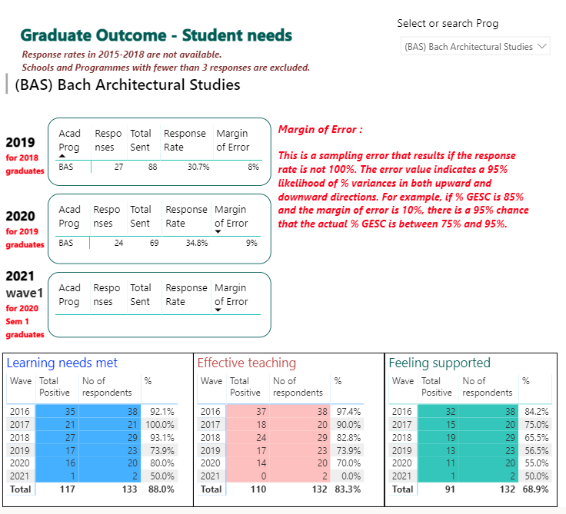
Use the Snipping Tool to snip and paste from the 2020 EoY PEP Dashboard (link): KEQ 3 - Summary 2 – PEP Course Survey Summary. An example of what this will look like follows. Delete the message in these square brackets]

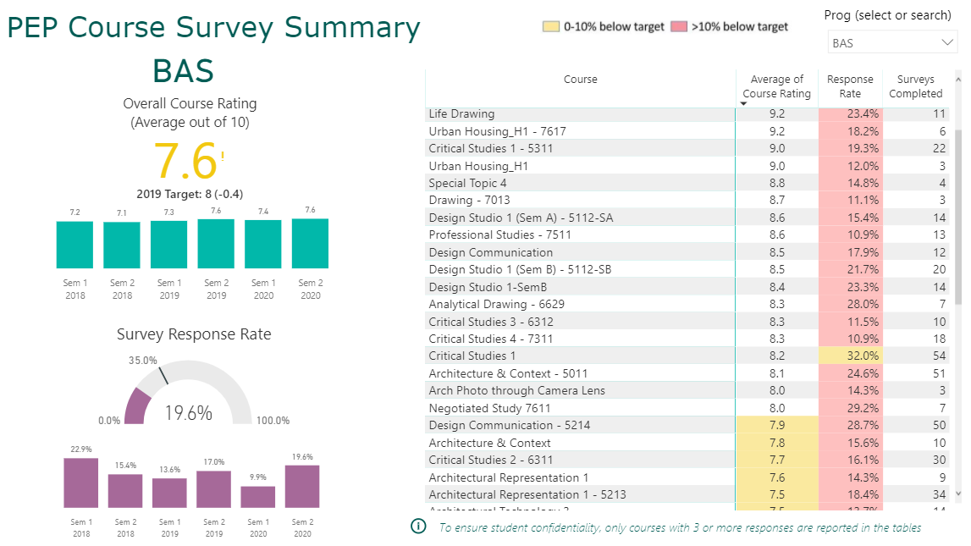

What is this data telling us (e.g. themes, areas of success, areas for improvement, trends)?

Why do we think this is?

What else do we do to get data about meeting student needs and what does this feedback tell us?

What did we say we were going to do about meeting student needs? Did we do it and did it work? (SMART and other actions)

What do we do to give students feedback on the changes we make to courses and the programme?

What are our gaps in meeting student needs?

What are we planning to do about it? (SMART Goals)

3.3 How well were stakeholder needs met?

What do we do to get data about meeting stakeholder needs? (Industry advisory, Community/Iwi engagement, Placement Feedback)

What has this feedback told us?

What did we say we were going to do about meeting stakeholder needs? Did we do it and did it work? (SMART and other actions)

What do we do to give our stakeholders feedback on the changes we make to courses and the programme?

What are our gaps in meeting stakeholder needs?

What are we planning to do about it? (SMART Goals)

KEQ4: How effectively are students supported and involved in their learning?
Indicative evidence sources:
2020 EoY PEP Dashboard/Support Services (Student Success) Dashboard | Learner Outreach/Programme trackers
Student Course Survey | Staff Capability Development
Student attendance/SEATS | SCC Dashboard
CEP Dashboard Semester 1 (B5, B6, C1, C2, D3, D4, D5, D6, D7, D19, D20, D21) | CEP questions Semester 2: B5, B6, B7, C2, D4, D15, D17, D18, D19
International Code of Conduct | ADEP completions
Badge completions | International Code of Practice
Professional Development (Zoom, Echo 360, etc),

Educational Performance Rubric Guidance
Excellent | - SMART goals and actions related to student support and engagement are completed and show positive impact SCC, and/or stakeholder outcomes and/or student engagement  - 80+ % of staff engaged in I See Me orientation and transition initiatives and all students supported to engage  - Students needs are identified early and are effectively followed-up  - Evidence of actions and monitoring undertaken by programme to provide academic and pastoral needs is positive  - Evidence of all staff engaging in capability development on priority areas (CEPS, badging in Te Noho Kotahitanga, Te Tipare, Pacific, International Code of Conduct) areas and this is analysed for its impact
Good | - SMART goals and actions related to student support and engagement are completed and show mostly positive impact SCC and/or stakeholder outcomes and/or student engagement  - Most (60 – 80%) of staff engaged in I See Me orientation and transition initiatives and all students supported to engage;  - Most student needs identified early and are effectively followed up  - Some positive actions and monitoring undertaken by programme to provide academic and pastoral support  - Evidence of most staff (80 – 90%) engaging in capability development on priority areas (CEPS, badging in Te Noho Kotahitanga, Te Tipare, Pacific, International Code of Conduct) areas and this is analysed for its impact
Marginal | - Some SMART goals and actions related to student support and engagement are completed and may show mixed impact on SCC and/or stakeholder outcomes and/or student engagement  - Some (50 – 60%) staff engaged in I See Me orientation and transition initiatives and students supported to engage  - Some student needs identified early and followed up  - Actions and monitoring undertaken by programme to provide academic and pastoral needs is mixed or inconsistent  - Evidence of some (60 – 80%) of staff engaging in capability development on priority areas: (CEPS, badging in Te Noho Kotahitanga, Te Tipare, Pacific, International Code of Conduct
Poor | - Few SMART goals and actions related to student support and engagement are completed and may not yet show impact on SCC and/or stakeholder outcomes and/or student engagement  - Under 50% of staff engaged in I See Me orientation and transition initiatives and students not supported to engage  - No/Limited student needs identified early and/or followed up  - No/Limited actions and monitoring undertaken by programme to provide academic and pastoral needs  - Under 60% of staff engaging in capability development on priority areas (CEPS, badging in Te Noho Kotahitanga, Te Tipare, Pacific, International Code of Conduct)

SUMMARY
The rating of Excellent/Good/Marginal/Poor [Choose one] is made due to [statement 1], [statement 2], [statement 3], [statement 4], [statement 5 and [statement 6].

4.1 How effective was student orientation and initial engagement?

What did we say we were going to do about orientation and engagement? Did we do it and did it work? (SMART and other actions)

Did staff engage in I See Me and orientation initiatives and what was the impact of this on student engagement?

What other events and activities in the programme or at Unitec were students involved in and what was their impact on student engagement and success?

What is the SEATS data telling us and what is the impact of class engagement on SCC?

What are our gaps in this area?

What are we planning to do about it?

4.2. How effective was student support?

What did we say we were going to do about student support? Did we do it and did it work? (SMART and other actions)

What else do we do to support students (especially priority groups)? What is the impact on SCC

How do we listen to (identify) and act on (follow-up) on student feedback? What is the impact of this?

KEQ 4 DASHBOARD

Use the Snipping Tool to snip and paste from the 2020 EoY PEP Dashboard (link): KEQ 4 - Summary – Student Services Summary. An example of what this will look like follows. Delete the message in these square brackets]
Special Note: The Support Services dashboard gets updated 6 monthly. Many of the services are pastoral in nature. The updated dashboard from the Student Support Team is expected before the end of January, 2021. An example of the type of dashboard is shown below.

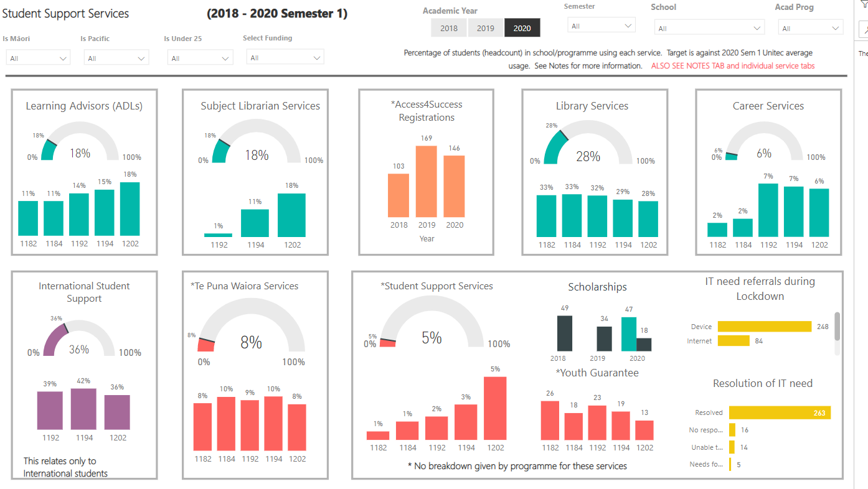

What is student support services data telling us?

Why do we think this is?

What are our gaps in student support?

What are we planning to do about it?

4.3 How well did staff capability development contribute to student support?

What did we say we were going to do about staff capability development? Did we do it and did it work? (SMART and other actions)

What else did we do to build capability and what was the impact on SCC, especially for priority groups?

What did we learn from COVID19 changes and staff development that can help us better support students in the future?

What are our gaps in staff capability development?

What are we planning to do about it?

KEQ 5: How effective are governance and management in supporting educational achievement?
Indicative evidence sources:
2020 EoY PEP Dashboard /NPS score | Staff survey
Resources (staffing/physical) | EER feedback (where relevant)
Strategies (Renewal, Te Noho Kotahitanga, Learning and Teaching. Professional Development) | Staff wellbeing
PAQC processes | International and Domestic Code of Conduct
SEATS | CEP Semester 1 Dashboard (D13, D14, D15)

Educational Performance Rubric Guidance
Excellent | - SMART goals and actions related to resources and or/governance and management are completed and show positive impact on programme quality and student success  - Resources are used effectively and meet needs, enhance programme quality and student success  - Feedback on resources is positive  - Actions are identified to improve resources and goals are SMART  - Actions to improve resources are moved into workplan with clear owners and/or completed on time  - School staff engagement score is above 80% in the Staff Engagement Survey
Good | - SMART goals and actions related to resources and or/governance and management are completed and mostly show positive impact on programme quality and student success  - Resources are used effectively and mostly meet needs, enhance programme quality and student success  - Feedback on resources is mostly positive  - Most actions to improve resources are moved into workplan with clear owners and/or completed on time  - School staff engagement score is 75 to 80% in the Staff Engagement Survey
Marginal | - Some SMART goals and actions related to resources and or/governance and management are completed and may show mixed impact on programme quality and student success  - Resources are sufficient and meet some needs but may impact negatively on others  - Feedback on resources is adequate or mixed  - Some actions identified to improve resources but goals may not be SMART  - Some actions are moved into workplan and/or completed with others outstanding  - School staff engagement score is 55 to 74% in the Staff Engagement Survey
Poor | - No/limited SMART goals and actions related to resources and or/governance and management are completed and may limit impact on programme quality and student success  - Resources do not appear to meet needs and/or support success  - Feedback on resources is generally negative  - Few actions identified to improve resources  - Most actions incomplete  - School staff engagement score is less than 55% of the Staff Engagement Survey

SUMMARY
The rating of educational performance for focus area five is Excellent / Good / Marginal / Poor. [Choose one] This is made due to [Statement 1], [Statement 2] and [Statement 3].

[Use the Snipping Tool to snip and paste from the 2020 EoY PEP Dashboard (link): KEQ 5 - Summary 1- 2020 Student Experience – how students rate each experience attribute. An example of what this will look like follows. Delete the message in these square brackets]

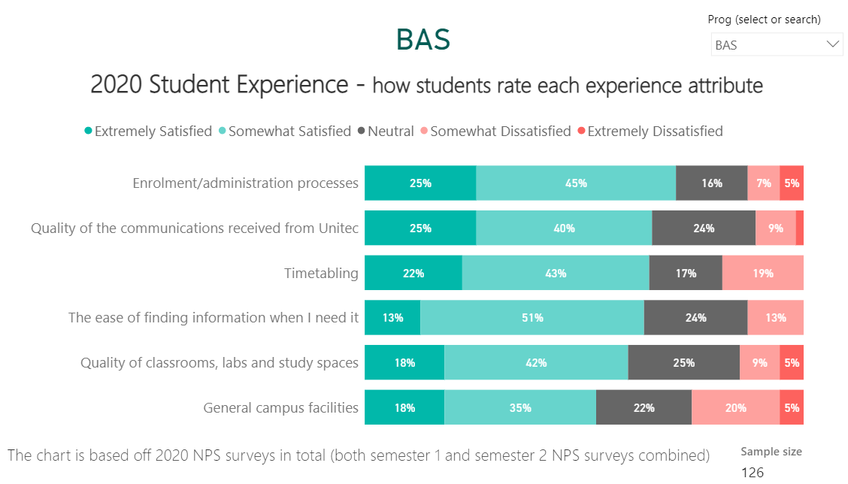

Resource Area | Quality rating for each of the following based on the KEQ 5 Rubric  Excellent, good marginal or poor | Comments on rating and actions taken in 2020 (including SMART goals) | Comments on new actions identified
Physical Resources (e.g. IT, facilities, materials)
Use and value of SEATS
Timetabling
Staffing Resources
Management Resources (e.g. FTE for PCs, APMs, HOS)
Net Promoters Score
Staff Engagement Score
Strategies (Manaakitia Te Rito, Te Noho Kotahitanga, Maori Success, Pacific Success, under 25 Success, International Success) embedded in programme
Use of data to drive decisions and development

KEQ 6: How effectively are important compliance accountabilities managed?
Indicative evidence sources:
Moderation Plans | 5-year and consistency review
SMART Goal tracking | EER feedback
CEP completion (dashboard completion rate) | ADEPS
PAQC meeting notes | Risk Register
Badging Completion

Educational Performance Rubric Guidance
Excellent | Quality Rating  - 95 – 100% tasks completed in time  - Feedback positive and minimal risks or recommendations made  - Comments in moderation, CEPs, PAQC reports are evaluative  - All actions from moderation, ADEPS and CEPS, monitoring or reviews are identified and goals are SMART (where relevant)  - All actions moved into workplan with clear owners and/or completed on time
Good | Quality Rating  - 75 – 94% tasks completed in time  - Feedback mostly positive and some risks or recommendations made  - Comments in moderation, CEPs, PAQC reports are mostly evaluative  - Most actions from moderation, ADEPS and CEPS, monitoring or reviews are identified and goals are SMART (where relevant)  - Most actions moved into workplan with clear owners and/or completed on time
Marginal | Quality Rating  - 60 – 74% tasks generally completed in time  - Some positive feedback but some risks not managed, and recommendations require action  - Comments in moderation, CEPs, PAQC reports are mixed, some evaluative and some gaps  - Some actions from moderation, ADEPS and CEPS, monitoring or reviews are identified  - Few actions moved into workplan with clear owners and/or completed on time
Poor | Quality Rating  - 59% and below of tasks completed on time and many outstanding  - Feedback highlights clear gaps, key risks not managed and significant recommendations made  - Comments in moderation, CEPs, PAQC reports are incomplete or not evaluative  - Significant actions from moderation, ADEPS and CEPS, monitoring or reviews required  - Minimal evidence of workplans or owners of actions

SUMMARY
The rating of educational performance for focus area five is Excellent / Good / Marginal / Poor. [Choose one] This is made due to [Statement 1], [Statement 2] and [Statement 3].

Compliance Area | Completion Rating  Estimate  (%) | Quality  Rating based on the KEQ 6 Rubric  Excellent, good marginal or Poor | Comments on rating and actions taken (where relevant) | Comments on actions required
Internal Pre-moderation (CEP Sem 2, B3)
Internal post-moderation
External moderation
Storage of summative assessment
ADEPS
Badging
International Code of Practice
CEPS (Completion and engagement on CEP dashboards)
SMART goals completed
Risk Register Maintenance
PAQC operation and reporting
Monitor’s visits
Industry Accreditation (as relevant)
Consistency or 5 Year Programme Review (as relevant)
Literacy Numeracy Assessment Tool completed (where relevant)

The APM supports that the programme is being delivered as planned in regards to
Compliance Area | Check Y/N
Moderation Planning | Y/N
Learning Hours | Y/N
Graduate Profile Statements | Y/N
The Programme Document | Y/N (review required)
Course Descriptors | Y/N

Table 1: SMART goals current and new
The table below is to be pre-populated with your programme PAQC SMART goal summary (PAQC workplan) in collaboration with your PAQC secretary. If a new SMART goal is required add the new SMART goal using the numbering format EoY 2020 - 1, EoY 2020 – 2 etc
Resources for writing SMART goals: https://www.atlassian.com/blog/productivity/how-to-write-smart-goals .

PEP Year - Action number | A goal should be linked to one issue or gap and the relevant KEQ/s.    What problem/issue needs addressing? | There should be clear tasks or actions you can take to make progress toward a goal.    What specific actions and specific steps need to be accomplished in order to achieve goal resolution? Is each step achievable and relevant? | A goal should be something you can track and measure progress toward.    The action will be considered successful when...  What measurable outcomes are you expecting to result from your proposed actions at each step? | A goal should be clearly assigned to a person and role.    Who specifically will be the individual  responsible for monitoring and reporting progress? Who will also be working on these actions? | A goal should have an end date. (ongoing is not an end-date)    When will steps in progress be reported? | What specific actions and steps have been achieved against the goal at the reporting date?
EoY 2020 - 1 | KEQ 1 Low SCC% for some courses.  KEQ 3 Student (course surveys) and lecturers have recurring issues with difficult assessments late in some courses. | Implement low-stakes assessment for AB1002, 1009 and AB 1110  - Add to moderation plan  - Write assessments  - Pre-moderate assessments  - Implement assessments | Moderation plan updated  Pre-moderation approved  New assessments Implemented  Post-moderation approved  Moderation plan updated | Lead A Jones – APM  Designer M Smith –Lecturer  Moderator J Ducati -ASM | Design complete 20/03/21  Moderation complete 20/04/21  Implemented 1214  Post moderation 20/08/21

PAQC review of the PEP report
The PEP is reviewed by the PAQC when the following questions are discussed with the decisions are minuted.
 | ACHIEVEMENT  Discussion prompts: Do the ratings given reflect a degree of reasonableness for the programme? Does the PAQC know of further evidence, not cited in the report, that supports or contradicts the ratings? What area(s) does the programme need to focus on in order to improve educational performance in student achievement in 2021?
 | Decide: The PAQC has confidence through its analysis of the PEP that the ratings and the narrative given for each KEQ are (select  one of the following):  ☐accurate with no changes to ratings and narrative  ☐accurate with no changes to ratings and only minor changes to the narrative as agreed by the PAQC. These minor changes will be undertaken before submission to the QAB.  ☐accurate with changes to no more than one rating and minor changes to narrative as agreed by the PAQC. These changes will be undertaken before submission to the QAB.  ☐required to be reviewed with more analysis, research and/or rework before resubmission to the PAQC  ☐not applicable due to [Add reason]  Summary comments or agreements made:
SMART GOALS
Discussion prompts: What progress does this PEP evidence toward the completion of SMART goals set previously? What reasons are known for any delays? Are there any suggested refinements to the SMART goals for the next period going forward?

Progress on previous goals
Decide: The PAQC can confirm the current SMART goals have had activity toward completion and/or delays have been explained and the achievement to date is (select  one of the following):
☐accurate with no changes required☐accurate with minor changes as agreed by the PAQC. These minor changes will be undertaken before submission to the QAB.
☐required to be reviewed, with research or rework and then resubmitted to the PAQC
☐not applicable due to [Add reason]
Summary comments or agreements made:

New goals set
Decide: That the PAQC has reviewed the new SMART goals for this PEP and confirms that they are (select  of the following):
☐valid SMART goals with no changes required
☐valid SMART goals with minor changes as agreed by the PAQC. These minor changes will be undertaken before submission to the QAB.
☐Required to be reviewed with further research or rework and then resubmitted to the PAQC
☐Not applicable due to [Add reason]
Summary comments or agreements:

SELF-ASSESSMENT CAPABILITY
Discussion prompts: How well has the programme team demonstrated its capability in self-assessment in determining educational performance? Use the attached criteria in Appendix B - Capability in Self-Assessment Rubric to provide a rating.

Decide: The rating of Excellent/Good/Marginal/Poor. [Choose one] is made due to:
- [Reason 1 from the criteria list]
- [Reason 2 from the criteria list]
- [Reason 3 from the criteria list]
- [Reason x from the criteria list]

Other narrative as applicable e.g. The PEP has one criterion from Appendix B that is excellent, four criteria (List) that are good and one criterion that is Marginal. This is why a rating of Good has been given.

Electronic submission of this report to QAB@unitec.ac.nz shall be considered as the final version.

Appendix B - Capability in Self-Assessment Rubric
Rating | NZQA criteria | Unitec criteria for 2020 EoY PEP
Excellent | - Self-assessment is exceptional and comprehensive  - Strong evidence of improved outcomes brought about by self- assessment activities  - Very few gaps or weaknesses  - Any gaps and weaknesses have no significant impact and are managed very effectively | - All sections of the PEP have been completed  - Ratings are made for each KEQ with justification supported by the rubric  - Where applicable analysis has been made against the recommended benchmarks provided, with reasons  - Sufficient evidence is provided for each KEQ  - Shortcoming in evidence have been explained  - Te Noho Kotahitanga Principles underpin all KEQ discussions and these are explicit in the narrative  - Trends are analysed in KEQ 1 and 2  - Margin of error in KEQ 2 is identified and discussed in depth  - Actions previously taken clearly link to outcomes or processes for each KEQ and have shown a positive impact  - Reference to I See Me is included in KEQs where relevant (especially, KEQ 1 and 3)  - Identified gaps in outcomes or process clearly link to the KEQ and are minor  - All SMART goals related to the KEQ have been actioned or addressed throughout the year with outcomes or changes recorded  - Goals that are not SMART are rewritten  - New SMART goals are identified that are clearly linked to the KEQ performance or process
Good | - Self-assessment is generally strong and comprehensive  - Evidence of improved outcomes brought about by self-assessment activities  - Few gaps or weaknesses  - Gaps or weaknesses have some impact but are mostly managed effectively | - All sections of the PEP have been completed  - Ratings are made for each KEQ with justification supported by the rubric  - Where applicable, analysis has been made against the recommended benchmarks provided, with some reasons.  - Sufficient evidence is provided for most KEQs  - Shortcomings in evidence have been identified with some explanation  - Te Noho Kotahitanga principles underpin most KEQ discussions and these are explicit in the narrative  - Trends are identified with some analysis in KEQ 1 and 2  - Margin of error in KEQs 2 is identified and with some discussion  - Actions previously taken generally link to outcomes or processes for each KEQ and have shown some positive impact  - Reference to I See Me is included in KEQs where relevant (especially, KEQ 1 and 3)  - Identified gaps in outcomes are process generally link to the KEQ  - SMART goals related to the KEQ have mostly been actioned throughout the year with outcomes recorded  - New SMART goals are identified that link to the KEQ
Marginal | - Self-assessment is inconsistent in quality and coverage  - Limited evidence of improved outcomes brought about by self- assessment activities  - Some gaps and weaknesses have some impact, and are not managed effectively | - PEP sections generally completed, with some information missing  - Ratings are made for each area, but may be inconsistent, for example the reasons for the rating is not clear or the rating given does not match the evidence  - Not all applicable areas are analysed against the recommended benchmarks, or reasons for analysis may not be given, or be inaccurate  - Some KEQs may lack evidence  - Shortcomings in evidence may not be explained or addressed  - Te Noho Kotahitanga principles are referred to inconsistently and may underpin some discussions but not others. Not explicit in the narrative  - Trends may be identified in KEQ 1 or 2, with limited analysis  - Margin of error in KEQ 2 is identified  - Actions previously taken may be described but not always clearly linked to outcomes or processes for each focus are, or may not show a positive impact  - Limited references to I See Me, especially in KEQ 1 & 3  - Gaps in outcomes or process may not be consistently identified or consistently linked to KEQs and have clear impact on outcomes  - SMART goals related to the KEQ may be inconsistently referred to and/or inconsistently actioned (e.g. some actioned, some not)  - Some new SMART goals missing, or goals not consistently linked to the KEQ performance or process
Poor | - Self-assessment is generally ineffective or weak  - No or minimal evidence of improved outcomes brought about by self- assessment activities  - Significant gaps or weaknesses have significant impact, and are not managed effectively  - Does not meet minimum expectations or requirements | - PEP sections have large gaps and missing information  - Ratings are not made for each KEQ or have minimal relationship to their rubric  - No analysis made against the recommended benchmarks  - No or very limited evidence provided  - No explanation or analysis of shortcomings of information including margin of error  - No reference to Te Noho Kotahitanga Principles in discussion  - Actions previously taken are not clearly described, or assessed against outcomes or processes for each KEQ, or have not shown positive impact  - No reference to I See Me  - Gaps in outcomes or process not identified or not linked to the KEQ and have clearly impacted outcomes  - Previous SMART goals related to the KEQ missing, or consistently not actioned , or outcomes not recorded  - New goals not identified, or not linked to KEQs performance or process

If you do not work to semester dates you may like to use Power BI to look at data from your last completion round and comment on this and use this and other evidence e.g. assessment data to date, or some course completions to comment on overall predicted SCC. Additionally, if you have a lot of deferrals due to COVID, you may like to compare your full results (Including deferrals) with results showing these deferrals removed, this may give a greater indication of predicted SCC)
Refer to data from Power BI Course Summary – Semester and filter for 2018, 2019 & 2020

