2020 Programme Evaluation and Planning (PEP) Report with exemplars
PeopleSoft Code: | Title of Programme:
XXX | e.g. New Zealand Certificate in Mechanical Engineering (Level 3)
Leading to the:
NZQA Qualification No.: | NZQA Qualification Title:
e.g. 2715 | e.g. New Zealand Certificate in Mechanical Engineering (Level 3)

2020 School Name: | Filenames to be used:
e.g. School of Trades and Services | e.g. 2020_PEP_EoY_TandS_NZCME_09Aug2020_final.docx
Head of School: | Report Writer:
e.g. Dr. Aaaaa Bbbbbbbb | e.g. Aaaaa Bbbbbbbb

Purpose of the 2020 Programme Evaluation and Planning Report (EoY PEP)
The EoY PEP reflects on educational performance and self-assessment capability of programmes, for Key Evaluation Questions and the Tertiary Education Indicators.
Unitec does this to:
- Monitor and improve our performance in delivering positive outcomes for our students and other stakeholders
- Monitor and improve our ability to reflect on the effectiveness of our actions in doing the above.
- Increase consistency in performance and self-assessment across the organisation
- Report on our performance to our key external stakeholder NZQA

Key Evaluation Questions
Outcome questions KEQ 1 and 2
Answered by the programme team and the PEP writer
KEQ 1 How well do students achieve?
KEQ 2 What is the value of the outcomes for key stakeholders, including students?
Process questions KEQ 2 to 6
Answered by programme team and the PEP writer
KEQ 3 How well do programme design and delivery, including learning and assessment activities, match the needs of students and other relevant stakeholders?
KEQ 4 How effectively are students supported and involved in their learning?
Pro-Forma answered by the HOS/APM and discussed in the team
KEQ 5 How effective are governance and management in supporting educational achievement?
KEQ 6 How effectively are important compliance accountabilities managed?

Capability in self-assessment demonstrated by the EoY PEP will be determined by the Programme Academic Quality Committee (PAQC) (see Appendix B - Capability in Self-Assessment Rubric).

What stage in its life cycle is your programme?
Provide a brief snap shot including:
- how long the programme has been offered
- dates of the last 5-year review (L7 and above), monitor’s visit (L7 and above) or consistency review. (If never, when are they due?)
The Bachelor of XXX is a small programme, with approximately 120 students in total. This programme began in 2007 and underwent its last five-year review in 2018. This review identified developments to some Level 7 courses to better meet industry needs. A number of these changes were first delivered in 2020 and have received positive student and industry feedback to date. The monitor’s visit in 2020 was positive with no requirements identified and two recommendations for further improvement to moderation practices.

KEQ 1: How well did students achieve in 2020?
Key indicative evidence sources
2020 EoY PEP Dashboard | Live Data Dashboard (TKK)
Student Course Surveys Dashboard (TKK) | CEP Online Dashboard Sem1 2020 (TKK) (D1/2/3/4)
Course Survey Reports | CEP Online Dashboard Sem2 2020 (TKK) and DEPs (C3, D1, D2, D3)
Student EPI TEC Dashboard | Assessment data * Where SCC is less relevant

External Benchmarks
From current TEC, ITP Ngā Kete - Tertiary Performance – Single Data Return (SDR)

Educational Performance Rubric Guidance
Excellent | - Overall SCC% (or predicted SCC%) are at or above Programme SCC target 2022  - Priority groups’ SCC% (or predicted SCC%) are at or above priority group targets 2020  - SMART goals and/or actions taken to improve SCC show a positive impact  - Further actions to maintain/improve SCC and expected impacts are identified  - QCR is at or above Programme QC target 2022  - Progression and First Year Retention is, at or above, Programme targets 2022  - Benchmarking SCC, QC, First-year retention and progression against available current TEC, ITP benchmarks are above in all applicable metrics
Good | - Overall SCC% (or predicted SCC%) are at or above Programme SCC target 2022  - Priority groups’ SCC% (or predicted SCC%) are no greater than 5% under respective priority group targets 2020  - SMART goals and/or actions that may have contributed to SCC are identified; their impact on SCC is mostly positive  - Further actions to improve SCC are identified  - QCR is no greater than 10% below Programme QC target 2022  - Progression and First Year Retention is no greater than 10% below Programme targets 2022  - Benchmarking SCC, QC, First-year retention and progression against available current TEC, ITP benchmarks are comparable in all applicable metrics
Marginal | - Overall SCC% (or predicted SCC%) are no greater than 10% under Programme SCC target 2022  - Priority groups’ SCC% (or predicted SCC%) are no greater than 10% under their respective priority group target 2020  - SMART goals and actions which may have contributed to improve SCC over the last year are mostly identified  - Further actions to improve SCC are identified  - QCR is no greater than 15% below Programme QC target 2022  - Progression and First Year Retention is no greater than 15% below Programme targets  - Benchmarking SCC, QCR, First-year retention and progression against available current TEC, ITP benchmarks are comparable in 50% of applicable metrics
Poor | - Overall SCC% (or predicted SCC%) are more than 10% under Programme SCC target 2022  - Priority groups’ SCC% (or predicted SCC%) are more than 10% under their respective priority group  - SMART goals and actions to improve SCC are behind schedule or have not made a noticeable difference to SCC  - QCR is more than 15% below Programme QCR targets 2022  - Progression and First Year Retention are more than 15% below of Programme targets 2022  - Additional/new gaps are evident and there are challenges with addressing these  - Benchmarking SCC, QCR, First-year retention and progression against current TEC, ITP benchmarks are below in most applicable metrics
Overall | - Consider the number of students that contribute to gaps or weaknesses  - Where predicted SCC is used there should be a strong evidence base e.g. previous performance and assessment data may be used to support predictions  - Where programme targets are not available then School targets may be used  - Trends to be considered

SUMMARY
The rating of Excellent / Good / Marginal / Poor [Choose one] is made due to, analysis and interpretation of [Enter SCC All phrase], [Enter priority group SCC phrase], [enter SCC for courses phrase], [enter other EPI against programme targets and external benchmarks phrase]and [other phrase].

The rating of Good is made due to overall SCC being at Unitec 2022 targets (85%), once Deferred grades (4 grades) are accounted for. SCC for Maori is currently below Unitec 2022 targets (78%), Pacific at 83% and Under 25 at 86%. QCR has improved over the last three years and is at 48%, up from 35% in 2017. First year retention is near the Unitec target, currently at 75%. Goals have been set to reach targets for Maori and Pacific SCC.


[Use the Snipping Tool to snip and paste from the 2020 EoY PEP Dashboard (link): KEQ 1 Summary 1 PEP – Programme Level Enrolment and EPI. This summary is available 8 February and uses the January 2021 Single-Data Return) (However if you are looking at SCC results before the 8 February then use 02 Live Data Dashboard – PEP SCC%) Delete the message in these square brackets]

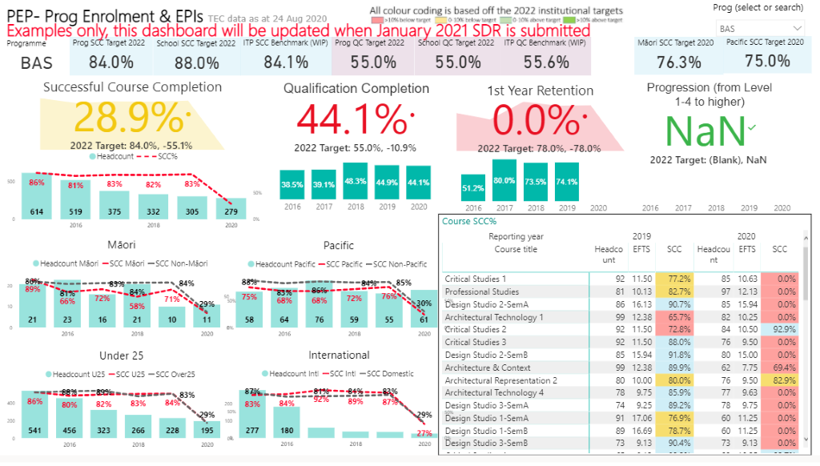

1.1 How well did all students achieve in 2020 (SCC overall)?
What is the data telling us? What's going up? Down? Staying the same? By how much? Are we above, on, near or far from targets and TEC benchmarks?
In 2020 the overall SCC is at 82% (n=98) equal to the 2020 Programme target. This is impacted by four deferred grades, which are due to be completed at the end of February 2021. This is predicted to lift the overall SCC to the Unitec 2022 target of 85%. There is a slight decrease in overall SCC from 2019 (88%, n=85).

Why do we think this is?
The SCC decrease is likely due to the impacts of COVID 19, where SCC was lower in Semester 1 (77%) due to a number of deferrals, especially in practicum courses. Some students did not successfully complete these deferrals, impacting overall SCC.

What did we say we were going to do about overall SCC? Did we do it and did it work? (SMART and other actions)
As SCC was above target in 2019 we did not set any goals for overall SCC. A number of actions were taken during COVID 19 to maintain SCC, including deferrals and assessment changes. These are discussed in KEQs 3 & 4.

What are our gaps/challenges to achieve overall SCC targets?
Once deferrals are completed successfully we will reach the overall SCC target.

What are we planning to do about it? (SMART Goals)
We will continue to support deferrals and have allocated staff to check in with these students.

1.2 How well did Māori students achieve in 2020?
What is our data telling us? Is Māori SCC going up or down or staying the same? By how much? Are we above, on, near or far from targets and TEC benchmarks?
Our Māori SCC 78% (n=15) is below 2022 Unitec priority group Māori targets (85%), above 2020 Unitec priority group Māori targets (76.3%) and below our school and programme targets (82 & 85% respectively). This rate has stayed relatively stable over the last three years.

Why do we think this is?
The stability of Māori SCC in the last three years suggests that our actions thus far have not yet been successful in impacting SCC. We have a small number of Māori students in our programme (12.5%). Many of our Māori students are juggling work, whānau responsibilities and full-time study which can make it difficult to attend classes. Covid 19 also impacted Māori students with three choosing to place their studies on hold with the hope of returning in 2021.
We have also identified that use of Mātauranga Māori in our courses is still limited, discussed in KEQ3

What did we say we were going to do about Māori SCC? Did we do it and did it work? (SMART and other actions)
In our 2019 EOY PEP we set the goal to implement a tracker for priority group students and ensure all priority group and struggling students were followed up. The tracker was implemented, but during COVID not all students were followed up by the team as planned. The LOP did follow up with students, but not all Māori students were retained. In Semester 2 Maori SCC improved compared with Semester 1 (82% compared to 76%) and we used the tracker as planned. Increases in Māori SCC in Semester 2 may also be due to the use of low stakes assessment.

What are our gaps/challenges to achieve Māori SCC targets?
Ensuring Māori students are monitored and supported and ensuring Matauranga Māori is included in all courses.

What are we planning to do about it? (SMART Goals)
We will continue to use the tracker and ensure students are followed up before assessments are due, rather than only when unsuccessful We will also focus on embedding Matauranga Māori content further in our courses so that Māori students can see their culture reflected in their learning.

1.3 How well did Pacific students achieve in 2020?

What is our data telling us? Is Pacific SCC going up or down or staying the same? By how much? Are we above, on, near or far from targets and TEC benchmarks?
Pacific students SCC is currently at 83% (n=10). This is an increase from 81% in 2019. Pacific SCC is only slightly below 2022 Unitec Pacific target (85%) and above the 2020 Unitec Pacific target (75%), and the TEC benchmark of 84%.

Why do we think this is?
As above Covid 19 impacted Pacific students, with a number being essential workers. Despite this SCC increased from 2020 which we believe was due to the tracker, LOP and online learning. During Covid, a number of Pacific students were supported with internet and laptop access which helped them to complete their studies. The recording of Zoom classes meant students could access lessons at times that suited them.

What did we say we were going to do about Pacific SCC? Did we do it and did it work? (SMART and other actions)
As above in 2019 we set a goal to implement a priority group tracker. This was done and as noted above, was not used as planned in Semester 1 but was well used in Semester 2, along with early low-stakes assessments. In Semester 2 all Pacific students were followed up after first assessments to check their progress and any concerns. However, student feedback suggests accessibility of lectures online has had more impact on SCC.
What are our gaps/challenges to achieve Pacific SCC targets?
Covid 19 highlighted that digital poverty and accessibility of lectures online affected Pacific success. These are areas that we can look to address in our normal delivery. Also limited Pacific content in courses is an issue.

What are we planning to do about it? (SMART Goals)
In 2021 we plan to record key in-person lectures so that they are accessible for students unable to attend live classes as well as embed more Pacific content in courses.

1.4 How well did Under 25 students achieve in 2020?

What is our data telling us? Is Under 25s SCC going up or down or staying the same? By how much? Are we above, on, near or far from targets and TEC benchmarks?
Under 25 SCC is above Unitec targets at 86% (n=45) and above the 2020 programme target (82%) and TEC benchmark of 84%. It exceeds non -U25 SCC by 4% (82% n=75). Under 25 SCC has stayed relatively stable in the last three years.

Why do we think this is?
Our team makes effort to engage under 25 students through numerous active learning strategies (See KEQ 3) which helps them to stay engaged. This is evidenced also by course surveys which consistently rate teaching and learning highly.

What did we say we were going to do about Under 25 SCC? Did we do it and did it work? (SMART and other actions)
As above, we implemented a tracker in 2020.

What are our gaps/challenges to achieve Under 25 SCC targets?
We note that the number of under 25 students has dropped significantly in 2020 compared to 2019. If this continues in 2021 we will develop a plan to run focus groups with under 25 students to investigate the reasons.

What are we planning to do about it? (SMART Goals)
We will continue to use the tracker with Under 25 students and review feedback from these students to ensure learning material is engaging and relevant.

1.5 How well did international students achieve in 2020?
What is our data telling us? Is international SCC going up or down or staying the same? By how much? Are we above, on, near or far from targets and TEC benchmarks?
The programme does not currently have any international students
Why do we think this is?

What did we say we were going to do about International SCC? Did we do it and did it work? (SMART and other actions)

What are our gaps/challenges to achieve International SCC targets?

What are we planning to do about it? (SMART Goals)

1.6 How well did all students achieve in courses in, 2020?

What is the data telling us (areas of success, areas for improvement, trends)?
A number of courses show an improvement from the 2019 SCC. In particular AD5004 has improved by 7% to (74%) 40) from an average over the previous three semesters of 67% (2019 Sem 2 (68%) 51, 2019 (Sem1 (67%) 80, 2018 Sem 2(66%) 92. However, some courses such as (AD 6003 and AD 7009) show a decrease in SCC for 2020.

Why do we think this is (team actions, factors inside and outside of the team)?
Courses with SCC decreases are largely practicum courses which were most impacted by COVID 19 as we were unable to deliver these online. A number of students deferred these courses, with some not completing the deferral successfully. Of courses that have increased, some are the Level 7 courses which were redeveloped as a result of programme review, suggesting the changes were relevant and successful.

What did we say we were going to do about course SCC? Did we do it and did it work? (SMART and other actions)
As above, we set a goal to redevelop a number of Level 7 courses following recommendations from the programme review. SCC on these courses has shown improvement, particularly in Semester 2 and student feedback has identified that the assessment requirements are clear.

What are our gaps in course SCC?
Despite improvements in AD5004, the SCC is below where it should be when compared to other courses. We also need to consider how to respond to more flexible delivery of practicum course should we enter further lockdown.

What are we planning to do about it (SMART Goals)?
We will review AD5004 in 2021. We will discuss with our Industry Advisory Committee and Te Puna Ako ways to increase flexibility in practicum courses and we will continue to use moderation data and student feedback from course surveys to identify where course related improvements can be made to maintain SCC.

1.7 How well did our students achieve qualifications (QCR), progressed to higher education or be retained in study?

What is our data telling us (areas of success, areas for improvement, trends)?
QCR has improved over the last three years and is at 48%, up from 35% in 2017, but is still below the Unitec target and School Target of 55%. First year retention is near the Unitec target of 78%, currently at 75%.

Why do we think this is (team actions, factors inside and outside of the team)?
It is difficult to ascertain exact influences on QCR increases. However, QCR is obviously related to SCC. Improvements to courses and increases in pastoral care activities may all have influenced QCR. In addition, approximately five years ago we amended entry requirements to include additional science subjects which may influence SCC and later QCR, as students are better prepared for the course. First year retention rates are influenced positively by low-stakes assessment and I See Me initiatives, but have been negatively influenced by COVID withdrawals. Retention would have been at the Unitec target if COVID had not impacted on these results. Use of our tracker, especially in the second semester has supported students to stay engaged.

What did we say we were going to do about QCR, Progression and Retention? Did we do it and did it work (SMART and other actions)?
SMART goals were focused on SCC and course development, which flow into QCR. It is too early to see the impacts of our actions on QCR but as above, first year retention may be positively impacted by our tracker and I See Me.

What are our gaps in QCR, Progression and Retention?
QCR is still below target

What are we planning to do about it? (SMART Goals)
Continue to provide pastoral and tracking support to offer early support to students in their study

KEQ 2: What is the value of the outcomes for key stakeholders, including students?
Indicative evidence sources:
2020 EoY PEP Dashboard/Graduate Dashboard (TKK) | Staff research/industry engagement
Industry Advisory meetings and feedback | Practicum feedback/experiences
Professional body feedback/accreditation | If Unitec graduate survey data is unreliable, then other GESC evidence should be used:  - Consistency and 5-year programme reviews  - Programme surveys of graduates
Iwi and community engagement/feedback | Monitor feedback

Educational Performance Rubric Guidance
Excellent | Programme consistently prepares students well for their next destination evidenced by:  - Previous SMART goals and actions to improve stakeholder outcomes are completed and have had positive impact  - GESC 85% (or above) of graduates in full-time employment or study  - Total positive responses of 80% (or above) in graduate survey for job requirements, relevance to employment and education and worth of investment  - Graduate Outcome KPIs consistently meets Unitec target or has increased over time  - Job titles and/or further education pathways are closely aligned to employment and educational pathways identified in the programme document  - Any challenges/weaknesses have minimal impact on overall graduate outcomes and there are appropriate responses in place  - Each GPO is rated as either Strongly agree or Somewhat agree by 80% of respondents  - At least one formalised engagement with industry or community stakeholders and positive feedback received from this  - Industry accreditation is maintained (where relevant) and positive feedback received  - All eligible staff research active and green lit, with research clearly benefiting industry  - Further actions to maintain/improve stakeholder outcomes and their expected impact identified
Good | Programme prepares students well for their next destination evidenced by:  - Previous SMART goals and actions to improve stakeholder outcomes completed and impact is mostly positive  - GESC 65 to 85% of graduates in full-time employment or study  - Total positive responses of 60 to 79% in graduate survey for job requirements, relevance to employment and further education, and worth of investment  - Graduate Outcome KPIs on or near target this year but variable over time  - Job titles and/or further education pathways are mostly aligned to employment and educational pathways identified in the programme document  - Any challenges/weaknesses have some impact on overall graduate outcomes and there are appropriate responses in place  - Each GPO is rated as either Strongly agree or Somewhat agree by 65% to 79% of respondents  - Evidence of some engagement with industry or community stakeholders and feedback received  - Industry accreditation is maintained (where relevant) with generally good feedback  - All eligible staff research active with 80% green lit and research relevant to industry  - Further actions to maintain/improve stakeholder outcomes are identified
Marginal | Programme generally prepares students for their next destination, with some inconsistencies evidenced by:  - Previous SMART goals and actions to improve stakeholder outcomes are partially completed with some positive impact  - GESC 45to 64% of graduates in full-time employment or study  - Total positive responses of 45 to 59% in graduate survey for job requirements, relevance to employment, and worth of investment  - Graduate Outcome KPIs below or near target this year and variable over time  - Some job titles and/or further education pathways are aligned to employment and educational pathways identified in the programme document  - Challenges/weaknesses have an impact on overall graduate outcomes and there are few appropriate responses in place  - Each GPO is rated as either Strongly agree or Somewhat agree by 45% to 64% of respondents  - Evidence of minimal engagement with industry or community stakeholders  - Industry accreditation is maintained (where relevant) with mixed feedback and/or actions required.  - 60 – 79% of eligible staff research active and 60-79% green lit and research relevant to industry  - Some actions to maintain/improve stakeholder outcomes are identified
Poor | Programme does not prepare most students for their next destination evidenced by:  - SMART goals and actions to improve stakeholder outcomes are behind schedule or have been ineffective  - GESC 0 to 44% of graduates in full-time employment or study  - Total positive responses of 0 to 44% in graduate survey for job requirements, relevance to employment, and worth of investment  - Graduate Outcome KPIs consistently below target  - Few job titles and/or further education pathways are closely aligned to employment and educational pathways identified in the programme document  - Many challenges/weaknesses have impact on overall graduate outcomes and there are no obvious responses in place  - Each GPO is rated as either Strongly agree or Somewhat agree by 0% to 44% of respondents  - No evidence of engagement with industry/community stakeholders  - Industry accreditation may/may not be maintained (where relevant) with significant changes suggested  - Under 60% eligible staff research active and green lit  - No/Limited actions to maintain/improve stakeholder outcomes are identified

SUMMARY
The rating of Excellent / Good / Marginal / Poor [Choose one] is made due to [Outcome Statement 1], [Outcome Statement 2] and, [Outcome Statement 3].

The rating of Good is based on solid evidence of successful employment and higher-level study outcomes for 70% of graduates (n=15). Perception of qualification value has been identified as an area of weakness, however this has not impacted graduate outcomes overall, which have improved over 2019/2020. A clear plan has been identified to address perceived qualification investment value. GPO statements are rated highly by 80% of students, with the exception of one statement, which has a lower weighting (15%) and this will be investigated in 2020. All eligible staff are research active, and green-lit. We maintained contact with our Industry Advisory Committee and shifted our meeting to Zoom during lockdown.
[Use the Snipping Tool to snip and paste from the 2020 EoY PEP Dashboard (link): KEQ 2 Summary 1- Graduate Outcomes KPIs, An example of what this will look like follows. Delete the message in these square brackets]

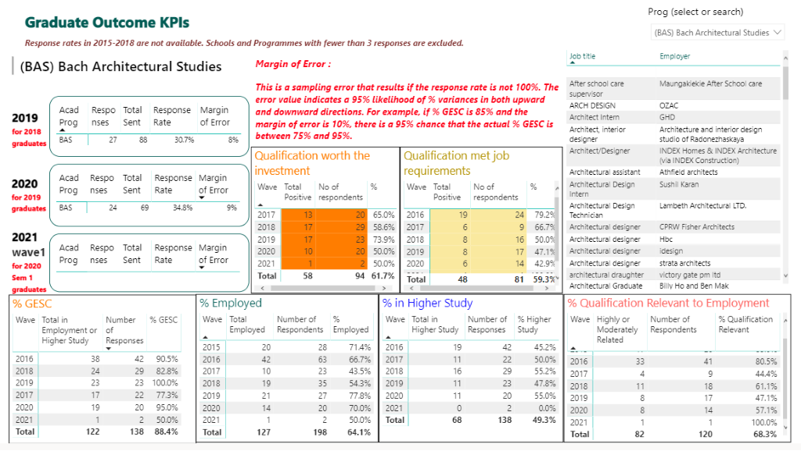

[Use the Snipping Tool to snip and paste from the 2020 EoY PEP Dashboard (link): KEQ 2 Summary 2- GPO Statement. Click on the link to the PDF provided for the Graduate Outcomes survey responses in bar chart format.
An example of what this will look like follows. Delete the message in these square brackets]

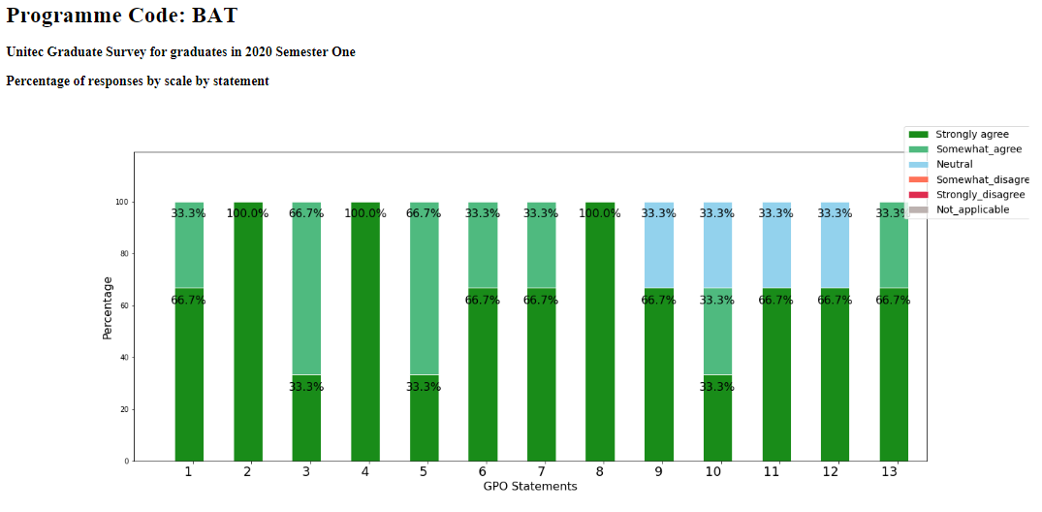
2.1 What is the value of the programme to graduates? Consider overall and specific outliers of priority groups (Māori, Pacific, International and Under 25s).

What is this data telling us (are graduates in relevant employment or relevant study? Do their jobs match the programme document? How do graduates rate the value of the programme? Areas of success, improvement, trends)?
Graduate Employment Study Combined (GESC) increased slightly (3%) in the graduate survey between 2019 and 2020, with70% (n=15) of graduates being either in full-time employment or higher-level study in 2020 and 67 % (n=14) in 2019. This is also a significant increase from 2018 levels of 60%. In 2020, more students have gone to higher level study (20% n=3) as compared to 12% n=2 in 2019, although these numbers are small. Graduates identify that their qualification has prepared them for their job roles (75% n=16)) and relevance to employment is further evidenced by most graduate job titles matching employment outcomes in the programme document. All GPO statements bar the GPO statement about collaborative practice, are rated highly by 80% of graduates, which shows an increase from the 2019 survey. Perception of qualification being worth the investment has decreased from 2019 (69% down to 60%). However, the low number of respondents to the Graduate Survey, (21 of a total of 35 graduates) and a margin of error of 17% does put a caveat on the reliability of this data.

Why do we think this is?
The slight increase in the number of students studying may be due to the impacts of COVID 19. The overall GESC increase may be related to the establishment of a sector advisory group in 2018, which following programme review recommendations helped to re-develop a number of Level 7 courses. Working with the advisory group has evidenced the Te Noho Kotahitanga value of rangatiratanga in drawing on the authority of our sector to enhance graduate outcomes. The lower ratings of our collaborative practice GPO statement may be due to the removal of a number of group assessments at Levels 6 and 7 as a result of student feedback. This is an area to investigate in 2020.
Perceived lack of value of investment may also be due to the impacts of COVID 19, but again this is an area to investigate.

What goals (SMART and others) did we set about graduate outcomes last time, have we achieved them and what was their impact?
We did not set SMART goals about graduate outcomes last time, but GPO statement ratings may have been impacted by changes to courses identified as a goal from programme review.

What are our gaps in GESC, Qualification relevance and value, job roles and Graduate Profile statements?
There is concern over the low response rate to the Graduate Survey and we plan to set up an alternative way of gathering this data in 2021.

What are we planning to do about it? (SMART Goals)
We will contact a number of graduates via phone to further understand perception of qualification investment
We will review the number of group assessments and collaborative opportunities across the programme by working with Te Puna Ako taking into consideration the possible impact of this on the GPOs. We will contact graduates ourselves to supplement survey data via phone and email mid-2021.

2.2 What is the value of the programme to stakeholders?

What do we do to find out if the programme is useful to stakeholders (feedback from employers, placements, industry advisory groups, accreditation bodies, iwi and community feedback, consistency reviews, monitor feedback, value of staff research/industry engagement)? What “two-way” feedback loops do we have with stakeholders, including industry advisory groups?
Industry Advisory Committee meetings (4 were held) to help us to understand the value of our programme to stakeholders. This group consists of employers and placement providers and the leader of the industry body. We also use monitor feedback to further understand stakeholder perceptions of the programme. Minutes show that input from the IAC on the requirement for graduates to use latest techniques supported the purchase of xxxxx. This was feedback to IAC members.

What is this data telling us?
In 2020 we met twice with the IAC, once during lockdown via Zoom and once in Semester 2. During the lockdown meeting we discussed the challenges with providing placements and the group recommended a focus on soft skills and professionalism. Semester 2 has seen a positive improvement in student reliability and professionalism. Learning from this is further discussed in KEQ 3.

Why do we think this is?
As above, the meetings this year identified a gap in professionalism of practicum students. We had incorrectly assumed that students had the communication and professionalism skills necessary for practicum,

What goals did we set about the value of the programme to other stakeholders last time, have we achieved them and what was their impact on outcomes?
Last time we set the goal to meet with our IAC twice which was achieved. As above, this has provided insight into what employers and practicum providers need from students so we are able to amend our courses accordingly.
Whilst we did not set goals in relation to research, 90% of our eligible staff are research active and have green-lit status. In 2020, two of our team published a journal article of some research partnered with an organisation from our IAC. This research is valuable in informing local practice in our sector and has strengthened our relationship with this employer and practicum provider. This is an example of mahi kotahitanga and working together for the good of our industry.

What are the gaps in stakeholder outcomes and value?
One gap identified during the Āta kōrero was the need to embed soft skills in practicum courses.

What are we planning to do about it?
We will add additional components to practicum classes and assessments related to soft-skills and will work with Te Puna Ako to achieve this.

KEQ3: How well do programme design and delivery, including learning and assessment activities match the needs of students and other relevant stakeholders?
Indicative evidence sources:
2020 EoY PEP Dashboard/SCC Dashboard | CEP Sem 1 Dashboard Semester 1 (B5, B6, D4, D5, D6, D7, D19, D20, D21)
Moderation feedback and actions (internal and external) | CEP Sem 2 questions: B5, B6, B7, B8, D9, D17, D18, D19
Student Representative feedback | Course Surveys
Course/Assessment/Programme changes | Industry feedback and actions
Industry accreditation | Iwi/community feedback
Monitor feedback | Consistency Reviews Reports
Literacy and Numeracy Assessment results

Educational Performance Rubric Guidance
Excellent | Course Development  - Analysis of moderation themes and relevant actions identified and implemented  - Relevant changes made throughout the year  - All courses contain relevant Mātauranga Māori and Pacific content  - All relevant courses contain low stakes assessment  - Strategies and processes for teaching and learning in response to COVID 19 minimised impacts on student SCC and stakeholder outcomes  Student Needs Met  - All Course Survey ratings are at or above Unitec positive rating targets  - Students receive feedback on surveys, suggestions or comments  Stakeholder Needs Met  - Formal and informal processes for stakeholder feedback are maintained with relevant actions identified and implemented  - Stakeholder feedback is positive  - Stakeholders receive feedback on their input  General  - SMART goals and actions to address student and stakeholder needs are completed and their impact on SCC and/or stakeholder outcomes are positive
Good | Course Development  - Analysis of moderation themes and relevant actions identified and implemented  - Relevant changes made throughout the year  - 80% - 90% of courses contain relevant Mātauranga Māori and Pacific content  - Low stakes assessment is embedded in 80 – 90% of relevant courses  - Strategies and processes for teaching and learning in response to COVID 19 worked to minimise impact on SCC and stakeholder outcomes but there were still some negative impacts  Student Needs Met  - 80 – 90% of Course Survey ratings are at or above Unitec positive rating target  - Students receive feedback on most surveys, suggestions or comments  Stakeholder Needs Met  - Some formal and informal processes for stakeholder feedback are maintained with some relevant actions identified and implemented.  - Stakeholder feedback is mostly positive  - Stakeholders mostly receive feedback on their input  General  - SMART goals and actions to address student and stakeholder needs are mostly completed and their impact on SCC and/or stakeholder outcomes are mostly positive
Marginal | Course Development  - Some themes from moderation may be identified with some actions implemented  - Some changes are made throughout the year  - 60 - 79% of courses contain relevant Mātauranga Māori and Pacific content  - Low stakes assessment is embedded in 60 – 79% of relevant courses  - Strategies and processes for teaching and learning in response to COVID 19 showed mixed results in minimising the impact of Covid 19 on SCC and stakeholder outcomes  Meeting Student Needs  - 60-79% of Course Survey overall ratings at or above Unitec positive rating target  - Processes to provide feedback to students on surveys, suggestions or comments are not consistently used  Meeting Stakeholder Needs  - Processes for stakeholder feedback may not be consistently used and some actions identified  - Stakeholder feedback is mixed  - Feedback to stakeholders about their input may be inconsistent  General  - Some SMART goals and actions to address student and stakeholder needs are completed and their impact on SCC and/or stakeholder outcomes may be mixed or unclear
Poor | Course Development  - Themes from moderation not identified and no actions implemented.  - No or inappropriate changes are made throughout the year  - Under 60% of courses contain relevant Mātauranga Māori and Pacific content  - Low stakes assessment is embedded in under 60% of relevant courses  - Strategies and processes for teaching and learning in response to COVID 19 did not appear to be effective in minimising negative outcomes on student achievement  Student Feedback  - Under 60% of student Course Survey ratings are at or above Unitec positive rating target  - No processes exist to provide feedback to students about changes as a result of feedback  Stakeholder Feedback  - No processes for stakeholder feedback are in place  - Stakeholder feedback (if received) is negative  - No processes to provide feedback to stakeholders about changes exist  General  - SMART goals and actions to meet student and stakeholder needs are behind schedule or have not yet made a difference to SCC or stakeholder outcomes

SUMMARY
The rating of Excellent/Good/Marginal/Poor [Choose one] is made due to [outcome analysis 1], [outcome of analysis 2], [outcome analysis 3], [outcome analysis 4], [outcome analysis 5], [outcome analysis 6], and [outcome analysis 7].

The rating of educational performance for this area is Good. This is due to responsiveness to moderation feedback and the successful implementation of low stakes assessments in our first-year courses. The rating is also based on positive feedback from graduate surveys and course surveys about their teaching and learning experience. The rating is not yet excellent because consistently embedding Mātauranga Māori and Pacific content is still a gap in our programme, and this may impact Māori and Pacific SCC. In addition, we can improve on providing students with information about the outcomes of their feedback, which may help to enhance programme engagement.

3.1 How well did course development processes contribute to improvement?
What did we say we were going to do about Course development? Did we do it and did it work? (SMART and other actions)
In 2019 we set the goal to complete external moderation, as this had not been finished as planned during 2019. Feedback from 2019 courses identified that two courses (AD1009 and AD2003) appeared to be over-assessing. We re-developed assessments and weightings for these courses and had changes approved by relevant committees. These courses are set to run again in Semester 1 2021, and we will monitor SCC and student feedback. The remainder of external moderation feedback was positive, with the moderator noting that students receive comprehensive feedback that supports their learning. The strength of feedback to students evidences the value of mahi kotahitanga and the teaching team partnering with students to support their success.

What else did we change and why? Did it work (impact on SCC or stakeholder outcomes)?
In 2020 we trialled the redevelopments made in 2019 to Level 7 courses as a result of programme review. SCC on these courses has shown improvement, particularly in Semester 2 and course survey feedback has identified that the assessment requirements are clear (90% positive rating on this indicator n=11).

What were the themes from moderation (internal and external) and what have we done about them? How has assessment design and practices been mindful of the student at the centre? What was the impact of changes on SCC and/or stakeholder outcomes?
CEP data shows that seven of our courses underwent minor changes as a result of internal moderation and student feedback from the previous year. For example, one course, AD 5006, redeveloped Moodle content as a result of student feedback that the previous material was difficult to follow. We will track the results of survey feedback for this course in 2021. As above, a theme of over-assessment was identified for two courses and acted on.

What have we done to embed I see me Mātauranga Māori and Pacific content in courses? What was the impact on SCC or stakeholder outcomes?
CEP data shows that 80% of courses say they embed Mātauranga Māori and 70% Pacific content. However, CEP data also shows that discussions of what this involves are limited, with few models and specific content included. The lack of specificity around this content may be impacting our Māori and Pacific SCC which are below target. Ratings for Mātauranga Māori in course surveys are generally low (below 60% positive ratings in 80% of courses). All of our staff have completed the Te Noho Kotahitanga badge in 2020 and in team meetings the team is discussing Mātauranga Māori and values further. This will continue in 2021.

Have we implemented I See Me Low stakes assessment in Level 5 and below courses? What was the impact on SCC or stakeholder outcomes? (% of courses with Low stakes assessment, Course SCC, follow up of students)
In the second semester of 2020 we embedded early low stakes assessment in three of our four first courses in line with I See Me initiatives. This helped to identify students who were struggling; all students who did not pass or only just passed were added to our student tracker and support was offered. Whilst we have not seen massive impacts on SCC, there has been some improvement to Maori SCC in Semester 2 and our first-year retention is nearly at Unitec’s target, currently at 75%. We also notice that there were less APCs submitted in Semester 2. We will continue to observe if this is an ongoing trend in 2020.

What did we change because of COVID 19 and how did this impact on student achievement and stakeholder outcomes?
COVID 19 meant that we had to quickly adapt our learning and teaching to online. This provided a number of challenges to staff and students, particularly in relation to digital poverty for students, and in relation to changing assessments and teaching material for staff. A number of assessments were redeveloped for online delivery, including exams (open book via Moodle) and presentations (via Zoom). This was done with the help of Te Puna Ako. We believe these changes supported overall positive SCC despite challenges. One gap occurred in our practicum papers, which could not continue during COVID and this impacted negatively with 25% of students unable to complete despite deferrals. Despite this, our focus on teaching soft skills and professionalism over this time appears to have had a positive impact on student engagement in placements in Semester 2, with positive feedback from placement supervisors, as evidenced by the quote below received via email: “(Student) is settling in well and we have been impressed by her positive attitude and willingness to take up any task”.

What are our gaps in this area?
Embedding Mātauranga Māori and Pacific content is still a gap.

What are we planning to do about it?
We will work with Te Puna Ako, Kaihautū and Māori and Pacific champions to embed this content further. This will begin with three specific Level 5 courses for Semester 1 2021.

3.2 How well were student needs met?
[Use the Snipping Tool to snip and paste from the 2020 EoY PEP Dashboard (link): KEQ 3 Summary 1- Graduate Outcome – Student needs. An example of what this will look like follows. Delete the message in these square brackets]

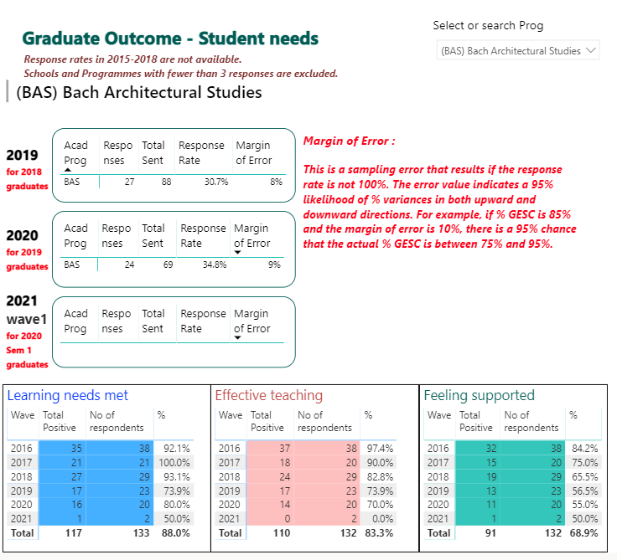
[Use the Snipping Tool to snip and paste from the 2020 EoY PEP Dashboard (link): KEQ 3 - Summary 2 – Course Survey Summary. An example of what this will look like follows. Delete the message in these square brackets]

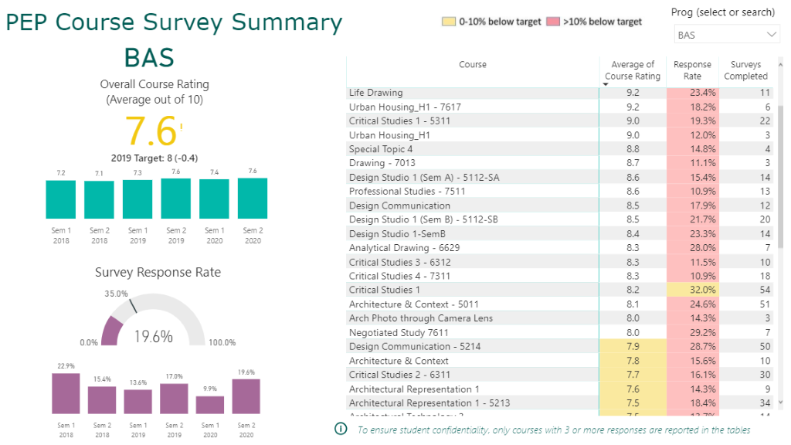

What is this data telling us (e.g. themes, areas of success, areas for improvement, trends)?
The overall average course rating of 8.4 is above the Unitec target of 8. Nearly one third of courses are performing very highly, with ratings over 9. The re-developed courses received high ratings for both teaching and assessment. A small number of courses are below target. Students rate the quality of teaching very highly, with elements of creating a culture of respect, lecturer knowledge and preparation all rating over 9. However, ratings about Mātauranga Māori are low. One caveat on these results is the low response rate of course online surveys, which generally occur during peak assignment times for students and therefore may not be a priority to complete. However, graduate survey data also supports course survey feedback.

Why do we think this is?
Overall ratings are positive because our lecturers work hard to create an engaging class environment for students. Lecturers are also industry linked and currently in practice which likely influences knowledge and preparation ratings.
Courses with below-target feedback ratings tend to have students providing lower ratings on the clarity of assessment requirements. One action is to work with Te Puna Ako to review these assessments for these courses, as we have already done for some of our Level 7 courses to positive effect. It is envisaged that changes to assessments may also positively impact SCC for these courses.

What else do we do to get data about meeting student needs and what does this feedback tell us?
Students have spoken with lecturers in classes and via email about timetabling issues. A number of students are parents who also work and lectures out of school hours are difficult for them to attend. A review of timetabling may be valuable, but changes may not be possible based on resources. However, as identified in KEQ 1, we intend to record lectures and put these on Moodle for students to view later.

What did we say we were going to do about meeting student needs? Did we do it and did it work? (SMART and other actions)
We did not set goals in this area for 2020.

What do we do to give students feedback on the changes we make to courses and the programme?
This is an area for development as we are inconsistent in providing student feedback. Some lecturers paste a summary of course survey feedback on the Moodle course for the next iteration. This is good practice which we would like to roll out to the whole team.

What are our gaps in meeting student needs?
Gaps identified include assessment requirement clarity in lower rated courses, closing the feedback loop with students and accessibility of classes for students who are parents/working.

What are we planning to do about it? (SMART Goals)
Work with Te Puna Ako to review the assessments in lower rated courses. Give students feedback on course ratings via Moodle and advise of changes made as a result of feedback. Discuss timetabling changes but also source equipment to video classes.

3.3 How well were stakeholder needs met?
What do we do to get data about meeting stakeholder needs? (Industry advisory, Community/Iwi engagement, Placement Feedback)
We now meet twice yearly with our Industry Advisory Committee made up of employers, placement providers and the leader of our industry body.

What has this feedback told us?
The feedback is largely positive and identified a need to work on professionalism for practicums.

What did we say we were going to do about meeting stakeholder needs? Did we do it and did it work? (SMART and other actions)
In 2019 we set a goal to meet twice with our industry advisory committee and to recruit two new members to this committee to replace outgoing members and ensure the committee was relevant to our programme. Despite COVID 19 this goal was achieved, although the meetings have been moved to Zoom/Teams. Two new members, one from an industry body and one from Auckland’s largest employers were recruited and inducted into the committee.

What do we do to give our stakeholders feedback on the changes we make to courses and the programme?
Although feedback to stakeholders is provided informally, this is an area for improvement.

What are our gaps in meeting stakeholder needs?
Gaps include closing the feedback loop to stakeholders and find out if our graduates are meeting the needs of employers through surveying employers.

What are we planning to do about it? (SMART Goals)
Goals include adding a feedback section to the agenda of each IAC meeting and identifying key employers of graduates for a survey.

KEQ4: How effectively are students supported and involved in their learning?
Indicative evidence sources:
2020 EoY PEP Dashboard/Support Services (Student Success) Dashboard | Learner Outreach/Programme trackers
Student Course Survey | Staff Capability Development
Student attendance/SEATS | SCC Dashboard
CEP Dashboard Semester 1 (B5, B6, C1, C2, D3, D4, D5, D6, D7, D19, D20, D21) | CEP questions Semester 2: B5, B6, B7, C2, D4, D15, D17, D18, D19
International Code of Conduct | ADEP completions
Badge completions | International Code of Practice
Professional Development (Zoom, Echo 360, etc),

Educational Performance Rubric Guidance
Excellent | - SMART goals and actions related to student support and engagement are completed and show positive impact on SCC, and/or stakeholder outcomes and/or student engagement  - 80+ % of staff engaged in I See Me orientation and transition initiatives and all students supported to engage  - Students needs are identified early and are effectively followed-up  - Evidence of positive actions and monitoring undertaken by programme to provide academic and pastoral support  - Evidence of all staff (100%) engaging in capability development on priority areas (CEPS, badging in Te Noho Kotahitanga, Te Tipare, Pacific, International Code of Conduct) areas and this is analysed for its impact
Good | - SMART goals and actions related to student support and engagement are completed and show mostly positive impact SCC and/or stakeholder outcomes and/or student engagement  - Most (60 – 80%) of staff engaged in I See Me orientation and transition initiatives and all students supported to engage  - Most student needs identified early and are effectively followed up  - Some positive actions and monitoring undertaken by programme to provide academic and pastoral support  - Evidence of most staff (80 – 90%) engaging in capability development on priority areas (CEPS, badging in Te Noho Kotahitanga, Te Tipare, Pacific International Code of Conduct) and this is analysed for its impact
Marginal | - Some SMART goals and actions related to student support and engagement are completed and may show mixed impact on SCC and/or stakeholder outcomes and/or student engagement  - Some (50 – 60%) staff engaged in I See Me orientation and transition initiatives and students supported to engage  - Some student needs identified early and followed up  - Actions and monitoring undertaken by programme to provide academic and pastoral needs is mixed or inconsistent  - Evidence of some (60 – 80%) of staff engaging in capability development on priority areas: (CEPS, badging in Te Noho Kotahitanga, Te Tipare, Pacific, International Code of Conduct)
Poor | - Few SMART goals and actions related to student support and engagement are completed and may not yet show impact on SCC and/or stakeholder outcomes and/or student engagement  - Under 50% of staff engaged in I See Me orientation and transition initiatives and students not supported to engage  - No/Limited student needs identified early and/or followed up  - No/Limited actions and monitoring undertaken by programme to provide academic and pastoral needs  - Under 60% of staff engaging in capability development on priority areas (CEPS, badging in Te Noho Kotahitanga, Te Tipare, Pacific, International Code of Conduct)

SUMMARY
The rating of Excellent/Good/Marginal/Poor [Choose one] is made due to [statement 1], [statement 2], [statement 3], [statement 4], [statement 5 and [statement 6].

4.1 How effective was student orientation and initial engagement?

What did we say we were going to do about student orientation and engagement? Did we do it and did it work? (SMART and other actions)?
In 2019 we set a goal for all staff to engage in I See Me initiatives. At the beginning of 2020 staff and students attended a powhiri and some staff supported other I See Me activities.

Did staff engage in I See Me and orientation initiatives and what was the impact of this on student engagement?
Not all staff engaged in I See Me as planned, (70% attended orientation activities) due to making amendments to courses. However, students did get to meet a number of their lecturers before courses began, but student attendance at orientation was lower than expected (approximately 50%). Informal feedback from students has identified that communication about these events was confusing and not always received. For those who did attend, a relationship was built with staff before classes, which may have helped with retention, especially over lockdown. Despite some withdrawals due to COVID, our first-year retention is nearly at the Unitec target.

What other events and activities in the programme or at Unitec were students involved in and what was their impact on student engagement and success?
Due to lockdown there were limited events for students to be engaged with at Unitec. This is an area we will monitor in 2021. In second semester we have had two students engaged with the Community Garden and they have used this experience to inform one of their assessments.

What is our SEATS data telling us and what is the impact of class engagement on SCC?
SEATS data is limited for 2020 due to lockdowns. Some lecturers kept manual summaries of attendance, however this was difficult with larger classes. Thus, we have limited attendance records for 2020, so it is difficult to comment on the impact of this on SCC. Anecdotally, we know that students who attend regularly perform better in their assessments.
As noted above, working and parenting impacts the attendance of some students with when classes are timetabled.

What are our gaps in this area?
Gaps in this area include: ensuring attendance is recorded, ensuring access of learning material for those who can’t attend, staff and student engagement in I See Me

What are we planning to do about it?
Re-train staff on SEATS in 2021
Record lectures and put on Moodle for students to access later on
Staff to send orientation reminders to students in 2021 in addition to centralised Unitec communication. This will ensure students have orientation information but also build relationships with staff.

4.2 How effective was student support?

What did we say we were going to do about student support? Did we do it and did it work? (SMART and other actions)
In our 2019 EOY PEP we set the goal to implement a tracker for priority group students and ensure all priority group and struggling students were followed up. The tracker was implemented, but during COVID not all students were followed up by the team as planned. The LOP did follow up with students, but not all Māori students were retained during this period. In Semester 2 we have used the tracker as planned.

What else do we do to support students (especially priority groups)? What is the impact on SCC?
In Semester 2, we have used the tracker to connect with all Māori, Pacific and Under 25 students. We believe this has had a positive impact on Māori SCC which has improved from Semester 1 (82% compared to 76%). However, we could connect better with these students before the first assessment rather than waiting to follow up until afterwards. SEATS data could help with contacting students who have not engaged in the first week.

During COVID whilst we did not use the tracker, we quickly identified students who were not attending Zoom classes and phoned them, which identified issues of digital poverty. We referred these students to the LOP team to help address these issues. We found that this was particularly helpful for some of our Pacific students and the Pacific SCC is close to Unitec targets.

How do we listen to (identify) and act on (follow-up) on student feedback? What is the impact of this?
Low stakes assessment in Level 5 courses has to identify and follow up with student needs. This may have impacted first year retention which is at 75% despite COVID 19. We have also used the tracker as planned in Semester 2, which has helped identify students who struggled in the previous semester and lecturers of their second semester courses could check in early and offer support.

KEQ 4 DASHBOARD

[Use the Snipping Tool to snip and paste from the 2020 EoY PEP Dashboard (link): KEQ 4 - Summary – Student Services Summary. An example of what this will look like follows. Delete the message in these square brackets]
Special Note: The Support Services dashboard gets updated 6 monthly. Many of the services are pastoral in nature. The updated dashboard from the Student Support Team is expected before the end of January, 2021. An example of the type of dashboard is shown below.
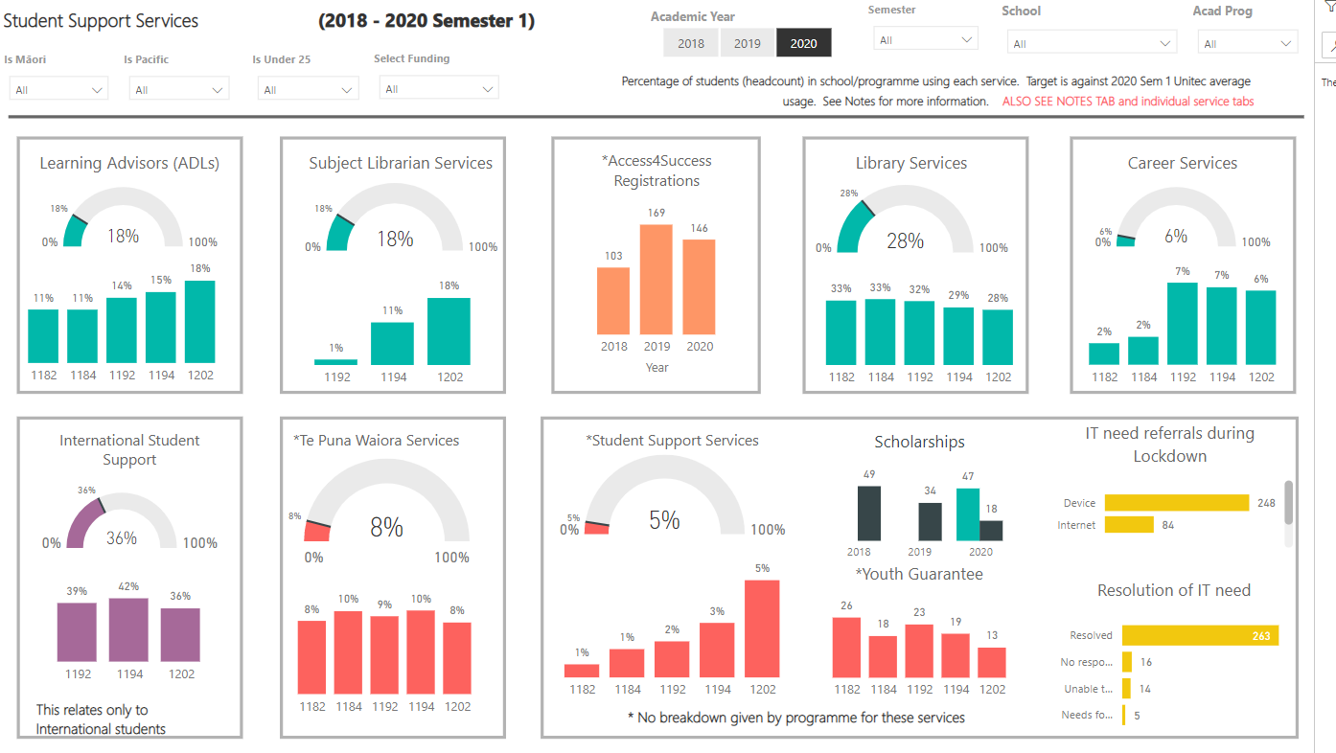

What is student support services data telling us?
Student support services data indicates that our student’s use of Learning Advisors is below the Unitec average of 18%, at 12%. Use of library services is on the average of 18% and use of library services is above the average at 54%. Use of Te Puna Waiora Services is below the Unitec average.

Why do we think this is?
The lower use of Learning Advisors may indicate that our team is not referring as much as we could, however it could also indicate that students do not feel they need this support. This may also be related to course survey data, where in redeveloped courses students felt that assessment requirements were clear. The high use of librarians is positive and suggests students are accessing course readings and others to support their learning. Use of library services may be related to the use of Unitec laptops as many students do not have their own laptops.

What are our gaps in student support?
Two gaps identified are a lack of referral to Learning Advisors and connecting with priority group students before the first assessment.

What are we planning to do about it?
Continue to use the tracker and monitor the impact on SCC
Invite Learning Advisors into early classes or more strategically just before assessments
Ensure referral to Learning Advisors is given on assessment feedback where relevant
Contact students who do not engage in Week 1.

4.3 How well did staff capability development contribute to student support?

What did we say we were going to do about staff capability development? Did we do it and did it work (SMART and other actions)?
In 2019 we set a goal that all staff would complete the Te Noho Kotahitanga badge in 2020 and all staff would complete two badges. The first part of the goal has been met but only 80% of staff have completed two badges. This may be due to the additional workload as a result of COVID 19.

What else did we do to build capability and what was the impact on SCC, especially for priority groups?
During the first lockdown all staff attended Zoom sessions with Te Puna Ako in online learning. This helped to support overall positive SCC in 2020 that is close to target, despite the challenges of COVID. We also believe these changes helped some of our Pacific students by making content available anytime to fit with work requirements.
Whilst not all staff completed CEPs in Semester 1 probably due to the pressures of the workload during COVID and learning a new tool for reporting, CEPs are 100% completed in Semester 2. Reflection from CEPS has helped to identify areas for improvement, particularly our need to focus more on embedding Mātauranga Māori. We hope to see an improvement in Māori SCC as a result of further developments next year. We have also improved our moderation capacity this year, with external moderation completed and two courses changing assessments with positive feedback from students. Staff have acted on feedback from internal moderation with seven courses making small changes. This shows our growing ability to reflect on our practice and be responsive to feedback to make changes that better meet student needs. We will continue to monitor changes in SCC from these courses.

What did we learn from COVID19 changes and staff development that can help us better support students in the future?
As noted we learned that having class material recorded helped some students, especially students who may be working. One of our aims is to record all lectures in 2021 to put on Moodle. We also learned the value of our student tracker and proactively checking in with priority group students. Our inability to do this as well as we would have liked during the first lockdown may have negatively impacted SCC, while our focused use of the tracker in Semester 2 has likely helped to contribute to overall SCC for the year.

What are our gaps in staff capability development?
Two gaps which need to be addressed are:
- Embedding Matauranga Maori
- Ensuring all badge requirements are completed

What are we planning to do about it?
For 2021 as a team we have agreed that everyone will do the same two badges. One of these will be Te Tipare, to further support embedding of Matauranga Māori.

KEQ 5: How effective are governance and management in supporting educational achievement?
Indicative evidence sources:
2020 EoY PEP Dashboard /NPS score | Staff survey
Resources (staffing/physical) | EER feedback (where relevant)
Strategies (Renewal, Te Noho Kotahitanga, Learning and Teaching. Professional Development) | Staff wellbeing
PAQC processes | International and Domestic Code of Conduct
SEATS | CEP Semester 1 Dashboard (D13, D14, D15)

Educational Performance Rubric Guidance
Excellent | - SMART goals and actions related to resources and or/governance and management are completed and show positive impact on programme quality and student success  - Resources are used effectively and meet needs, enhance programme quality and student success  - Feedback on resources is positive  - Actions are identified to improve resources and goals are SMART  - Actions to improve resources are moved into workplan with clear owners and/or completed on time  - School staff engagement score is above 80% in the Staff Engagement Survey
Good | - SMART goals and actions related to resources and or/governance and management are completed and mostly show positive impact on programme quality and student success  - Resources are used effectively and mostly meet needs, enhance programme quality and student success  - Feedback on resources is mostly positive  - Most actions to improve resources are moved into workplan with clear owners and/or completed on time  - School staff engagement score is 75 to 80% in the Staff Engagement Survey
Marginal | - Some SMART goals and actions related to resources and or/governance and management are completed and may show mixed impact on programme quality and student success  - Resources are sufficient and meet some needs but may impact negatively on others  - Feedback on resources is adequate or mixed  - Some actions identified to improve resources but goals may not be SMART  - Some actions are moved into workplan and/or completed with others outstanding  - School staff engagement score is 55 to 74% in the Staff Engagement Survey
Poor | - No/limited SMART goals and actions related to resources and or/governance and management are completed and may limit impact on programme quality and student success  - Resources do not appear to meet needs and/or support success  - Feedback on resources is generally negative  - Few actions identified to improve resources  - Most actions incomplete  - School staff engagement score is less than 55% of the Staff Engagement Survey

SUMMARY
The rating of educational performance for focus area five is Excellent / Good / Marginal / Poor. [Choose one] This is made due to [Statement 1], [Statement 2] and [Statement 3].

[Use the Snipping Tool to snip and paste from the 2020 EoY PEP Dashboard (link): KEQ 5 - Summary 1- 2020 Student Experience – how students rate each experience attribute. An example of what this will look like follows. Delete the message in these square brackets]

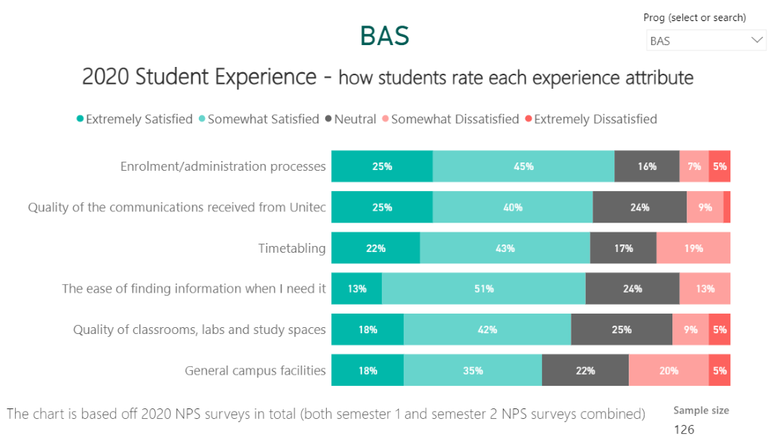

Resource Area | Quality rating for each of the following based on the KEQ 5 Rubric  Excellent, good marginal or poor | Comments on rating and actions taken in 2020 (including SMART goals) | Comments on new actions identified
Physical Resources (e.g. IT, facilities, materials) | Good | Staff quickly set up for working from home. | Recording equipment to record lectures
Use and value of SEATS | Marginal | Staff did not manually enter seats data during lockdown. | Re-train staff on SEATS in 2021
Timetabling | Marginal | Timetabling can negatively impact attendance for students who are working/parents | Record lectures for students to access via Moodle
Staffing Resources | Excellent | The team is fully staffed with all staff in workload as per the workload model. One staff member received an excellence award in 2020.
Management Resources (e.g. FTE for PCs, APMs, HOS) | Good
Net Promoters Score | Good
Staff Engagement Score | Excellent | This has improved from 2019 with the highest staff engagement score ever in our school 85%
Strategies (Manaakitia Te Rito, Te Noho Kotahitanga, Maori Success, Pacific Success, under 25 Success, International Success) embedded in programme | Good | Staff are engaging with strategies, with some developments identified especially in embedding Māori success strategy to continue to improve SCC
Use of data to drive decisions and development | Good | SCC, CEPs and Moderation data are well used by the team to identify gaps and set goals.

KEQ 6: How effectively are important compliance accountabilities managed?
Indicative evidence sources:
Moderation Plans | 5-year and consistency review
SMART Goal tracking | EER feedback
CEP completion (dashboard completion rate) | ADEPS
PAQC meeting notes | Risk Register
Badging Completion

Educational Performance Rubric Guidance
Excellent | Quality Rating  - 95 – 100% tasks completed in time  - Feedback positive and minimal risks or recommendations made  - Comments in moderation, CEPs, PAQC reports are evaluative  - All actions from moderation, ADEPS and CEPS, monitoring or reviews are identified and goals are SMART (where relevant)  - All actions moved into workplan with clear owners and/or completed on time
Good | Quality Rating  - 75 – 94% tasks completed in time  - Feedback mostly positive and some risks or recommendations made  - Comments in moderation, CEPs, PAQC reports are mostly evaluative  - Most actions from moderation, ADEPS and CEPS, monitoring or reviews are identified and goals are SMART (where relevant)  - Most actions moved into workplan with clear owners and/or completed on time
Marginal | Quality Rating  - 60 – 74% tasks generally completed in time  - Some positive feedback but some risks not managed, and recommendations require action  - Comments in moderation, CEPs, PAQC reports are mixed, some evaluative and some gaps  - Some actions from moderation, ADEPS and CEPS, monitoring or reviews are identified  - Few actions moved into workplan with clear owners and/or completed on time
Poor | Quality Rating  - 59% and below of tasks completed on time and many outstanding  - Feedback highlights clear gaps, key risks not managed and significant recommendations made  - Comments in moderation, CEPs, PAQC reports are incomplete or not evaluative  - Significant actions from moderation, ADEPS and CEPS, monitoring or reviews required  - Minimal evidence of workplans or owners of actions

SUMMARY
The rating of educational performance for focus area five is Excellent / Good / Marginal / Poor. [Choose one] This is made due to [Statement 1], [Statement 2] and [Statement 3].

Compliance Area | Completion Rating  Estimate  (%) | Rating based on the KEQ 6 Rubric  Excellent, good marginal or Poor | Comments on rating and actions taken (where relevant) | Comments on actions required
Internal Pre-moderation (CEP Sem 2, B3) | 100% | Excellent | Moderation improved significantly in 2020 with clear feedback and comments provided
Internal post-moderation | 100% | Good | All completed but more detailed comments required and themes identified | Increase feedback in post-moderation forms
External moderation | 100% | Good | Team has caught up on external moderation and acted on feedback
Storage of summative assessment | 80% | Good | Some assessments still to be uploaded to H drive | Follow up with relevant staff before Feb 2020
ADEPS | 70% | Marginal | ADEP processes behind schedule due to COVID | Ensure all 2021 ADEPS completed on time. Team day identified
Badging | 80% | Good | All staff completed Te Noho Kotahitanga badge but only 80% completed 2 badges | To complete badges in team environment
International Code of Practice | 100% | N/A | No international students in 2020
CEPS (Completion and evaluative engagement on CEP dashboards) | 82% | Marginal | 100% completion in Semester 2, but not Semester 1. Some developments required in adding relevant detail to CEPS | To complete in team environment and contact TKK for additional training
SMART goals completed | 90% | Good | Goals around moderation and IAC completed.  Tracker goals not 100% completed
Risk Register Maintenance | 70% | Marginal | Risk register maintained but still some issues outstanding
PAQC operation and reporting | 75% | Marginal
Monitor’s visits | 100% | Excellent | Positive visit only 2 recommendations
Industry Accreditation (as relevant) | N/A
Consistency or 5 Year Programme Review (as relevant) | N/A
Literacy Numeracy Assessment Tool completed (where relevant) | N/A

The APM supports that the programme is being delivered as planned in regards to
Compliance Area | Check Y/N
Moderation Planning | Y/N
Learning Hours | Y/N
Graduate Profile Statements | Y/N
The Programme Document | Y/N (review required)
Course Descriptors | Y/N

Table 1: SMART goals current and new
The table below is to be pre-populated with your programme PAQC SMART goal summary (PAQC workplan) in collaboration with your PAQC secretary. If a new SMART goal is required, add the new SMART goal using the numbering format EoY 2020 - 1, EoY 2020 – 2 etc
Resources for writing SMART goals: https://www.atlassian.com/blog/productivity/how-to-write-smart-goals .

PEP Year - Action number | A goal should be linked to one issue or gap and the relevant KEQ/s.    What problem/issue needs addressing? |  | There should be clear tasks or actions you can take to make progress toward a goal.    What specific actions and specific steps need to be accomplished in order to achieve goal resolution? Is each step achievable and relevant? | A goal should be something you can track and measure progress toward.    The action will be considered successful when...  What measurable outcomes are you expecting to result from your proposed actions at each step? | A goal should be clearly assigned to a person and role.    Who specifically will be the individual  responsible for monitoring and reporting progress? Who will also be working on these actions? | A goal should have an end date. (ongoing is not an end-date)    When will steps in progress be reported? | What specific actions and steps have been achieved against the goal at the reporting date?
EoY 2020 - 1 | KEQ 1 Low SCC% for some courses.  KEQ 3 Student (course surveys) and lecturers have recurring issues with difficult assessments late in some courses. |  | Implement low-stakes assessment for AB1002, 1009 and AB 1110  - Add to moderation plan  - Write assessments  - Pre-moderate assessments  - Implement assessments | Moderation plan updated  Pre-moderation approved  New assessments Implemented  Post-moderation approved  Moderation plan updated | Lead A Jones – APM  Designer M Smith –Lecturer  Moderator J Ducati -ASM | Design complete 20/03/21  Moderation complete 20/04/21  Implemented 1214  Post moderation 20/08/21
 | Māori SCC KEQ1, KEQ3 |  | Embedding Mātauranga Māori in three of our Level 5 courses during Semester 1 2021.  - Identify courses  - Work with Kaihautū  - Redevelop material  - Pre-moderate assessment changes (where relevant) | Mātauranga Māori is embedded in these courses  Māori SCC increases | Lecturer for xxxxx | Identification of Courses – Complete  Work with Kaihautū – Feb 2021  Redevelopment – Feb 2021  Pre-moderation – Feb 2021 | The three courses were identified at the Āta Kōrero  ADxxx  ADxxx  ADxxxx
 | Māori SCC | Completion of the Te Tipare Badge for the whole team  - Te Tipare Workshop  - Team day for badge completion  - Submission of badge |  | Badge is completed  Māori SCC increases | Whole team | Te Tipare Training - 1 Apr 2021  Team Day for completion – 31 May 2021  Submission by – 10 June 2021
 | Student Engagement and SCC KEQ1, KEQ4 | Recording of lectures for later access on Moodle  Identify recording process  Purchase equipment  Train staff  Record |  | All lectures available on Moodle  SCC increases | APM  Whole team | Recording process identified  Jan 2021  Equipment – Jan 2021  Training Staff – Feb 2021  Recording – Semester 1 2021 and beyond
 | Course SCC AD5004 | Review the course with the support of Te Puna Ako  Meet with Te Puna Ako  Redevelopment  Course Changes (if required) |  | The course is redeveloped  SCC for this course improves | AD5004 lecturer | Te Puna Ako meeting – March 2021  Redevelopment – Sem 1 2021  Delivery – Sem 2 2021

PAQC review of the PEP report
The PEP is reviewed by the PAQC when the following questions are discussed with the decisions are minuted.
 | ACHIEVEMENT  Discussion prompts: Do the ratings given reflect a degree of reasonableness for the programme? Does the PAQC know of further evidence, not cited in the report, that supports or contradicts the ratings? What area(s) does the programme need to focus on in order to improve educational performance in student achievement in 2021?
 | Decide: The PAQC has confidence through its analysis of the PEP that the ratings and the narrative given for each KEQ are (select  one of the following):  ☐accurate with no changes to ratings and narrative  ☐accurate with no changes to ratings and only minor changes to the narrative as agreed by the PAQC. These minor changes will be undertaken before submission to the QAB.  ☐accurate with changes to no more than one rating and minor changes to narrative as agreed by the PAQC. These changes will be undertaken before submission to the QAB.  ☐required to be reviewed with more analysis, research and/or rework before resubmission to the PAQC  ☐not applicable due to [Add reason]  Summary comments or agreements made:
SMART GOALS
Discussion prompts: What progress does this PEP evidence toward the completion of SMART goals set previously? What reasons are known for any delays? Are there any suggested refinements to the SMART goals for the next period going forward?

Progress on previous goals
Decide: The PAQC can confirm the current SMART goals have had activity toward completion and/or delays have been explained and the achievement to date is (select  one of the following):
☐accurate with no changes required☐accurate with minor changes as agreed by the PAQC. These minor changes will be undertaken before submission to the QAB.
☐required to be reviewed, with research or rework and then resubmitted to the PAQC
☐not applicable due to [Add reason]
Summary comments or agreements made:

New goals set
Decide: That the PAQC has reviewed the new SMART goals for this PEP and confirms that they are (select  of the following):
☐valid SMART goals with no changes required
☐valid SMART goals with minor changes as agreed by the PAQC. These minor changes will be undertaken before submission to the QAB.
☐Required to be reviewed with further research or rework and then resubmitted to the PAQC
☐Not applicable due to [Add reason]
Summary comments or agreements:

SELF-ASSESSMENT CAPABILITY
Discussion prompts: How well has the programme team demonstrated its capability in self-assessment in determining educational performance? Use the attached criteria in Appendix B - Capability in Self-Assessment Rubric to provide a rating.

Decide: The rating of Excellent/Good/Marginal/Poor. [Choose one] is made due to:
- [Reason 1 from the criteria list]
- [Reason 2 from the criteria list]
- [Reason 3 from the criteria list]
- [Reason x from the criteria list]

Other narrative as applicable e.g. The PEP has one criterion from Appendix B that is excellent, four criteria (List) that are good and one criterion that is Marginal. This is why a rating of Good has been given.

Electronic submission of this report to QAB@unitec.ac.nz shall be considered as the final version.

Appendix B - Capability in Self-Assessment Rubric
Rating | NZQA criteria | Unitec criteria for 2020 EoY PEP
Excellent | - Self-assessment is exceptional and comprehensive  - Strong evidence of improved outcomes brought about by self- assessment activities  - Very few gaps or weaknesses  - Any gaps and weaknesses have no significant impact and are managed very effectively | - All sections of the PEP have been completed  - Ratings are made for each KEQ with justification supported by the rubric  - Where applicable analysis has been made against the recommended benchmarks provided, with reasons  - Sufficient evidence is provided for each KEQ  - Shortcoming in evidence have been explained  - Te Noho Kotahitanga Principles underpin all KEQ discussions and these are explicit in the narrative  - Trends are analysed in KEQ 1 and 2  - Margin of error in KEQ 2 is identified and discussed in depth  - Actions previously taken clearly link to outcomes or processes for each KEQ and have shown a positive impact  - Reference to I See Me is included in KEQs where relevant (especially, KEQ 1 and 3)  - Identified gaps in outcomes or process clearly link to the KEQ and are minor  - All SMART goals related to the KEQ have been actioned or addressed throughout the year with outcomes or changes recorded  - Goals that are not SMART are rewritten  - New SMART goals are identified that are clearly linked to the KEQ performance or process
Good | - Self-assessment is generally strong and comprehensive  - Evidence of improved outcomes brought about by self-assessment activities  - Few gaps or weaknesses  - Gaps or weaknesses have some impact but are mostly managed effectively | - All sections of the PEP have been completed  - Ratings are made for each KEQ with justification supported by the rubric  - Where applicable, analysis has been made against the recommended benchmarks provided, with some reasons.  - Sufficient evidence is provided for most KEQs  - Shortcomings in evidence have been identified with some explanation  - Te Noho Kotahitanga principles underpin most KEQ discussions and these are explicit in the narrative  - Trends are identified with some analysis in KEQ 1 and 2  - Margin of error in KEQs 2 is identified and with some discussion  - Actions previously taken generally link to outcomes or processes for each KEQ and have shown some positive impact  - Reference to I See Me is included in KEQs where relevant (especially, KEQ 1 and 3)  - Identified gaps in outcomes are process generally link to the KEQ  - SMART goals related to the KEQ have mostly been actioned throughout the year with outcomes recorded  - New SMART goals are identified that link to the KEQ
Marginal | - Self-assessment is inconsistent in quality and coverage  - Limited evidence of improved outcomes brought about by self- assessment activities  - Some gaps and weaknesses have some impact, and are not managed effectively | - PEP sections generally completed, with some information missing  - Ratings are made for each area, but may be inconsistent, for example the reasons for the rating is not clear or the rating given does not match the evidence  - Not all applicable areas are analysed against the recommended benchmarks, or reasons for analysis may not be given, or be inaccurate  - Some KEQs may lack evidence  - Shortcomings in evidence may not be explained or addressed  - Te Noho Kotahitanga principles are referred to inconsistently and may underpin some discussions but not others. Not explicit in the narrative  - Trends may be identified in KEQ 1 or 2, with limited analysis  - Margin of error in KEQ 2 is identified  - Actions previously taken may be described but not always clearly linked to outcomes or processes for each focus are, or may not show a positive impact  - Limited references to I See Me, especially in KEQ 1 & 3  - Gaps in outcomes or process may not be consistently identified or consistently linked to KEQs and have clear impact on outcomes  - SMART goals related to the KEQ may be inconsistently referred to and/or inconsistently actioned (e.g. some actioned, some not)  - Some new SMART goals missing, or goals not consistently linked to the KEQ performance or process
Poor | - Self-assessment is generally ineffective or weak  - No or minimal evidence of improved outcomes brought about by self- assessment activities  - Significant gaps or weaknesses have significant impact, and are not managed effectively  - Does not meet minimum expectations or requirements | - PEP sections have large gaps and missing information  - Ratings are not made for each KEQ or have minimal relationship to their rubric  - No analysis made against the recommended benchmarks  - No or very limited evidence provided  - No explanation or analysis of shortcomings of information including margin of error  - No reference to Te Noho Kotahitanga Principles in discussion  - Actions previously taken are not clearly described, or assessed against outcomes or processes for each KEQ, or have not shown positive impact  - No reference to I See Me  - Gaps in outcomes or process not identified or not linked to the KEQ and have clearly impacted outcomes  - Previous SMART goals related to the KEQ missing, or consistently not actioned , or outcomes not recorded  - New goals not identified, or not linked to KEQs performance or process

If you do not work to semester dates you may like to use Power BI to look at data from your last completion round and comment on this and other evidence e.g. assessment data to date, or current course completions to comment on overall predicted SCC. Additionally, if you have a lot of deferrals due to COVID, you may like to compare your full results (Including deferrals) with results showing these deferrals removed; this may give a greater indication of predicted SCC)
Refer to data from Power BI Course Summary – Semester and filter for 2018, 2019 & 2020

