Employer Survey for Programme or Consistency Reviews

**Instructions**

This is a suggested survey template to be sent to employers of Unitec graduates. The questions are designed to provide programme data and evidence for consistency and 5-year reviews.

The key area that requires input is the Graduate Profile Outcome (GPO) statements. Rather than just copy straight from the programme document, these need to be reviewed and potentially modified so that they are easy to understand for a survey respondent and are clearly stating one skill per statement.

Given that programme managers know their programmes best and what key skills their graduate should have, we require programme manages to attempt to draft the GPO statements first and send to [tkkinsights@unitec.co.nz](mailto:tkkinsights@unitec.co.nz) who will provide assistance in finalising the statements and overall survey.

Once the survey is finalised, this is to be sent to Industry Partners team to build and send out through their Industry CRM tool.

**Suggested Email Invite**

Kia ora,

This email has been sent to you because we want to get feedback on Unitec [Programme Name] graduates that may be at your organisation.

This is a short survey (2-4 mins) and the responses that you give will help us improve our programmes and ultimately improve the quality of our graduates entering your industry.

Unitec strictly adheres to the Research Association of New Zealand (RANZ) code of conduct and as such, all responses will be treated confidentially.

Please click on the link below to begin

[LINK]

[Name]

[Role]

Unitec Institute of Technology

**Suggested Survey**

Thanks so much for your time, it's very much appreciated. This survey will take 2-4 mins depending on your answers.

The information you provide is completely confidential, won't identify individuals and will only be used to ensure our programmes are meeting the needs of employers.

Q1 Firstly, do you have, or have had, Unitec [Programme Name] graduates at your organisation?

* Yes (1)
* No (2)
* Don’t know

IF No or Don’t Know, Skip to Q6

Q2 Approximately how many Unitec [Programme Name] graduates do you have at your organisation?

* 1 to 2 (1)
* 3 to 4 (2)
* 5 to 10 (3)
* More than 10 (4)
* Don't know (5)

Q3 What positions do these graduates hold in your organisation?

________________________________________________________________

________________________________________________________________

________________________________________________________________

Q4 Please rate the Unitec [Programme Name] graduates on the following statements using the 5-point scale below.

You should consider graduates abilities **in their first year** after they have settled into their work (i.e. after their first few months). Some graduates may vary in their performance and we invite you to elaborate on your answers in the subsequent open-response question.

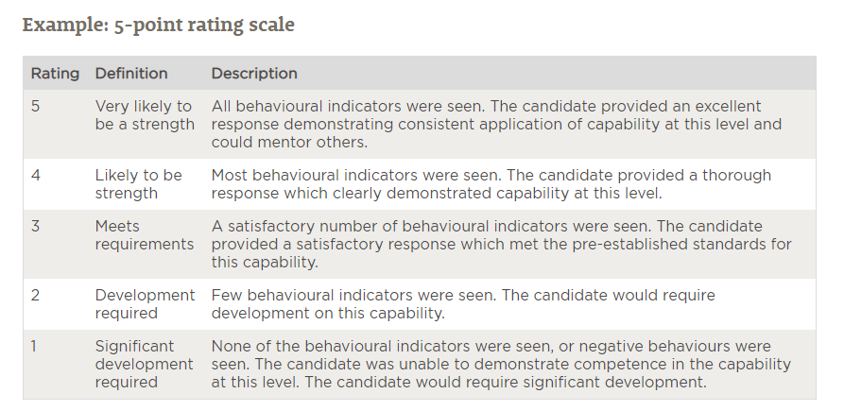

|  |  |  |  |  |  |  |
| --- | --- | --- | --- | --- | --- | --- |
| GPO related statements  (need to be in plain English and clearly state one skill per statement only) | Very likely to be a Strength | Likely to be a Strength | Meets Requirements | Development Required | Significant Development Required | Don't know/Not applicable |
| Examples ONLY  Have good knowledge of their area of construction | 🌕 | 🌕 | 🌕 | 🌕 | 🌕 | 🌕 |
| Can work effectively with specialists from other construction areas | 🌕 | 🌕 | 🌕 | 🌕 | 🌕 | 🌕 |
| Can effectively assess the feasibility of projects and operations | 🌕 | 🌕 | 🌕 | 🌕 | 🌕 | 🌕 |
| Can produce and communicate quality outcomes | 🌕 | 🌕 | 🌕 | 🌕 | 🌕 | 🌕 |
| Can work in a multi-disciplinary team and manage differing expectations of stakeholders | 🌕 | 🌕 | 🌕 | 🌕 | 🌕 | 🌕 |
| Can apply business systems and processes in their role | 🌕 | 🌕 | 🌕 | 🌕 | 🌕 | 🌕 |
| Can appreciate the legal and economic contexts of projects | 🌕 | 🌕 | 🌕 | 🌕 | 🌕 | 🌕 |

Q5 If you would like to elaborate on your responses to any of the statements, please enter your comments below.

________________________________________________________________

________________________________________________________________

________________________________________________________________

Q6 We want to make sure the skills and knowledge that our Unitec [Programme Name] graduates are learning are relevant to your industry.

How relevant are each of these skills and knowledge in your organisation?

Graduates that have:

|  |  |  |  |  |  |
| --- | --- | --- | --- | --- | --- |
| GPO related statements  (need to be in plain English and clearly state one skill per statement only) | Highly Relevant | Quite Relevant | Somewhat Relevant | Not Relevant | Don't know/Not applicable |
| Examples ONLY  Good technical and applied knowledge of construction | 🌕 | 🌕 | 🌕 | 🌕 | 🌕 |
| Work effectively with construction specialists | 🌕 | 🌕 | 🌕 | 🌕 | 🌕 |
| Good judgements about the feasibility of projects and their operations | 🌕 | 🌕 | 🌕 | 🌕 | 🌕 |
| Quality outcomes and clear communications | 🌕 | 🌕 | 🌕 | 🌕 | 🌕 |
| Work in multi-disciplinary team and managing differing expectations | 🌕 | 🌕 | 🌕 | 🌕 | 🌕 |
| Apply business systems and processes in their role | 🌕 | 🌕 | **🌕** | 🌕 | 🌕 |
| Appreciate the legal and economic contexts of projects | 🌕 | 🌕 | **🌕** | 🌕 | 🌕 |

Q7 What types of skills (technical and soft skills) would you like graduates to have when they enter your industry?

________________________________________________________________

________________________________________________________________

________________________________________________________________

Q8 Finally, what changes or improvements would you like to see made to Unitec’s [programme name] going forward?

________________________________________________________________

________________________________________________________________

________________________________________________________________

THANK & CLOSE