TEAMS 1

TEAMS vs SKYPE vs ZOOM vs SHAREPOINT vs ONEDRIVE 2

COEXISTENCE OF SKYPE 3

CALLING: 4

CHANNELS: 4

PLANNER 4

TRAINING 5

FILES 5

CHAT 6

# TEAMS

* **Can I use Teams on my personal device?**
  + Yes, you can log in at [www.Teams.microsoft.com](http://www.Teams.microsoft.com) with your Unitec email address and standard password.
* **I signed out and now I cannot get back in to Microsoft Teams?**
* Use the web browser to sign back in to Microsoft Teams, and not the desktop app if working remotely
* Maybe use Google Chrome or Firefox, as Internet Explorer may not work, depending on version
* **Can I add someone to a team who is from outside my organisation or not a member of my department or normal work group?**
* You can search for and add someone from the directory from all across Unitec
* Guests from outside the organization can be added to a team. Request to add a guest through the Service Desk.
* **Can we invite people to a team for only a limited time, say 1 week?**
* Yes, but they will have to be removed manually, there is no way to automate this.

**Will we be linked to the other subsidiaries?**

* Yes, once our rollout is complete, we can look at becoming Federated with other subsidiaries.

**When is migration happening?**

* We are running three Pilot groups over July and early August and the rollout is schedule for 17th August. People will be invited to training and emailed instructions on how to download and access Microsoft Teams.

# TEAMS vs SKYPE vs ZOOM vs SHAREPOINT vs ONEDRIVE

**Is Teams replacing Skype?**

* Yes, Teams will replace Skype for Business. Zoom will still be used for Teaching online classes.

**What is OneDrive for?**

* OneDrive is your personal drive. You may upload files from OneDrive to Teams if you wish to share and collaborate on them. No one has access to your Personal OneDrive.

**Are our H: Drives going to be on SharePoint?**

* Once Teams is rolled out, the next project is to migrate the H: drives etc onto SharePoint online. The advantage of this is that you will be able to access these files through Teams directly.
* **Each Team site is built on a SharePoint platform – how secure is SharePoint?**
* SharePoint is stored in the cloud and is encrypted and backed up by Microsoft. However, basic site security, admin and external sharing will be governed by Unitec.
* **MIT use Teams for teaching. Is this something we need to anticipate moving our online teaching on? If so, could you please share how this could be used. Is there a video platform?**
* Zoom will be used for Teaching at Unitec.
* Teams for teaching is something we will be working with Te Puna Ako on next year, but it will depend on how much they want to roll this out.
* **With this replacing Skype, for those of us where Skype is a nightmare when you are not working on Unitec sites (home or other places) is it more stable that Skype?**
* Yes, it is more stable than Skype as it compresses the files far more than what Skype does meaning it doesn’t use as much of your home wifi bandwidth

# COEXISTENCE OF SKYPE

* **Can I share my screen with someone who is on Skype, or can a Skype user share their screen with a Teams user?**
* No, desktop sharing is not possible between the two applications. Instant messaging, voice and video calls will continue to work as normal.
* **Can I call someone at Unitec that is still on Skype?**
* Yes, you can make calls just like you did before you were upgraded to Teams
* **Can I still call a landline/cell phone once Teams has been installed?**
* Yes, if you were able to make external calls before you were migrated to Teams, you will still have that capability.
* **What happens when I book a meeting via Teams with someone who is on Skype?**
* When they click on the link to join the online meeting, their internet browser will start up and they will be presented with options similar to the menu below.

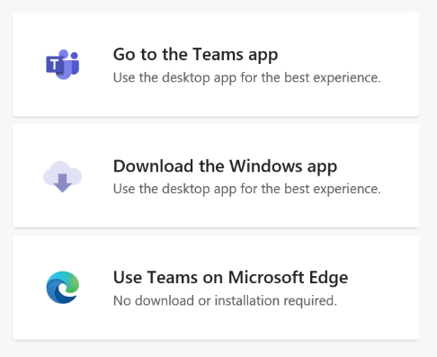

We recommend that non-teams participants join your meeting via the “No download of installation required” option, which will then user their Internet Browser to join the meeting.

* **What happens if I have been migrated to Teams but get a Skype meeting request?**
* When you click on your meeting link you will be prompted to join the online meeting via your browser.
* **Teams has been installed, but I still have the Skype Icon – which one should I use?**
* If you accidently click on your Skype icon, you will be directed to use Teams.

* **Can I dial in via a landline or cell phone to a meeting?**
* This feature has been restricted and will be assigned on a case by case.

# CALLING:

* **How can I make a group call? is there a feature like that in Teams?**
* Go to the Calls view and select the purple button to create a New Group, type in a name for your group.
* Your group will be listed. Go to the three dots to the right of your group and select the option to ‘Add a contact to this group’.



* **When my headset is plugged in & I’m not wearing it, if someone calls me I can’t hear the phone ring. Can this be fixed?**
* As long as your machine has external speakers, (i.e. iMac, Laptop etc.) when Teams running, right click on the Teams Icon in your Task Bar, select ‘**Settings’** and then ‘**Devices’**. Under ‘Secondary ringer’, select the appropriate sound device from the drop down list.

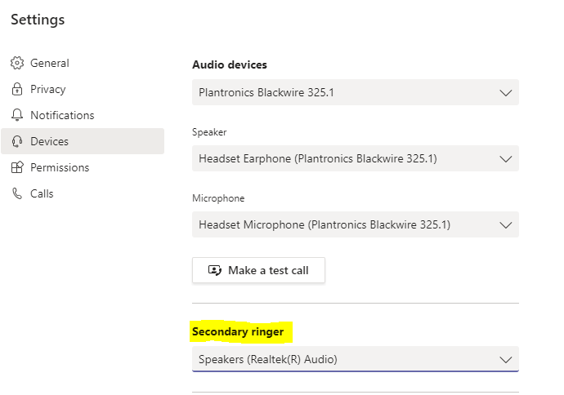

# CHANNELS:

* **Can Channels created get archived if not desired to be used anymore?**
* Yes, definitely. They can be archived and hidden from view if they are no longer relevant.
* **How can I create a channel?**
* View who is the owner of your Team and ask them to create a channel for you.
* Go to the three dots beside the Team name and click ‘Manage Team’ to see who your Team site owners are.
* You can also create a private channel within a team, with a selected number of members and share information that others cannot access. The private channel is locked and files are kept separate from the main team.
* **Can you create a channel within a channel like a folder?**
* Inside each Channel is a Files Tab. Inside the Files Tab you create a folder structure if required.
* **Is the General Channel just for the Team, or for all of Unitec staff?**
* The General Channel is just for that Team

# PLANNER

* **Can the Planner data be downloaded to a spreadsheet format?**
* No
* **How many people can be allocated a Task in Planner?**
* A maximum of 11 people can be allocated the same task in Planner
* **Can one person be allocated every task in a Planner?**
* No, Tasks must be allocated on a one by one basis.

TRAINING:

* **Where can I access training information.**
* Go to the bottom left icon Help icon in Teams and view options by Help Topic or click the ‘Training’ option for further video resources.
* Training videos and material are available on the Nest and if you wish to go deeper into Microsoft based training, click [here](https://docs.microsoft.com/en-us/microsoftteams/enduser-training) - <https://docs.microsoft.com/en-us/microsoftteams/enduser-training>
* **Is there training available?**
* Yes, training sessions can be arranged to run via Skype. A trainer will help run through tips and tricks on using Teams. Check out timings for training on Nest.

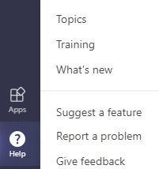

* **What's the timeframe for moving from SFB to Teams? All staff will need to be trained.** 
  + Yes, the rollout date is planned for 17th August and all staff will be offered training and support.

# FILES

* **Should we store files in Teams?**
* Yes, documents that relate to the Teams Group can be stored within Teams, but please note that confidential/official documents remain in your H: Drive repository for now.
* **If someone leaves a Team, does that impact the files that person has shared with the Team**
* No, any files uploaded into Teams become shared by everyone in that Channel
* **OneDrive, H:Drive, Teams, SharePoint… which drive should I use?**

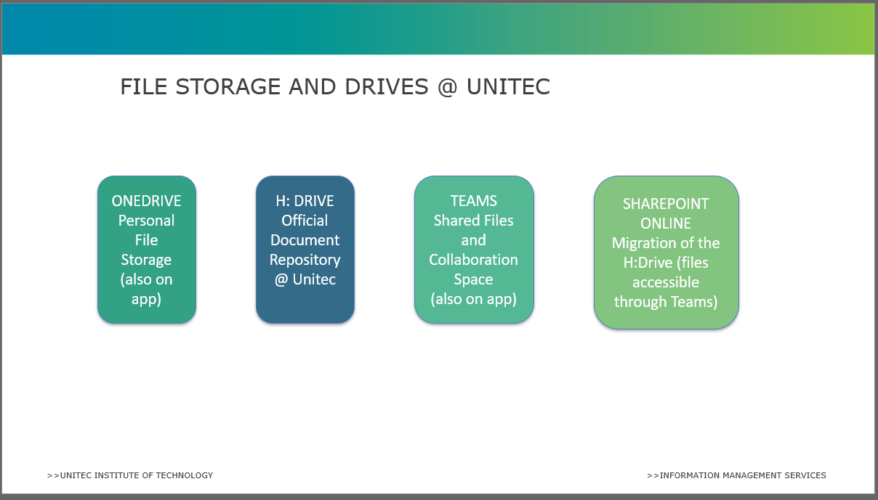

# CHAT

* **Can we share Files in Chat**
* Yes, files shared in Chat are independent of any Team
* **Can we tell if someone has seen our Chat message?**
* Yes, there is an ‘eye’ icon to show that the message has been seen.
* **Can we email a chat conversation?**
* No, you can’t. You can take screenshots and share.