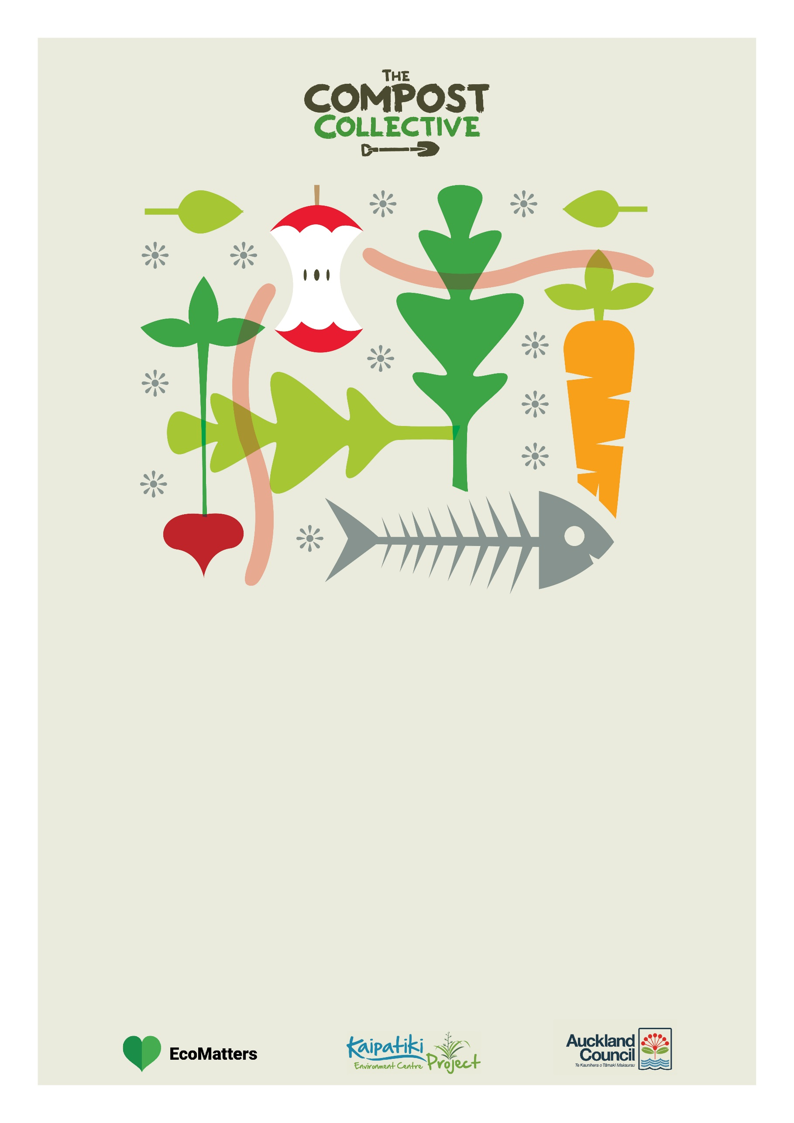

**UNITEC INSTITUTE OF TECHNOLOGY**

**Venue:** 139 Carrington Road, Mt Albert, Room 170-1015

**Date**: Wednesday, 12 August **Time:** 12:00-1:00 pm

**Register here**: <https://compostcollective.org.nz/events/composting-basics-mt-albert/>

**This workshop will cover 3 home composting systems, come along to find out which one suits yours best! ☺**

**All participants will be offered; a $40.00 discount coupon**

COLD COMPOST - BOKASHI – WORM FARMS

**HOME COMPOSTING SYSTEMS OVERVIEW**