Meet the Te Puna Ako team:

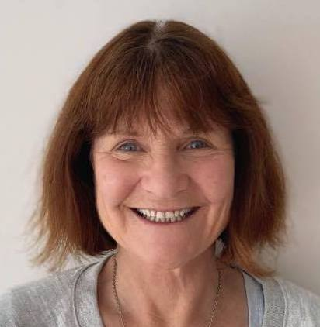 | Anne McKay Academic Advisor  Liaison: Healthcare and Social Practice |  |  |  | Working with teachers to design and facilitate teaching and learning is a real interest for me. I really enjoy working alongside teachers and learning with them as we develop teaching ideas that engage students in the learning process and developing authentic and relevant ways of assessing. The opportunities to collaborate and work with Maia and the Pacific centre continue to grow my understanding of culturally responsive pedagogy. My particular areas of interest are with assessment and feedback and considering ways of growing learners’ agency in both these areas.
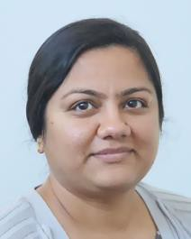 | Abha Chitalia Academic Advisor  Liaison: Computer Science |  |  |  | In my role as an Academic Advisor, I enjoy working with teachers in developing courses with an all-inclusive approach towards providing students with the wide array of skills necessary to succeed in life, and a rich environment that brings a culturally diverse approach to classroom interaction. My areas of expertise include assessment and moderation, including unit standards.
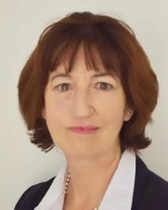 | Diana Ayling Academic Advisor |  |  | I hold a special interest in teacher education and enjoy mentoring and coaching teachers to reach their full potential. I am interested in helping you solve your problems in teaching and learning with the use of quality information and data. I can help you manage teaching and learning projects to ensure the best possible outcome for your team.
 | James Oldfield Digital Learning Lead |  |  | I am particularly interested in the effect of mobile BYOD devices on the student learning experience. My preferred teaching style is based upon constructivist pedagogies, and I have a passion for helping others to create engaging learning experiences for their students.
 | Karen Haines Academic Advisor  Liaison: Community Development |  |  | I enjoy working with teachers to actively develop and reflect on good teaching and learning practices, including face to face and blended learning. My passion is for supporting classroom and online environments where students feel valued and are engaged actively and collaboratively in learning processes.
 | Lisa Simperingham Academic Advisor  Digital Learning  Tools: Turnitin, Moodle, SEAtS  Liaisons: Language Studies,  Bridging Education |  |  | In my role as eLearning Capability Developer, I support staff in developing their skills, and helping them make best use of various technologies for their pedagogical outcomes. My aim is to be both teacher and student focused, providing optimal solutions for both parties. I particularly enjoy the “aha” moments when small learnings make a big difference. My TCD area of expertise is Collaborative Learning.
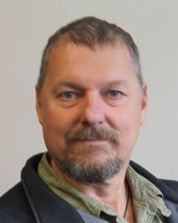 | Malcolm Hay Academic Advisor  Digital Learning  Liaison: Engineering |  |  | My industry background is in Construction and Structural Engineering. During my 12 years teaching before coming to Unitec, I became passionate about the role technology would play in the future of education.  My role at Te Puna Ako is to assist in the meaningful implementation of technology and software in everyday teaching whether it is face to face or online. My specialties are Moodle, Video Conferencing and, to a lesser extent, Echo 360 as well as hardware and connected devices.
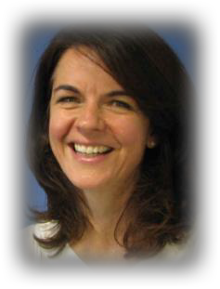 | Maura Kempin Te Puna Ako Manager |  |  | I am passionate about designing applied and authentic leaning experiences to help prepare students holistically for the challenging world of work and employment. In my role as Academic Advisor, I enjoy working with colleagues to develop programmes and courses which advance progressive pedagogy to deliver good student outcomes.
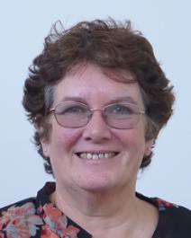 | Maureen Perkins Academic Advisor  MyPortfolio Support  Tools: MyPortfolio, Moodle, TurnitIn  Liaisons: Architecture  Creative Industries,  Ako Ahimura Mātauranga Māori |  |  | I enjoy providing teaching staff with personalised professional and course development support. My focus is on ensuring that all students experience carefully planned, personalised (and fun) face to face and digital learning environments that provide positive outcomes. I have been involved in adult teaching for several decades in various settings and love to work with others to creatively solve problems. I love using technology – but only where it actually makes a difference. I enjoy working with Moodle, Turnitin, and MyPortfolio and helping others to develop the amazing potential of these tools. Most of all I enjoy the learning that I do alongside the teachers I work with.
 | Quentin Williams Academic Advisor  Liaison: APL |  |  | I have done quite a lot of course development across a wide range of disciplines, from programme writing through to resource design. Instead of having a liaison role with a specific pathway, I work across all pathways at Unitec to support assessment of prior learning (APL/RPL) and work-integrated/Work-Based Learning.
 | Sarah Kirk Academic Advisor  Digital Learning  Tools: Echo360, MyPortfolio  Liaison: Applied Business |  |  | I relish the opportunity to work alongside teachers to develop engaging, personalised learning experiences. Problem-solving with fellow educators to develop technology-based solutions that enhance learning is one of the highlights of my role. In particular, I am curious about how technology allows for new learning tasks not previously possible and how this might positively impact learning outcomes. As the resident Echo360 Champion I support teachers using this active learning platform.
 | Treena Brand Academic Advisor  Liaisons: Environmental Animal Sciences  Construction |  |  |  | I love all aspects of learning. I especially enjoy the collaborative nature of working within a group and recognize that effective teams are built on a high trust model. Having a growth mindset plays a large part in how I approach problem solving. I enjoy digging into the ‘why’ of any project so that I can best understand how a problem might be solved creatively. I love the ubiquitous nature of working in a digital platform and the affordances that these tools offer, especially how they can unlock a student’s thinking to gauge their understanding with course content.
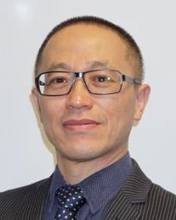 |  | William Lu eLearning Support  Moodle  Echo360 bookings | I believe in promoting best practice in the use of high-quality multimedia material and Web support to ensure students achieve their learning objectives and receive a positive and memorable experience. I am highly experienced in using Moodle within teaching environments and I am committed to assisting academic staff to deliver quality educational experiences to their students.
Director Ako Simon Nash  Manager, TPA Maura Kempin  Digital Learning Lead James Oldfield |  |  | TPA Events and Administrator Judith King  Moodle Support William Lu  APL/WBL Quentin Williams

