|  |  |
| --- | --- |
|  | Quick Start Guide |

[Unitec Moodle](https://moodle.unitec.ac.nz/)Accessing Moodle/Enrolling in Moodle:

You can access Moodle from [the Nest (our intranet)](http://thenest.unitec.ac.nz/?720EA0A8-9807-75AA-96FA-3BABDFD460E7) by clicking on the Moodle icon:

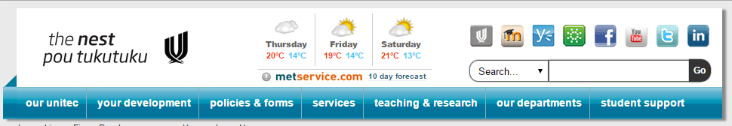

Or using the following web address: [http://moodle.unitec.ac.nz](http://moodle.unitec.ac.nz/)

To access remotely (offsite) navigate via the external Unitec site <http://www.unitec.ac.nz/> . Scroll to the bottom of the homepage, click the **Staff** link and choose the **Moodle** option.

|  |
| --- |
| **TIP:** Once logged in you may like to add a bookmark to your browser for easy access to a particular course |

Login details:

|  |  |  |
| --- | --- | --- |
| **New Staff:** | You will have received your Moodle login details (Username and default password) with the rest of your Unitec network login information.  Please note that changes to your network password will not change the Moodle password and vice versa. |  |
| **Existing Staff:** | Your username will be the same as your Unitec network login however please note that any changes to your network password will not have changed your Moodle password.  So if it has been a while since you accessed Moodle you may need to use the **‘Lost password?’** function. |

|  |
| --- |
| **TIP:** If you are not using a shared computer, you might like to check the ‘Remember username’ box. |

Once you clicked on Lost Password a new link will be sent to your Unitec email address to update your password.

Moodle: How to self-enrol in Education (Pastoral care of International Students) Code of Practice 2016

Please click on [Code of Practice Moodle quiz](https://moodle.unitec.ac.nz/course/view.php?id=6053) to access the Self Enrolment section

Please type “Code” – as per example below - the Enrolment Key is case sensitive

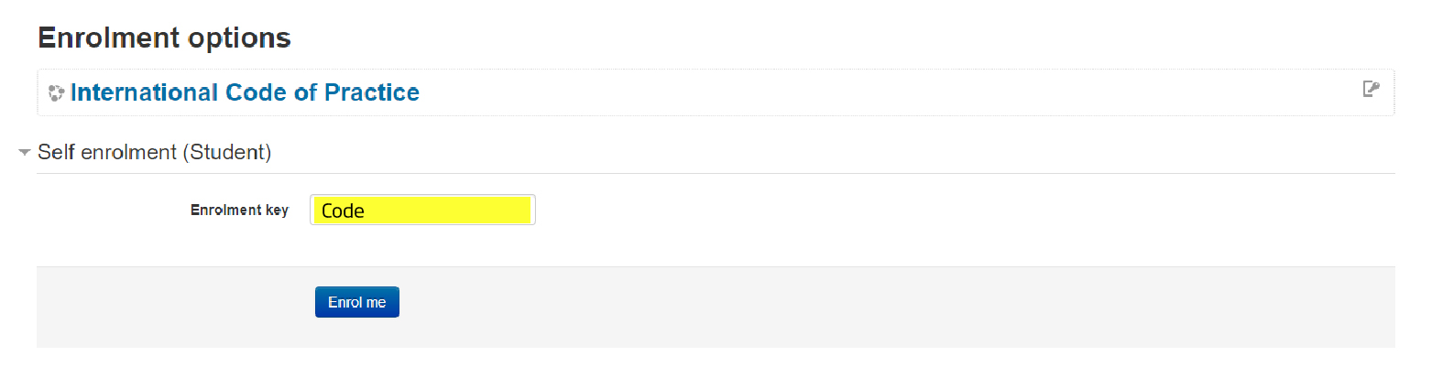

It should take you straight to the main page with resources and Code of Practice Quiz:

