# Self-rating

Once your team have gathered and reviewed the evidence, and completed your evaluative conversation, you will need to give a rating on how well you believe your programme is doing in terms of each KEQ. How well are you doing on student achievement, providing value on outcomes for stakeholders, offering student support and engaging them, matching needs in programme design and delivery, and being compliant, and how well are governance committees (PAQC to the Unitec Council) and management serving you?

Use the below rubric to rate your programme Excellent/Good/Marginal/Poor.

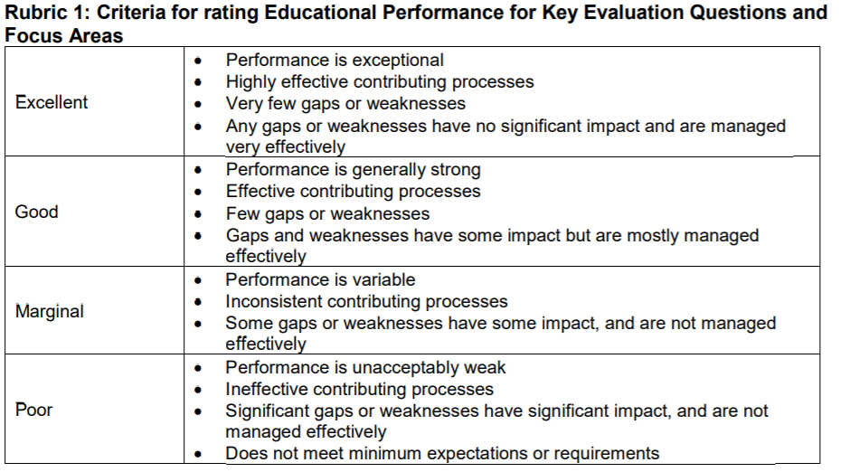

“Gaps or weaknesses” refers to those things that have emerged over the semester – or continue from the previous one – that are challenging the credibility, viability and/or effectiveness of the programme. For example, a Bridgepoint programme noted that many of their students were women with families and timetabling of lectures beyond 9am-3pm was affecting enrolment and attendance. Architecture noted that financial constraints meant staff were unable to keep conference and publishing standards crucial for ongoing status as supervisors of research theses, affecting their ability to support students. Other gaps or weaknesses emerge internally – teachers inexperienced in online education or in providing effective feedback on assessments, or students lacking basic skills in literacy and numeracy to successfully complete courses, etc.

“Managed effectively” refers to being able to demonstrate your ability to diagnose, understand, problem solve, and successfully address gaps or weaknesses that emerge. Something is “effective” when it is starting to show a positive outcome. You therefore need to be able to demonstrate awareness of implicit and overt sources for strength or weakness, the implications of those sources, and what you are doing and proactively planning toward resolution – however best that comes.

“Effective contributing processes” refer to those that you and/or others (eg Student Success) have put in place to keep the self-evaluative journey going across a semester or a year. How do you collect data – and how well and comprehensively do you do this? How skilled are you becoming as a team in understanding the factors affecting the success of your programme informed by sound evidence? How effectively are you addressing the goals you have set yourselves, and reviewing those?