Intranet Page Editor Guide – WordPress

**Table of Contents:**

1 Login and Setup 3

1.1 Dashboard 3

1.2 Screen Options 3

2 Navigating Pages 4

3 Finding pages 4

4 Using Media Library 5

4.1 Navigation 5

4.2 Adding to Media Library 5

4.3 Delete Media from Library 5

4.4 Replace Media 5

4.5 Add new Category 7

4.6 Delete a Category 8

5 Creating a new page 9

5.1 Adding Hyperlinks 9

5.1.1 Email address 9

5.1.2 Link to Documents or Files 9

5.1.3 Link to other Pages (or Posts) on Intranet 9

5.2 Adding Images 10

5.3 Edit a Hyperlink 10

6 Using Short Codes 12

6.1 Displaying All Category Content on a page 12

6.2 Finding the Category Code 12

7 Using TablePress 13

7.1 Table Options 13

8 Working with Images 15

9 Using Bookmarks and Page Jumps 16

9.1 How to Create WordPress Page Jumps / Bookmarks 16

9.2 The Link 16

9.3 The Target 17

9.4 Linking to Specific Spots on Other Pages 18

9.5 Linking to the Top of the Page 19

10 Event Manager 20

10.1 Creating an Event 20

10.1.1 Booking and registrations 20

10.1.2 Excerpts 21

10.1.3 Adding a Featured Image 21

10.2 Recurring Events 21

10.2.1 Editing a Recurring Event 22

10.3 Managing Bookings 22

10.4 Email Notifications 23

10.5 Export Booking Details 24

10.6 Online Documentation for Event Manager: 24

# Login and Setup

The URL for accessing the Nest Editing software for the LIVE site is:

<http://thenest.unitec.ac.nz/TheNestWP/wp-admin/>

1. Login with your unitec **username** and the default password provided.
2. Move cursor over avatar in top right corner
3. Click on **Edit My Profile** Scroll down and click on Generate Password
4. Type in **New Password**
5. Click **Update Profile**

## Dashboard

This is where you start when you first login in at <http://thenest.unitec.ac.nz/TheNestWP/wp-admin/index.php>

## Screen Options

The Screen Options allow you to choose which columns are displayed, or not displayed, in the underlying Table.

Clicking on the Screen Options tab (at top of screen) shows a list of the columns with a check-box next to each column. Check the box for each column you want displayed in the Table, or uncheck the box to not display that column. Click the Screen Options tab again to close the Screen Options. In addition, the number of Posts per page can be set.

# Navigating Pages

1. Click on **Pages**
   1. Note that we are using a plugin view that allows the children to be collapsed within parents.
2. Click on **Default Pages** to show the default view
   1. Note this view shows Author (e.g. Page owner)
   2. Also shows filters – Mine, Published, Drafts etc
3. Click **Nested View** or **All Pages** to return to the original view
   1. Note how this view has a drag and drop feature for organising order of pages (ADMIN only not Editors?)
4. 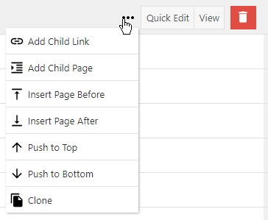Other options available are shown in image.

# Finding pages

You can use the **Search** function to find pages or some of the built in filters.

You can switch between **Default pages** and **Nested View** too.

**Default pages** view has a column that shows the Author of a page. It also has a ‘Mine’ filter to show pages that you are the assigned **Author** of.

# Using Media Library

The Media Library is where all images and attachments (PDF, DOC, PPT), that you may wish to include in your page, must be uploaded to.

## Navigation

1. Click on **Media**
   1. This opens the **Media** **Library**
   2. Note default is all media items
   3. Note default is **Grid** view > click  to show **List** mode
   4. Use **Filters** - Media types, dates and Category.
   5. **Search** for names/titles
2. Click on an item to explain Categories
   1. View attachment details pane

## Adding to Media Library

1. Click on **Add New**
   1. Show choose file and upload
2. Alternative is drag and drop

The file will be added to the Media catalogue

1. View the ATTACHMENT DETAILS section on the right
2. Check the file has a meaningful Title
3. Scroll down page and add the File to a **category** if required

**NOTE**: A File can be added to Category which makes it easier locating at a later date. Another use of categories is covered in Using Short Codes Section below.

## Delete Media from Library

1. Locate the media you wish to delete (use filters or search)
2. Click to Select file/s (Hold the Ctrl key to select multiple files)
3. Click the Delete Selected button 
4. Click OK when prompted.

## Replace Media

Sometimes you may need to replace media. For example you may need to display a new version of a document or an image.

1. Locate the media you wish to replace (use filters or search)
2. 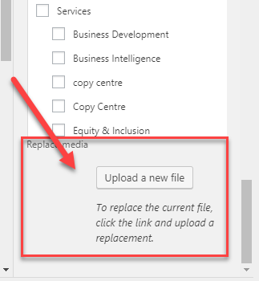Click to Select the file
3. Under the ATTACHMENT DETAILS section on the right, scroll to the bottom of the page, and click on **Upload a new file** button

**Alternatively**, if you are viewing the media as a list, you can locate file and click Replace media link as shown in example below.

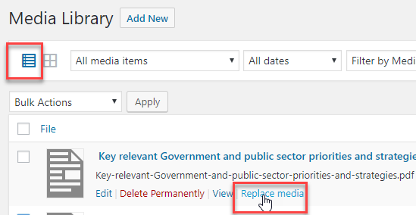

This will open the Replace Media Upload window.

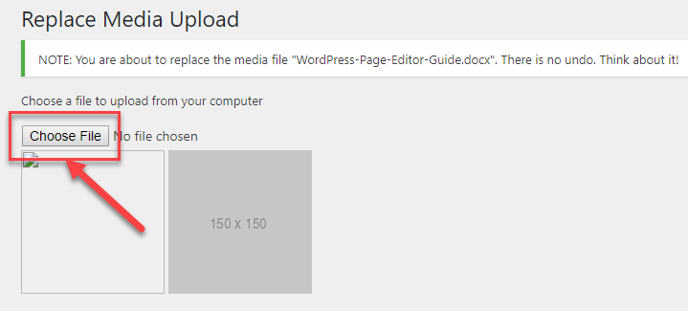

1. Click **Choose File** button
2. Locate and select the new file

The **Replace Media Upload** window will now display the file name of the file you just selected.

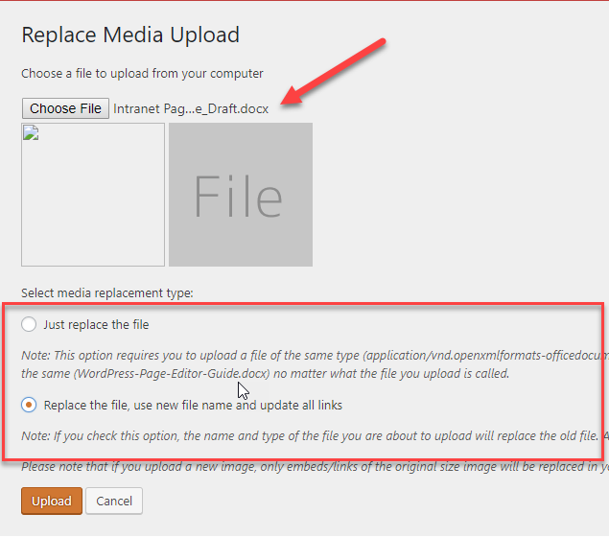

1. Select **media replacement type** by clicking in the radial button.
2. Click **Upload** button

**Note**: The **Replace… and update links option** is recommended for all documents. The ‘Just replace the file’ option is ok for images.

## Add new Category

The Media Categories we are using mainly relate to the parent and child structure used to display Policies and Form by sub-categories. The other main categories relate to the main topic headings (e.g. Services) and the categories that come under them.

When viewing the categories as below, note that they display in a hierarchy where ‘no dash’ indicates a Parent, single dash indicates ‘child’ and double a ‘child of a child’.

1. Click on **Media Categories**
2. Complete field as follows:
   1. Name – *Required*
   2. Slug – Not Required; system will generate
   3. Parent Media Category – Leave as None for 1st level or add to a parent
   4. Description - *Optional*
3. Click on **Add New Media Category** (Note there is no indicator that the new category has been added)
4. Click on **Media Categories** to check the new category has been added.

## Delete a Category

**Warning**: Only delete a category you have created yourself. You do not know how other categories may be used and deleting could have an adverse outcome.

1. Click on Media Categories
2. Move cursor over Name of category
3. Click on **delete**
4. Click **OK** when prompted.

# Creating a new page

Page editing is through a WYSIWYG interface with a tool bar that allows you to format text and media.

1. Click on **Pages**
2. Click on **Add New**
3. Type in a Page Title
4. Add content to the main body
5. Set Page attributes
   1. **Parent** – use drop down and choose where page will appear in navigation.
6. Click **Preview** to see what it will look like
7. Click **Publish** to make visible on the NEST (if you do not want to publish yet you can click **Save Draft** and continue editing and then publish at a later stage).

Note: a creator of a page will be set as the **Author.**

## Adding Hyperlinks

You can include links to email addresses, Documents and Images, other pages on the Intranet, or external sites.

### Email address

1. Click in the body of the page you want to insert the link
2. Write in the email address in the page body (e.g. [mmouse@unitec.ac.nz](mailto:mmouse@unitec.ac.nz)) and then highlight the address with your mouse
3. Click on insert link icon  from toolbar.

This will automatically recognise the link as an email and include the ‘mailto:’ suffix.

1. To include a subject with the email add the following to the end of the hyperlink **?subject=Intranet enquiry** (i.e. subject of the email will be set to ‘Intranet enquiry’)

### Link to Documents or Files

We recommend uploading the document to the media library before proceeding.

1. Click in the body of the page you want to insert the link
2. Click the **Add Media** button 

This will open the Media Library.

1. Click on the **Document** from the Media Library
2. Click on **Insert into page** button in bottom right.

### Link to other Pages (or Posts) on Intranet

1. Click in the body of the page you want to insert the link
2. Click on insert link icon  from toolbar.

This will display the link editor where you can either paste in the URL or if you know the name of the page then start typing the name and select from the list presented.

1. Click on blue arrow icon  to **Apply** the link.

NOTE: to change the way the hyperlink responds or edit the text See Edit a Hyperlink

## Adding Images

We recommend uploading the Image to the media library before proceeding.

1. Click in the body of the page you want to insert the link
2. Click the **Add Media** button 

This will add the image to your page

1. Click on the image in the page and the formatting tool bar will display
2. Click on alignment button to allow text to wrap around the picture.
3. 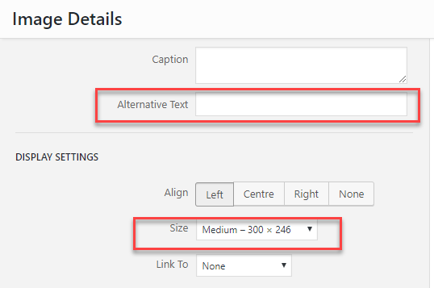Click on the pencil icon to display Image Details interface
4. Alternative Text is recommended (as this is read by screen readers for the vision impaired).
5. Size can be set here using drop down and selecting from the list displayed.
6. Click **Update** to save changes

## Edit a Hyperlink

1. 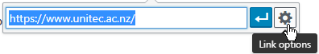Click on the hyperlink in the page
2. Click on Link Options icon

This will present the following Insert/edit link dialogue:

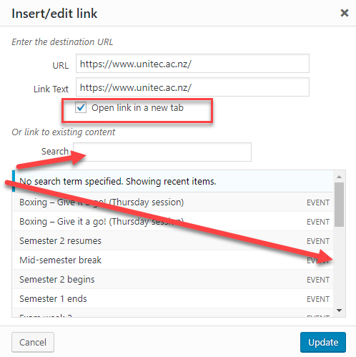

1. Tick the box ‘Open link in new tab’ for all external links and documents.

NOTE: You can also search for other intranet pages and posts through this interface.

1. Click **Update**

# Using Short Codes

WordPress makes use of this feature to enable certain pieces of information, for example documents from a Media Category, to be displayed on a page.

## Displaying All Category Content on a page

The Policies and Procedures page make use of this feature to display all the content from the Media Library that have been added to the Policies and Procedures Category by simply including the following code into the page body.

For example, [p_list_media mediacat=16] would display the contents of Category ID16 on a page as list.

There is a Demo page within WordPress that has the codes and you can copy and edit as needed.

Here are the two commonly used examples:

To display category ID 128: [p_list_media mediacat=128]

**To display category ID 22 as alpha list:** [p_list_media mediacat=22 show_alpha_list=0]

Replacing ID number shown with the Category ID of your choosing will display accordingly.

## Finding the Category Code

In order to do the above you will need to know the category code. Here is a way to find it.

1. Click on **Media Categories** from the **Media** menu on the left
2. Navigate to the Category you want to Display
3. Place cursor on Category name

With the cursor over the name, look at the bottom of the screen. This will display a long string of code.



1. Make note of **the ID** (as highlighted in the example above) as this is the category number that can be used with the shortcode).

# Using TablePress

Tables can be a useful way to display content on a page. However, using them in a page usually requires some HTML code understanding. A simpler way to insert a table is using the **TablePress** function.

Step 1 – Create a Table

You either let the plugin create an empty table for you, which you then edit in TablePress or you import an existing table from either a CSV, HTML, JSON, XLS, or XLSX file.

Step 2 – Edit the Table

You can edit your data or change the structure of your table (e.g. by inserting, deleting, moving, or swapping rows or columns or sorting them) and select specific table features like alternating row colours or whether to print the name or description, if you want. To easily add a link or an image to a cell, use the provided buttons.

Step 3 – Place in your page

To insert a table into a page, or post, copy its Shortcode **[table id=<ID> /]** and paste it at the desired place in the editor. You can also click the “Table” button in the editor toolbar to select and insert a table.

## Table Options

Each table has individual options that only concern that table. They can be changed on the table’s “Edit” screen.

The following options are available:

* **Alternating row colours**
  + If enabled, every odd row will get the additional [CSS](https://tablepress.org/documentation/#qa-faq5) class odd, every even row will get the class even.
* **Row Highlighting**
  + If enabled, the background colour of all cells of the row that is currently hovered with the mouse cursor is changed to highlight the row. (There’s an example on how to change the colour in the [FAQ](https://tablepress.org/faq/change-color-highlighting-hovered-rows/).)
* **Table Head Row**
  + If this is activated, all cells in the first **displayed** row will be encapsuled by the <th> instead of the <td>HTML tag and the row will be put inside a <thead> HTML tag. This is mandatory for using any of the JS libraries functions!
* **Table Foot Row**
  + If this is activated, all cells in the last **displayed** row will be encapsuled by the <th> instead of the <td>HTML tag and the row will be put inside a <tfoot> HTML tag.
* **Table Name**
  + If enabled, the Name of the Table will be printed above/below the table inside a <h2> HTML tag, which has the [CSS class](https://tablepress.org/documentation/#qa-faq5) *tablepress-table-name*. The position can be selected from “above” or “below”.
* **Table Description**
  + If activated, the Description of the Table will be printed above/below the table inside a <span> HTML tag, which has the [CSS class](https://tablepress.org/documentation/#qa-faq5) *tablepress-table-description*. The position can be selected from “above” or “below”.
* **Use JavaScript library**
  + This option is **only** available, if the option “Table Head Row” is checked. If enabled, certain features of the DataTables JavaScript library can be enabled.

**NOTE**: If an option is set as a Shortcode parameter, it has preference over the corresponding option on the table’s “Edit” screen.)

There are some advanced options for changing how the table then displays in the page that can be done through the page editor and adding code to the ‘Custom CSS’ field.

For example, below shows the code that allows for the 1st column to be resized (rather than display as equal width on a page).

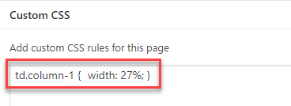

You may want to talk to a IMS Trainer

**References:**

<https://tablepress.org/faq/>

# Working with Images

Images are another element to a page that can sometimes be difficult to control.

There are some default sizes that are set in WordPress as follows:

|  |  |  |  |
| --- | --- | --- | --- |
| Sizes | Width | Height | Uses |
| Thumbnail | 150 | 150 | This is best when maintaining a proportional size image. |
| Medium | 300 (max) | 300 (max) | This is usually as large as you want on a page. |
| Large | 720 (max) | 1024 (max) | An image this large will need to be scaled down to fit within our page template. |

More to follow . . . . . . . .

# Using Bookmarks and Page Jumps

A “page jump” in WordPress is when you link to a specific spot on a page. Clicking that link takes you directly to that spot. Many already know this function in Microsoft Word as bookmarking.

Page jumps (or bookmarks) are especially convenient if you have a lot of content on a single page. Many use page jumps to create a mini table of contents at the top of their content; however, you can also link from the middle of paragraphs too, of course.

## How to Create WordPress Page Jumps / Bookmarks

Creating page jumps is fairly easy, but it does involve going into the HTML section of your editor.

You will need two parts to your page jump:

* The **link**
* The **target**

## The Link

The link code will need to take this form:

<a href="#unique-name">Your Link Text</a>

You need to create a unique name for your page jump link and place that in your coding. Notice that you also need to use a hashtag (#) before the name.

**Example:**

So, for example, let’s say we create the unique name “music-history” for this particular page jump link.

<a href="#music-history">Your Link Text</a>

Then, of course, you can make your visible link text say whatever you like. I’m going to use “Music History Section.”

<a href="#music-history">Music History Section</a>

[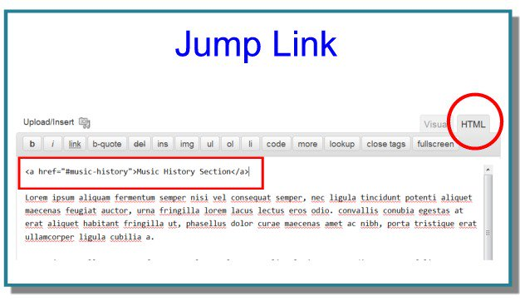](https://premium.wpmudev.org/blog/link-to-any-spot-in-a-wordpress-post-with-page-jumps-bookmarks/jump-link/)

## The Target

The target (the spot where you’re jumping to) will need to take the following form:

<a name="unique-name">Target Text</a>

Or, you can do without the text, and simply place the code in your editor.***

<a name="unique-name"></a>

**Example:**

In the example above, I made my unique name “music-history,” and so I need to name my target the same (however, there is no need for a hashtag # here).

<a name="music-history">Music History Section</a>

Or, if I’ve decided not to use visible text, it would look like this:

<a name="music-history"></a>

**\*\*\*Note:** You may decide not to use text because often when you jump to a spot on your site, a tool bar or something else at the top might cover up the actual beginning spot you want your visitors to see.

The way to get around this is to put the “target” just ABOVE the spot you actually want your visitors to begin.

For example, if I want my visitors to see my heading labelled “Music History Section,” I might find it’s better to use the coding like this:

<a name="music-history"></a>

[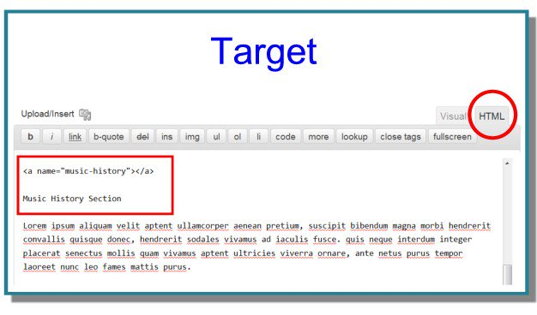](https://premium.wpmudev.org/blog/link-to-any-spot-in-a-wordpress-post-with-page-jumps-bookmarks/target-3/)

## Linking to Specific Spots on Other Pages

Once you set up these page jumps and test them out, you will notice that when you jump to a target, the URL in your browser changes to reflect exactly where you are.

For example, if your main page is mysite.com/music/, and you jump to your “music history” target, your URL will now show as mysite.com/music/#music-history.

Because of this, you can also set up links between pages and go directly to the spot on the page that you want.

For example, if you had a post on your site about all your interests, and you wanted to link to the “Music History Section” of your “music” page (mysite.com/music/), you would link directly to that spot:mysite.com/music/#music-history.

## Linking to the Top of the Page

Perhaps you’ve been on a site before that had a link at the bottom of the page that said “Top” or “Go to the Top of the Page.”

You can also easily do that with the same type of code we’ve gone over here.

Put the following “target code” at the very top of your page:

<a name="top"></a>

And then wherever you  like, put the following link code (again, notice the hashtag #):

<a href="#top">Go to the Top</a>

The same principles are at work here: you’ve got a link (even though it’s at the bottom) and you’ve got a target (even though it’s at the top).

And that’s all there is to it.

# Event Manager

*This section is only relevant to Staff with Access to the Event Manager Functions in WordPress.*

The Intranet uses a Plugin called Event Manager. Event Manager can only be accessed directly via the backend however general users can submit Events from the front end.

NOTE: User submitted Events will be saved as **Pending** so that an authorised Event Admin can moderate them before publishing.

## Creating an Event

1. Click on **Events** from left-hand menu
2. Click on **Add New** button
3. Type in Title of Event (NOTE: keep this as short and concise as possible
4. Click in the body of the event editor and type in details of the Event. We recommend putting **the Event Title as a Heading 3 format** in the body as this displays in the calendar pop-up
5. Set up the **Date** and event **Time** in the right-hand side of the screen.
6. Enter an **Event Location** if required.
7. 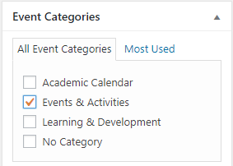Scroll down page and Tick the appropriate **Event Category**
8. Click **Publish** (or Save as Draft)

### Booking and registrations

If this option is checked then you can manage additional options as below.

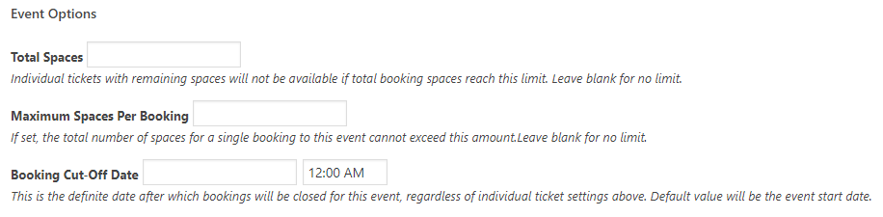

See Managing Bookings

### Excerpts

If the Event text is rather long then a summary entered in the Excerpt field will display in the Events lists as an alternative to the long text.

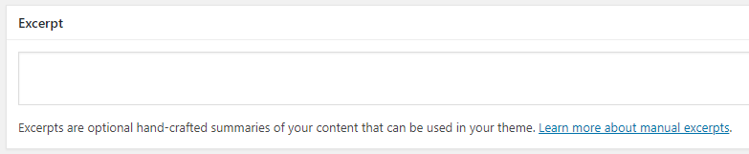

### Adding a Featured Image

A Featured image will appear as a small thumbnail in the event ‘Popup’ that displays from the main Calendar View when the cursor hovers over the event entry.

## Recurring Events

If an event is going to be recurring then you need to set this up slightly differently.

1. Go to Events > Recurrent Events
2. Click Add Recurring Event
3. Type in Title of Event (NOTE: keep this as short and concise as possible
4. Click in the body of the event editor and type in details of the Event. We recommend putting **the Event Title as a Heading 3 format** in the body as this displays in the calendar pop-up
5. Set the frequency of Recurrences as required.
6. Enter an **Event Location** if required.
7. Scroll down page and Tick the appropriate **Event Category.**
8. Click Publish (or Save as Draft)

If this event requires registrations then see Booking and registrations

### Editing a Recurring Event

Recurring Events can be edited as a ‘set’ by editing the Recurring Event itself. Modifications to recurring events will be applied to **all** recurrences and will overwrite any changes made to those individual event recurrences.

Bookings to individual event recurrences **will** be preserved if event times and ticket settings are not modified.

You can edit individual recurrences via the Events menu. If required, you can **disassociate** them from the recurring event set, which will preserve the changes, independent of any further changes to the set.

## Managing Bookings

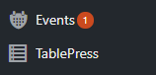If an event is created that allows registrations then notifications of pending bookings will appear in the Events menu.

The number shown (e.g. 1) will be the total notification for review (they may not all be ‘bookings’.

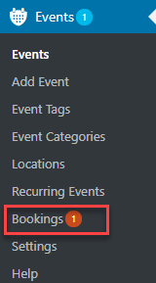Click on **Events** menu to expand and you will see the whether any are bookings (in this example, there is 1).

Click on **Bookings** to see the details.

This will open the **Event Bookings Dashboard** and at the top of the page are the **Recent Bookings.**

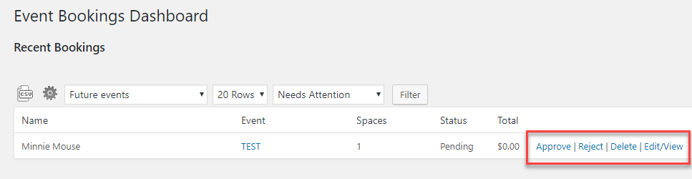

From here you select whether to **Approve**, **Reject**, **Delete** or **Edit** the Booking that has been submitted.

Upon selecting an action, an email notification will be sent to the person who made the booking.

## Email Notifications

The **Event Manager Settings** include an option whereby you can choose to receive an email when users submit an event. To activate the feature, go to Events > Settings > Emails > Event Submission Templates.

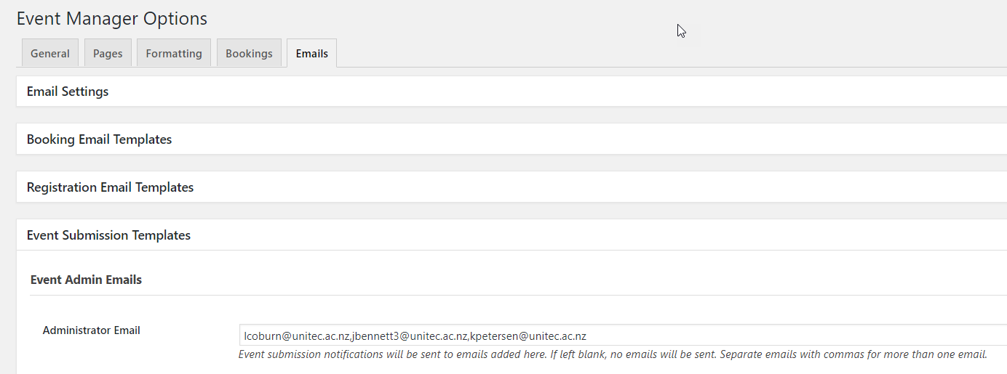

**Note**: This is a general rule and will apply to all Event Submissions.

Add the email address you want to send notifications to in the **Administrator Email** field. You can add more than one address by separating them with a comma. If you don’t want to receive notifications, leave the box empty.

Under the Administrator Email field, there are templates that control which information is included in emails sent to administrators. Whenever an event is submitted by a non-admin users, Events Manager will send out the appropriate emails.

## Export Booking Details

There is a function to export all the ‘bookings’ to a spreadsheet via CSV file.

Some uses might be:

* Keep a record of total attendees.
* Send a customised email (using mail merge) to all registered attendees.

1. Go to **Events** > **Bookings**
2. Click on the Event you want to view
3. Click on **CSV** icon (as shown below)

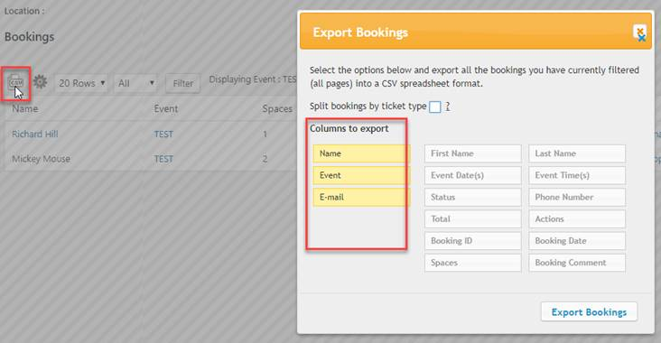

1. Move columns you want to export to the left (click and drag)
2. Click **Export Bookings**

This will export a CSV file to your Downloads folder on your computer.

1. Open the file in Excel

## Online Documentation for Event Manager:

<https://wp-events-plugin.com/documentation/getting-started-guide/>