Your business card reflects Unitec's professionalism. Please complete this form carefully.
- Your job title and department name must match what was stated on your offer of employment letter. Your qualification abbreviations must be correct.
- Please do not change the type font in any field or add additional data to the fields.
- Check the spelling carefully. Mistakes will lead to reprints at your cost and delays.
- Your Head of Department or Manager must check and sign off your form to confirm that it is correct and then forward it to the Copy Centre.
- If you need a business card using a language other than English, please type the translation in the appropriate fields on this form
- Samples of what your business card will look like are provided on Page 2 of this form.
Please allow 10 days for processing, unless it is urgent. In these cases there will be an additional cost.

1. Please enter your business card details and check carefully

*Date requested: |  |  |  | *Date required: |  |  |  | Language:  (if not English)
*Quantity required: |  |  | 250 or 500 |  | Your ID No.
*Charge code: (default is 268810) | 268810 |  |  | *Dept code:  (e.g. 02BC) |  |  | Programme code: (if required)

For Department codes see | https://thenest.unitec.ac.nz/TheNestWP/wp-content/uploads/2018/08/Sector-Alignment-PSoft-Network-Tree_31Jul2018.xls

(a) *Your name (as it is to appear on the card):
(b) Your qualifications:

For qualification format, see: | Academic Qualifications and Titles Protocol Policy.doc

(c) *Job title (as approved by Head of Dept/Manager):
(d) Job title line 2 (leave blank unless approved)
(e) *Your department name:

For official school names see the ‘Primary Offering Dept’ column in the spreadsheet | ( update soon)

(f) * Your Faculty
(g) *phone  + 64 9 815 4321 ext |  |  |  | (h) direct dial  + 64 9
(i) mobile
(j) fax
(k) *email |  |  |  |  | @unitec.ac.nz
web www.unitec.ac.nz
address | Standard template for Unitec address: please indicate campus location |  |  |  | Waitkatere Mt Albert
postal | Private Bag 92025 |  |  |  | Auckland, New Zealand

2. Email form to your Head of Department / Manager for checking & approval

*HoD/Manager Name: |  | *Position: |  |  | * Dept:
I have checked that the details (a) to (k) above are correct. This card and any “author” corrections may be charged to my budget. |  |  |  | If mailing, please sign

3. The Head of Department or Manager must email the completed form to copy@unitec.ac.nz or sign a copy and send to Copy Centre at Building 114.
COPY CENTRE - OFFICE USE  ONLY | DTP |  | X |  | @ $
COPY CENTRE - OFFICE USE  ONLY | PRN |  | X |  | @ $

- Directorates template: | 
Front | Back

Sample Format of Business Cards

- Faculty of Creative Industries and Business
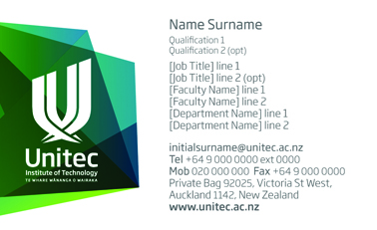 | 
Front | Back

- Faculty of Social & Health Sciences
 | 
Front | Back

- Faculty of Technology & Built Environment
 | 
Front | Back

