Environmental Sustainability Strategy Committee

Wednesday 01st March 2017 12.00pm at B48

|  |  |
| --- | --- |
| **Present**  Adam Weller (AW), Jo Barnes (JB), (AS), Magdalena Garbarczyk (MG),Deborah Rolland (DR), |  |
|  |  |

1. **Apologies**

Terri-Ann Berry (TB), Linda Kestle (LK), Shirin Caldwell (SC), Christian Hurzeler (CH), William Smith (WS), Glenn Huggard (GH), Mieke Sieuw (MS), Jessica Rose (JR), Amos Sander, Danae Ripley(DR), Mary Panko (MP), Carolyn Cox (CC),

1. **Monthly Results– AW** 
   1. Reviewed January 2017 results using the new SoFi data and the new Sustainability template.
   2. Concern was raised by MG & DR about Air Conditioning being kept on during the Christmas break, so cooling rooms and wasting energy when no-one is around. Building 202, and room B183-1104 – **AW to discuss with FM.**
2. **Previous Actions – ALL**
   1. None
3. **Discussion on date & time of meeting**
   1. Confirmed 12 on Wednesday’s instead of at 1pm on a Wednesday works for everyone.
4. **Sustainability data and reporting with SoFi Update – AW** 
   1. Historical data has now been loaded into SoFi.
   2. Annual and monthly Reports have been created for quick and easy access to environmental data.
   3. All sources of data have agreed to supply Unitec’s environmental data on a monthly basis including Aquaheat for Refrigerant.
   4. Question raised by JB about intensity reporting and not just absolute reporting e.g. reporting electricity use by student numbers and not just in kWh’s etc. SoFi has been setup to store student numbers, and student numbers have been captured. Currently no reports using student numbers have been created, but the long term plan is to do so and to include them in the monthly reports. It was discussed and recommended to use Student Numbers not EFTS.
5. **2016 Sustainability Summary – AW.** 
   1. Review of the 2016 sustainability report.
   2. It was noted by MG & DR that some staff kitchens have no recycling bins at all e.g. B115 & 111, B001-2041 – **AW to investigate.**
6. **Solar Competition Update – AW**
   1. The recommendation from the Solar Competition Team is that the funds are split 1/3’s for the winning design and 2/3’s solar panels and that the winning street light is designed for use in the Future Campus.
   2. So the winning concept solar panel and light are designed and instead of fabricating the whole pole are designed to retrofit onto existing poles from 1/3 of the available funds.
   3. The rest of the budget is used on solar panels from 2/3 of the available funds.
   4. This way Unitec gets to honour the commitment to the student and in addition will also get solar panels up and generating power as per the Zero Carbon Principle - and it's target of 'Generate ≥ 1% of Unitec’s energy renewably onsite'
   5. The One Planet Committee agrees with the recommendation from the Solar Competition Team.
7. **General business – ALL** 
   1. Carolyn Cox has handed in her notice and leaves on the 29th on March.
   2. As Angela Jones has left there is a spare space on the Integrated Reporting training and it is recommenced that Zhivan Alach is invited to attend and Jo Alexander has agreed to pass Angela’s place onto Zhivan even though he is in a different team. As Carolyn has left there is now another space.
   3. Skype Meeting:
      1. This was the first meeting using Skype meeting, and it didn’t go very well. It was started on my laptop and it appears Jessica tried to join in but she didn’t come up for some reason.
      2. Also identified as an issue is that if my laptop is being used to capture the minutes of the meeting and to display items this may get in the way of the skype meeting.
   4. MG raised some concerns about the student’s orientation bag for semester 1 2017:
      1. A Lighter is provided; Unitec is a smoke free campus – This promotes the wrong message to our new students.
      2. There was lots of wasteful packaging such as plastic bottles, products in single serve aluminium foil packaging etc.
      3. There is nothing in the bag that mentions Unitec cares about the environment.
      4. All the bag contents are third party. So where for example is the library info?, counselling services?, One Planet Sustainability? Etc.

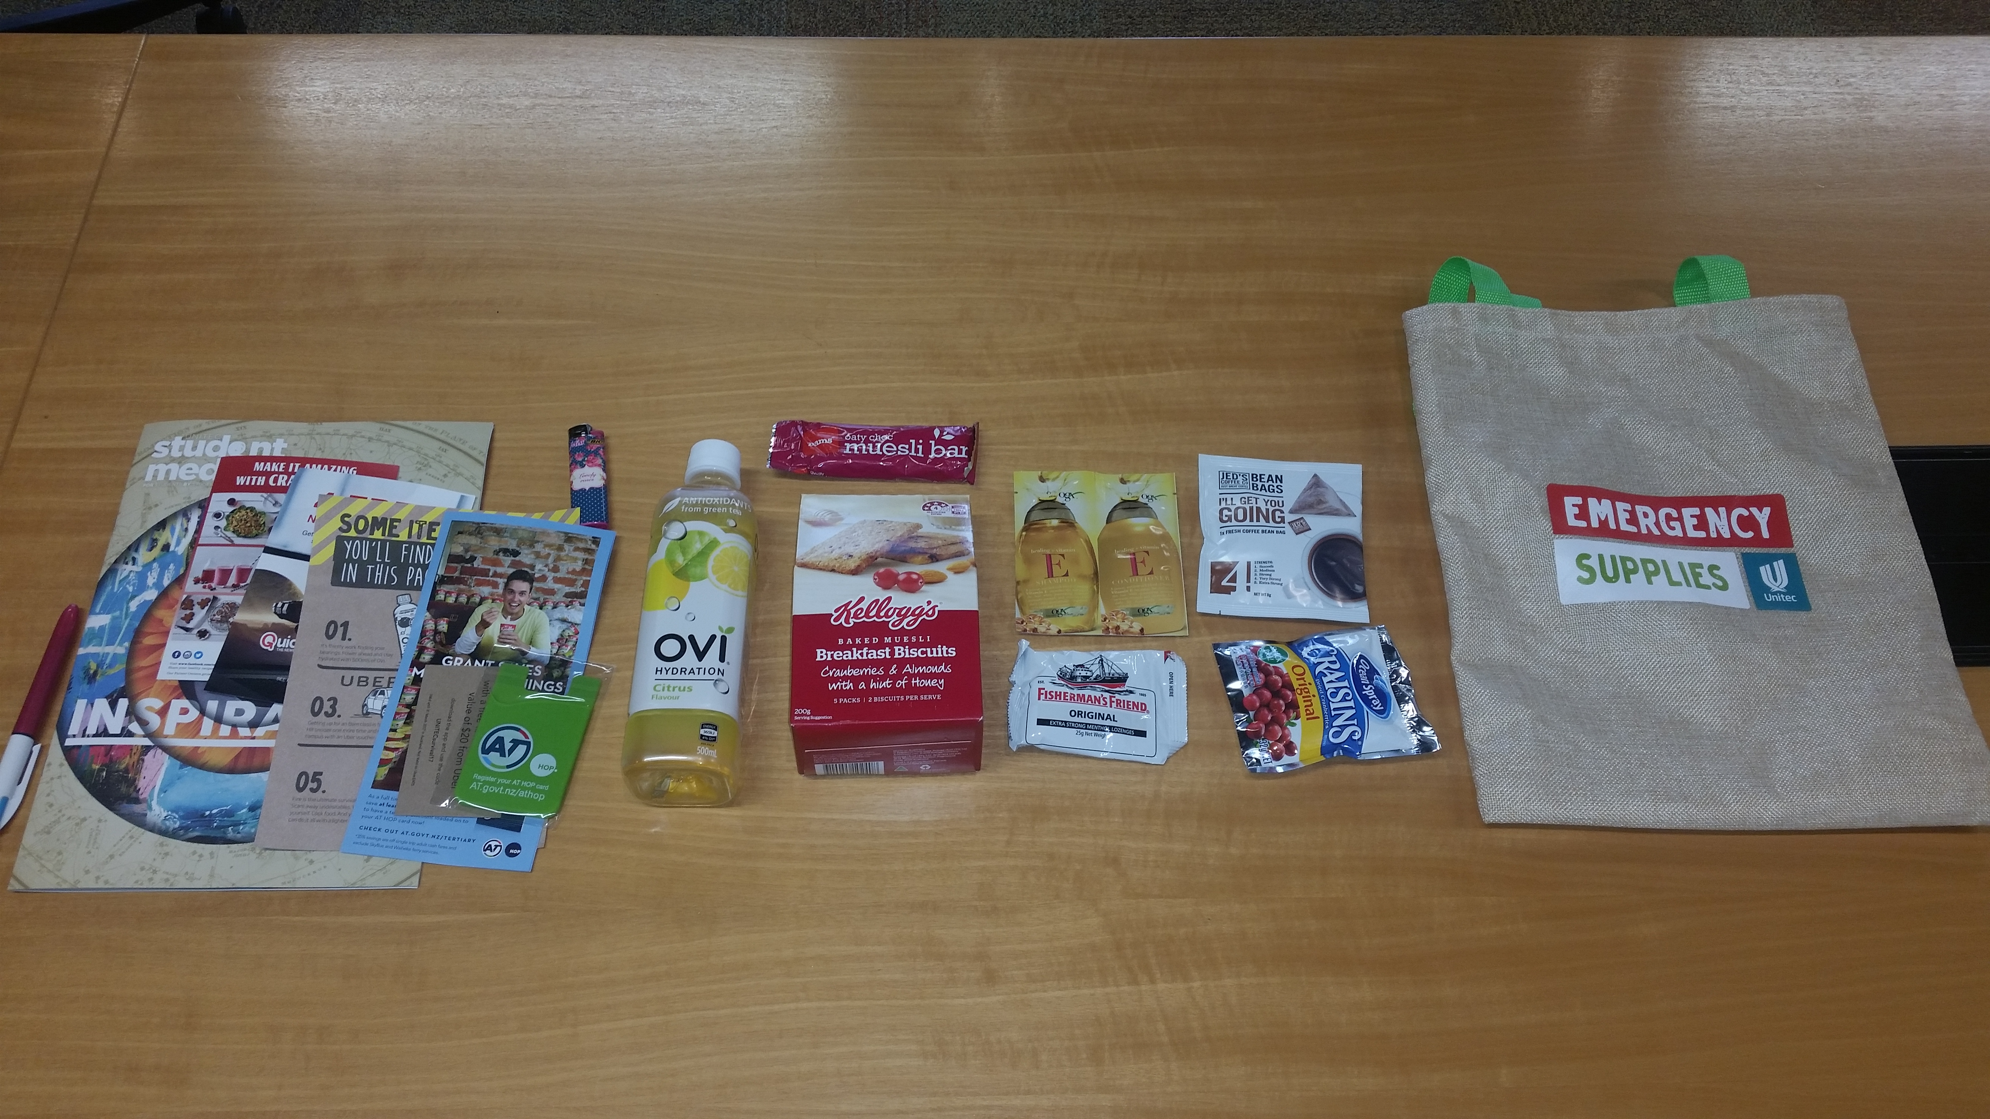

* + 1. **AW to investigate**

1. **Next Meeting: TBC**