**Staff Claim for Refund of Expenses and Travel Allowance**

**Has Moved**

All claims are now completed on-line

**Navigation**

The Nest > Staff Portal > Expense Claims

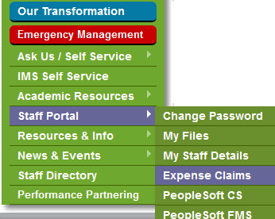

**How to Documents**

To find documentation on how to use the system, go to:

The Nest > Quick Links > Ask Us/Self Service > Ask IMS > Documentation and User Guides

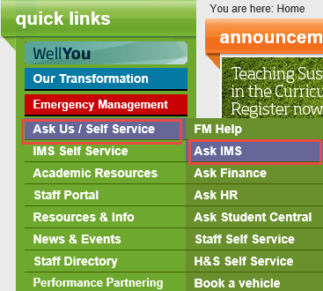

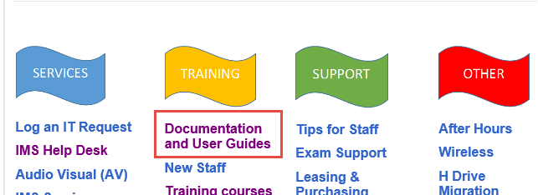

**On-Line Help**

When you’re signed into PeopleSoft Expenses and need help, use the **Help** link in the top-right of the screen which has a range of guides to help you

