Leave Requests to now be submitted via HR Self Service

With the introduction of HR Self Service in October 2011, all staff must now submit their leave requests online.
The exception to this is: Leave without Pay, Parental Leave and Unplanned Leave such as ACC related incidents. Please use the manual form on the next page to apply for these types of leave or contact Payroll for queries.

To submit an online leave request:

1. Click on the link below and login

Note: You may have to log in twice – once into the Unitec Portal and again into the HR Self Service (PeopleSoft) application itself.

https://myunitec.unitec.ac.nz/psp/HCMLIVE/EMPLOYEE/HRMS/s/WEBLIB_PTPP_SC.HOMEPAGE.FieldFormula.IScript_AppHP?pt_fname=CO_EMPLOYEE_SELF_SERVICE&FolderPath=PORTAL_ROOT_OBJECT.CO_EMPLOYEE_SELF_SERVICE&IsFolder=true

2. Once you have successfully logged in (you should see something similar to the screen below) select ‘Leave Request’

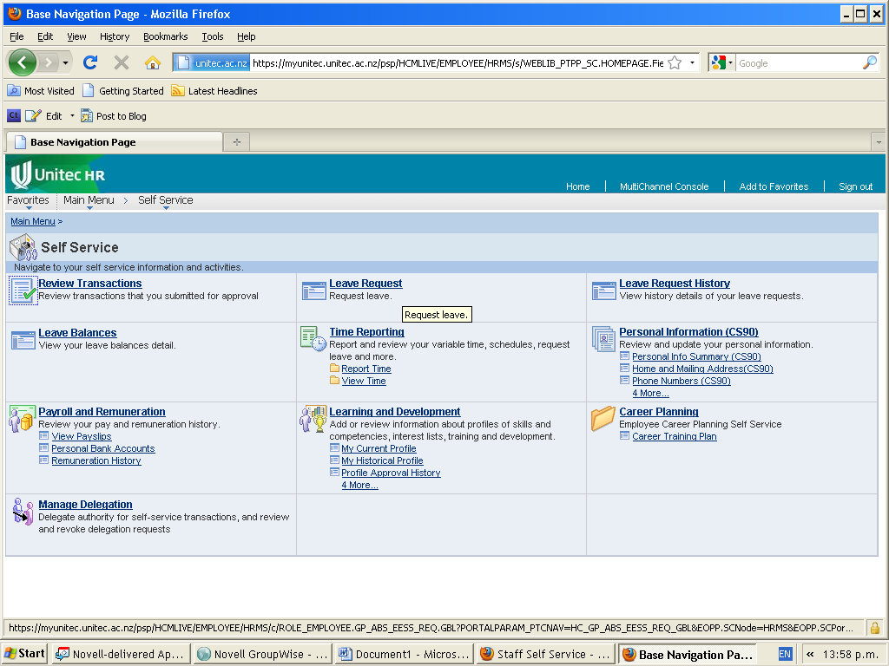

For further information and to access online demonstrations on how to apply for leave, click here.

 All other leave not included on this Form to be applied for online
via Peoplesoft Self Service
LEAVE APPLICATION FORM

Employee Name: |  |  | Unitec ID: | Contact Number:
Academic | Allied | Monthly Paid

Panel 1: Planned Leave |  | First Working Day of Absence | Last Day of Absence |  | Proportional or Less than Full Time –Leave in Hours |  | Full Time –Leave in Days
Leave Without Pay (Please refer to payroll before applying for LWOP)
Other Leave (Please specify)
eg Parental Leave, Leave In Advance.

Panel 2: Unplanned Leave

Work/Home Injury: See Panel 3
Comments:

Panel 3: Work or Home Injury

If your absence is the result of an accident or injury please provide the injury details requested below:

Date of Injury / /   Work Injury   Home or Sport Injury | Duration of Absence:  1st Working Day of Absence / /  1st Day Back at Work / / |  |  |  |  | ACC 45 attached  (first medical certificate)  ACC ARC 18 attached  (further medical certificate)
Employee Declarations and Manager Authorisations

Leave in Advance (where applicable)
I understand that leave applied for in this application may be in advance of my accrued entitlement and, in the event of termination of my employment I hereby authorize Unitec New Zealand to deduct from my final pay the amount of holiday pay paid in advance. Where the amount of holiday pay paid in advance is greater than the monies due to me on termination, I undertake to pay Unitec the balance owing immediately upon my termination.

Employee Signature:

Approved By:  (please print) |  |  |  | Contact Number:
Signature:  (please sign) |  |  |  | Date: / /

